Activity 2: Peripheral Smears

Name of Patient: Felicy Jane Pactores DOB: 2002-10-31

In this prepared slides, identify and count the number of WBCs and platelets you can find per field
(specify type of white blood cell) and compute for the WBC estimate and platelet estimate.

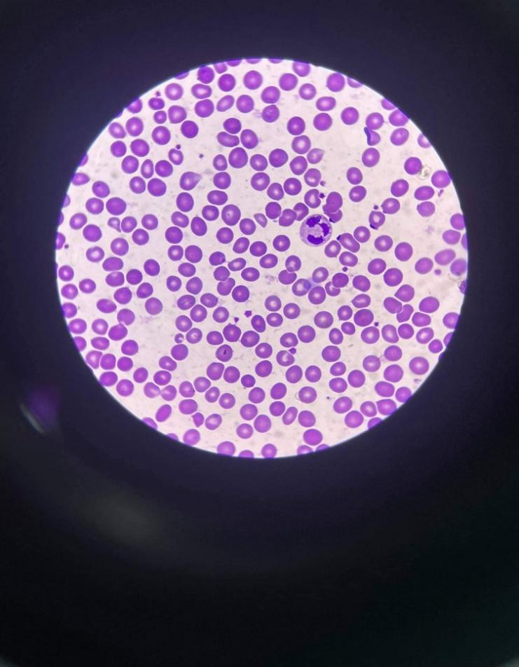
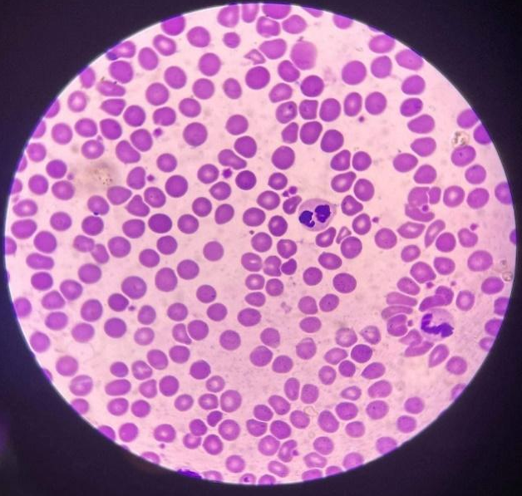

wbc -2 : neutrophil, lymphocyte wbc -2 : eosinophil
platelet: 12 platelet: 19
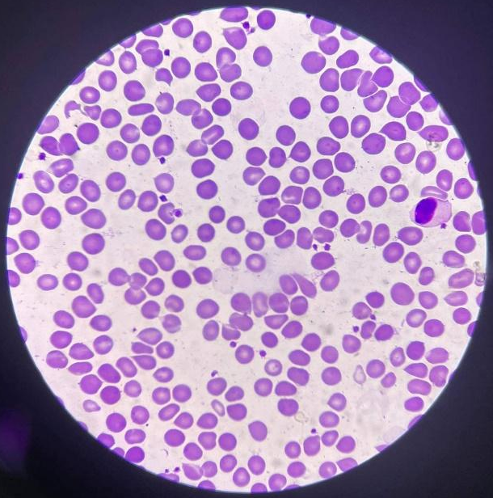
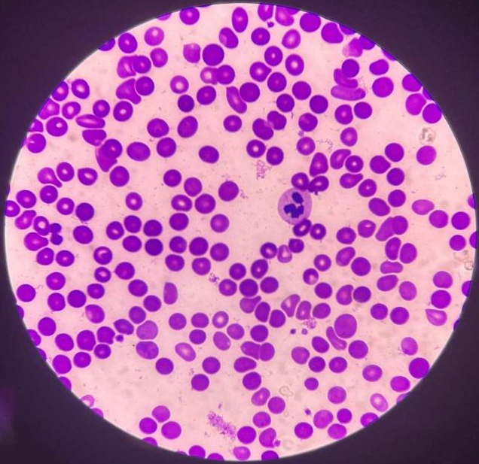

wbc -1 : monocyte wbc -1 : neutrophil
platelet: 20 platelet: 9

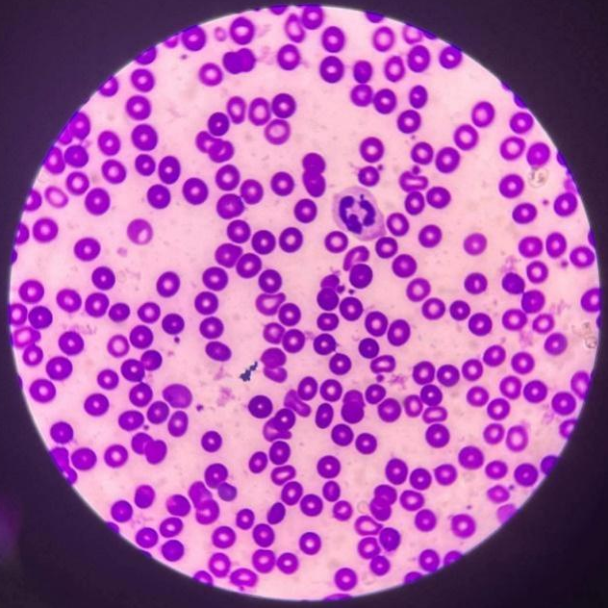
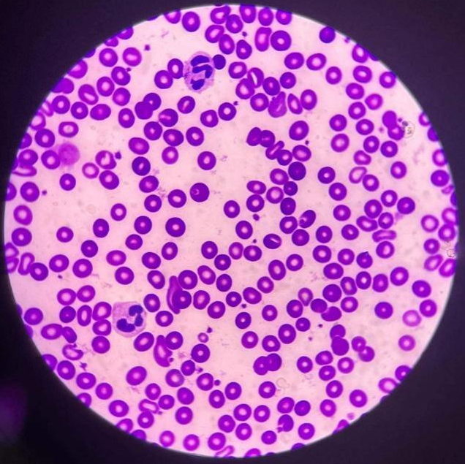

wbc -1 : neutrophil wbc -2 : neutrophil
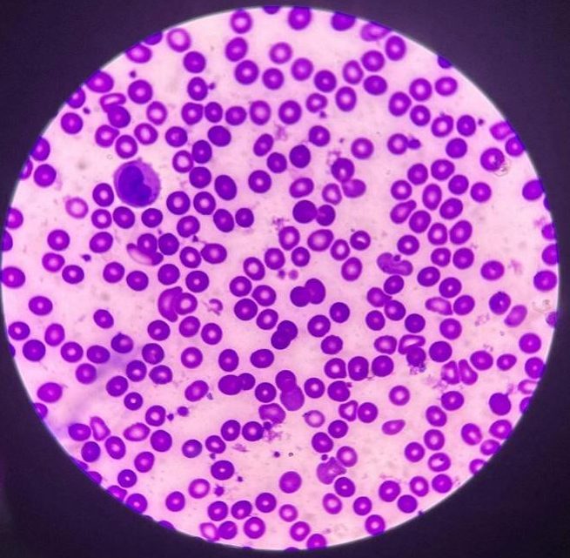
platelet: 20 platelet: 25
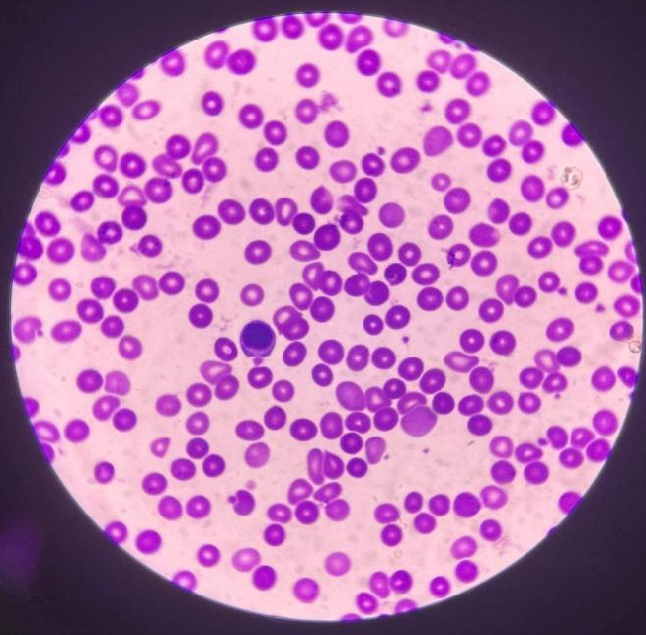

Wbc - 1: Monocyte wbc - 1 : Monocyte Platelet: 25 Platelet: 15

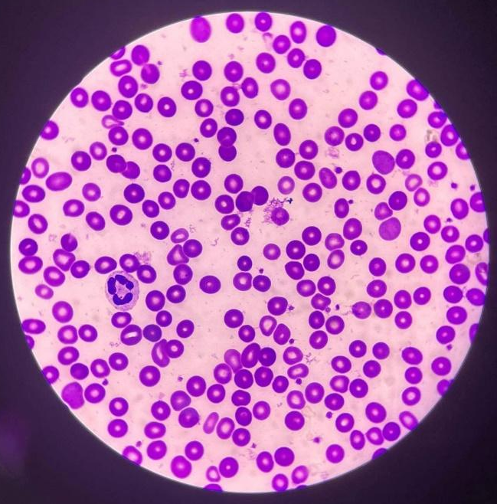
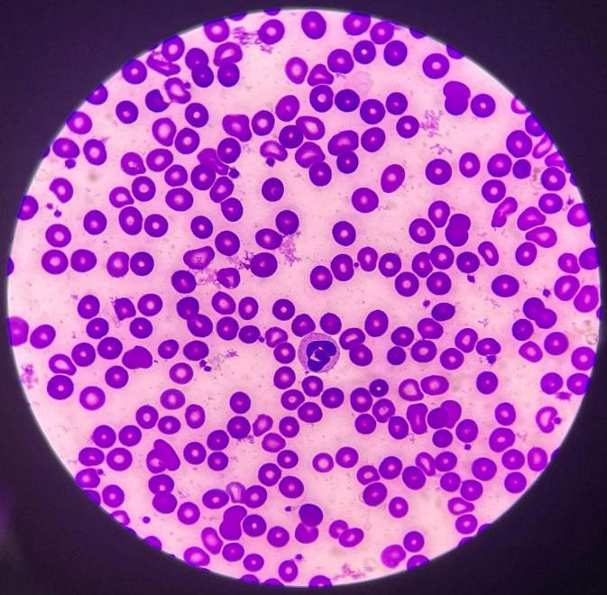
Wbc 1: neutrophil wbc 1: neutrophil Platelet: 21 Platelet: 29

Computation:
WBC count: 1.3 x 2000 = 2,600/${mm}^{3}$

platelet count: 19.5 x 20,000 = 390,000/${mm}^{3}$

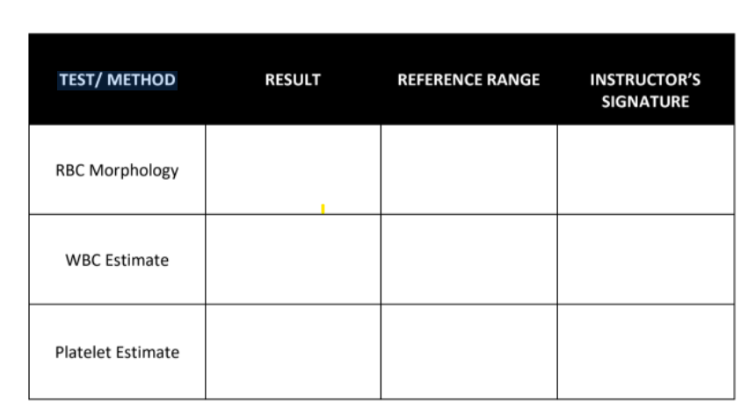

3+ (11-25%) 3+ (11-25%)

2,600/${mm}^{3}$ 5,000-10,000/${mm}^{3}$

390,000/${mm}^{3}$ 150,000-450,000/${mm}^{3}$

Time and Date Performed: 10:00 pm June 3, 2022
Date Submitted: June 3, 2022
Medical Technologist: Shajn Justin Majarocon

