Activity 2: Peripheral Smears
Chastaine G. Salvacion
February 28, 2001
Name of Patient: ______________________ DOB: ___________________

In this prepared slides, identify and count the number of WBCs and platelets you can find per field
(specify type of white blood cell) and compute for the WBC estimate and platelet estimate.

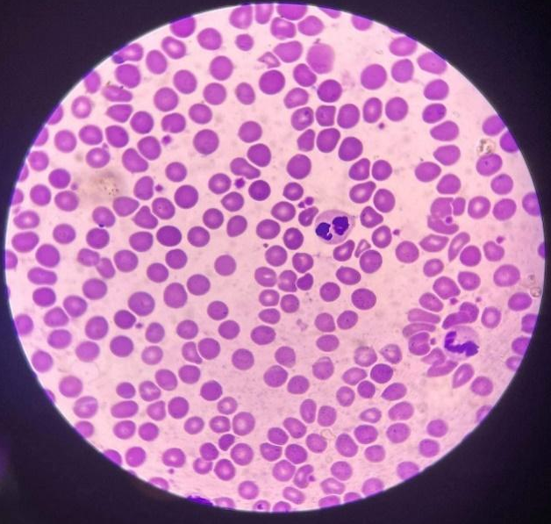
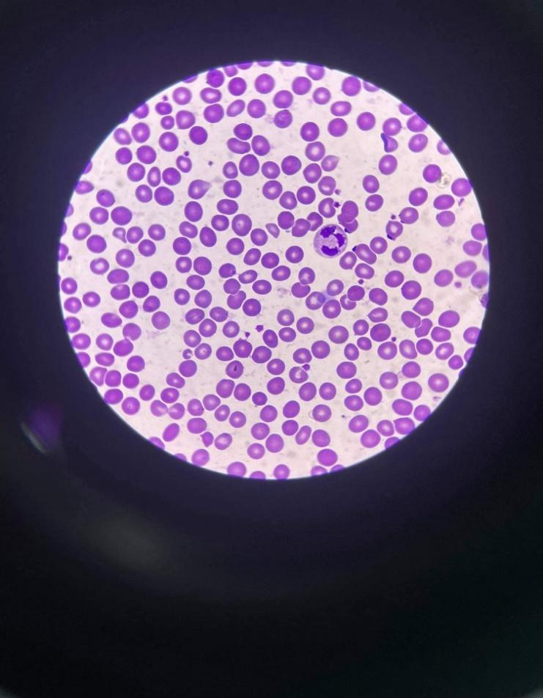

WBC: 2 – neutrophil both
Platelet: 14

WBC: 2 – neutrophil, lymphocyte
Platelet: 12

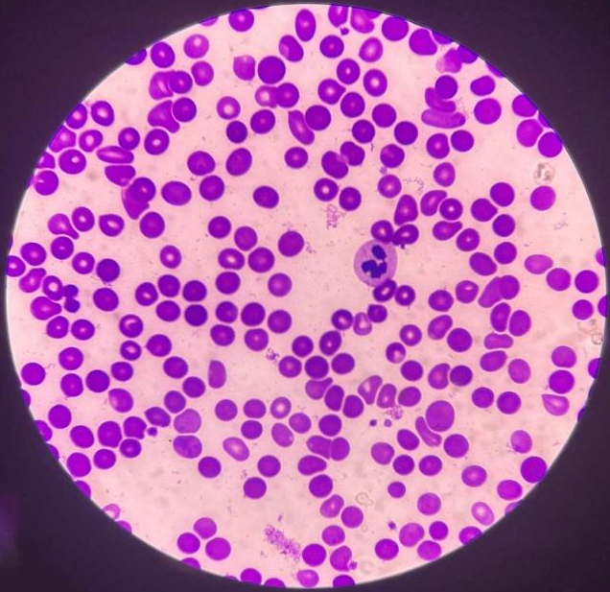
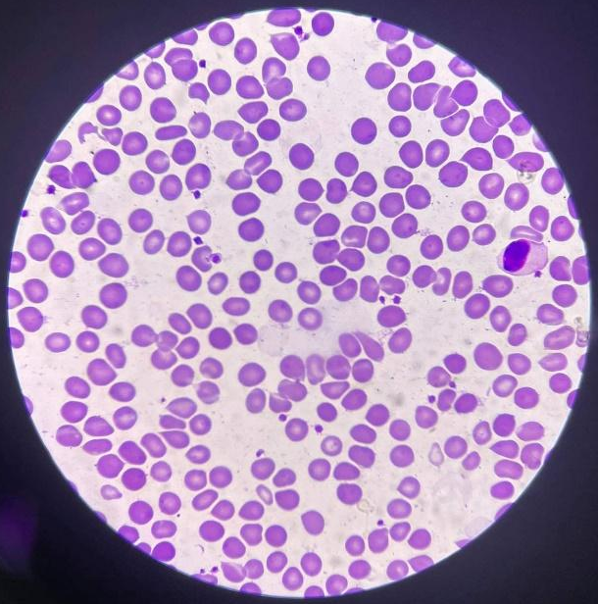

WBC: 1 – eosinophil
WBC: 1 – neutrophil
Platelet: 6

Platelet: 17
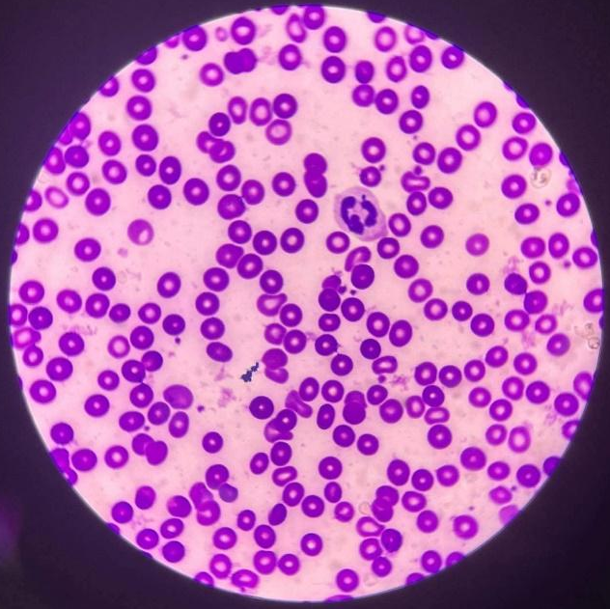
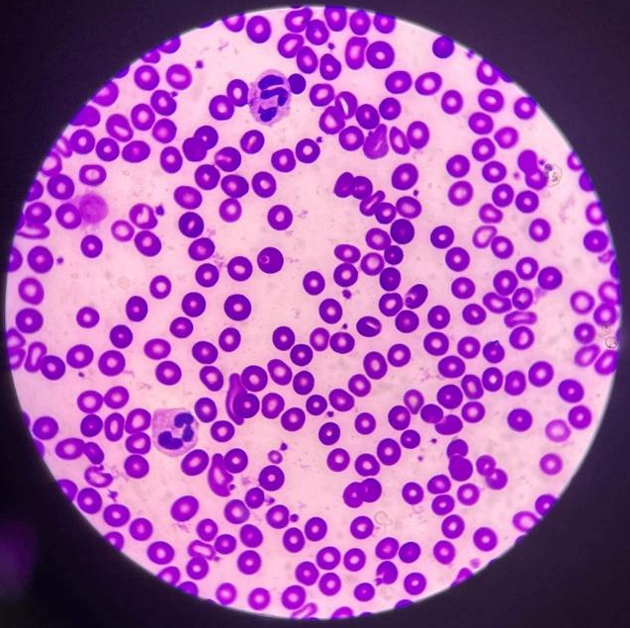

WBC: 2 – two neutrophils
Platelet: 18

WBC: 1 neutrophil
Platelet: 12

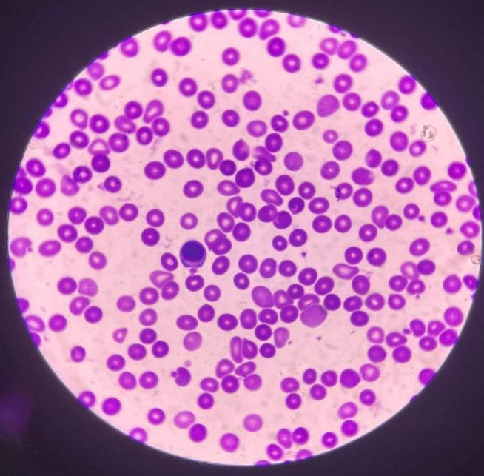
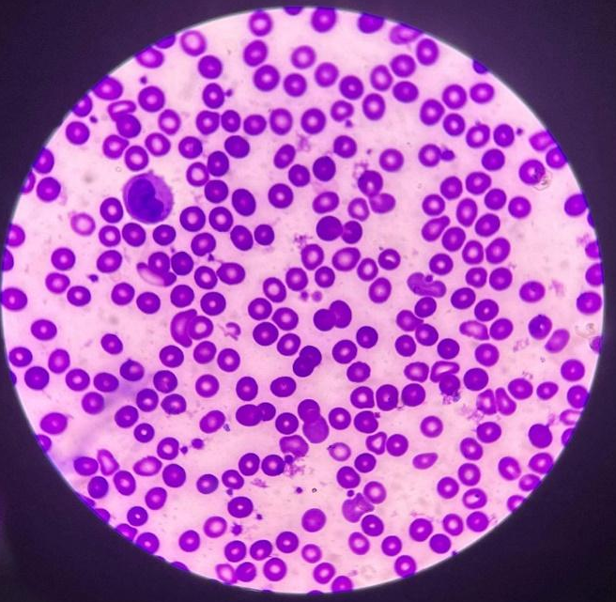

WBC: 1 – monocyte
WBC: 2 – lymphocyte, basophil
Platelet: 6

Platelet: 12

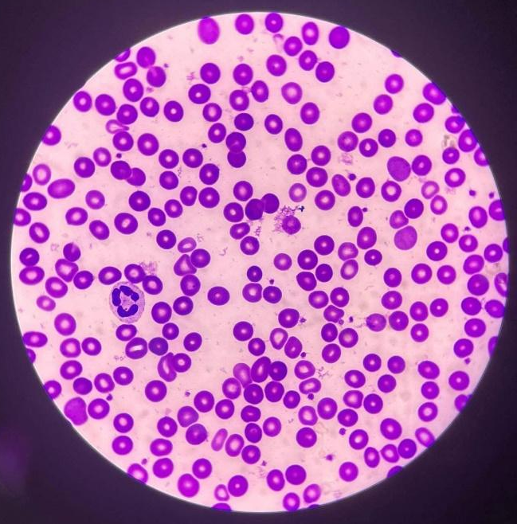
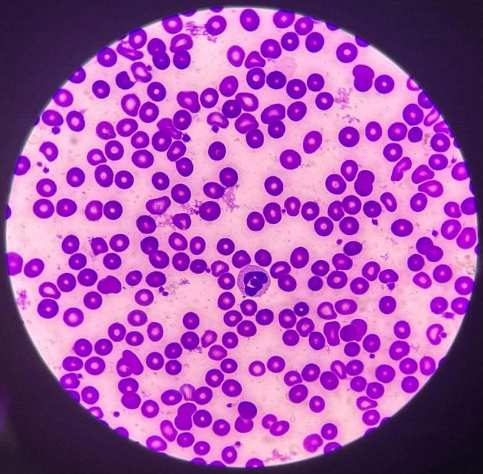
WBC: 1 – monocyte
WBC: 2 – neutrophil, basophil
Platelet: 18

Platelet: 16

Computation:
WBC count:
$$WBC count=\frac{total number of wbc from slides}{10 }×2000$$
$$WBC count=\frac{15 }{10 }×2000$$
$=1.5×2000$
$=3,000/{mm}^{3}$ or $3.0×{10}^{9}/L$

platelet count:
$$Platelet count=\frac{Average no. of platelets}{10}×20,000$$
$$Platelet count=\frac{131}{10}×20,000$$
$=262,000{ mm}^{3} or 262×{10}^{9}/L$
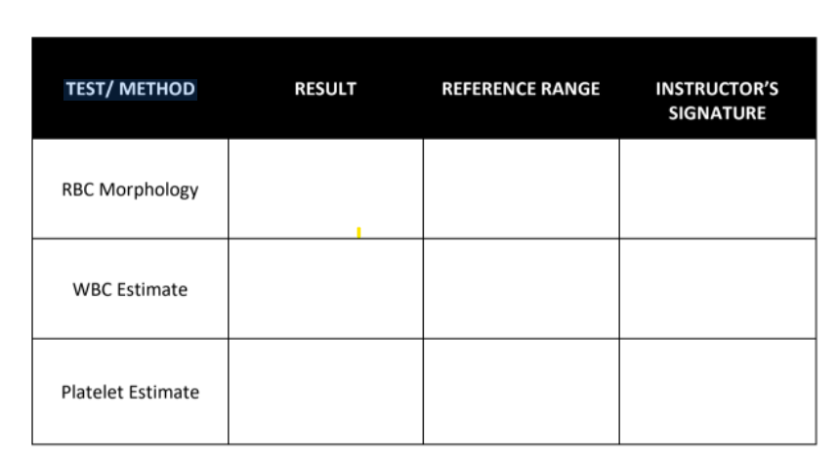

4+
(51 and above poikilocytes/OIF)
1+ = 2 – 10 poikilocytes/OIF (1-5%)
2+ = 11-20 poikilocytes/ OIF (6-10%)
3+ = 21 to 50 poikilocytes/ OIF (11-25%)
4+ = 51 and above poikilocytes/ OIF

$$3.0×{10}^{9}/L$$
3,000 ${mm}^{3}$
$4.5 to 11.5×{10}^{9}/L$
4,500 to 11,500 ${mm}^{3}$

$$262×{10}^{9}/L$$
262,000 ${mm}^{3}$
150,000 to 450,000 platelets per microliter

9:30 AM – 06/02/22
Time and Date Performed: __________________
06/03/22
Date Submitted: __________
Frances Camille M. Real
Medical Technologist: ____________________________

