Activity 2: Peripheral Smears

Name of Patient: Shajn Justin H. Majarocon DOB: February 28, 2001

In this prepared slides, identify and count the number of WBCs and platelets you can find per field
(specify type of white blood cell) and compute for the WBC estimate and platelet estimate.
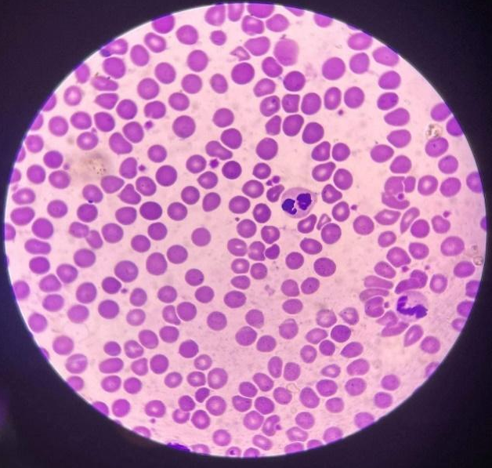
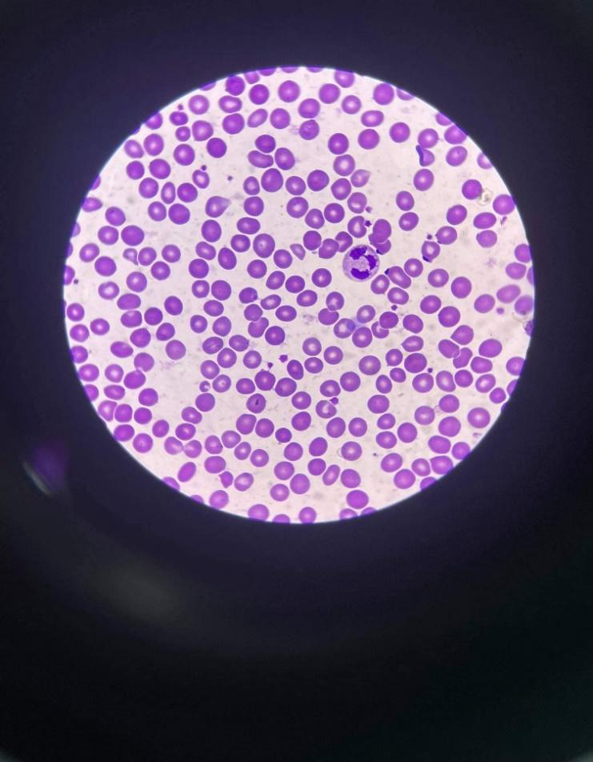

WBC: 1- neutrophil WBC: 2- Eosinophil, Neutrophil
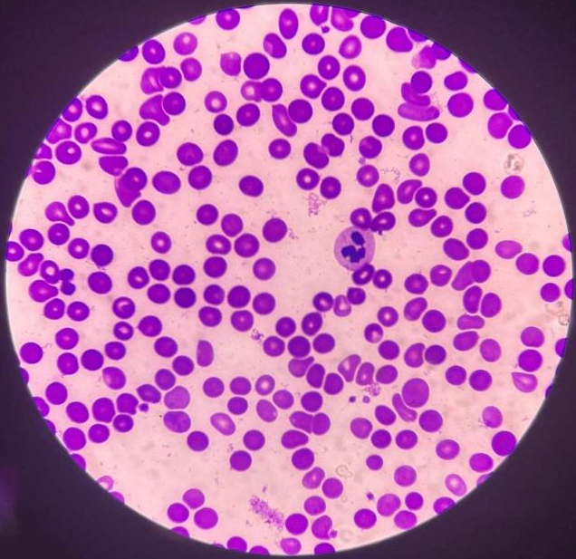
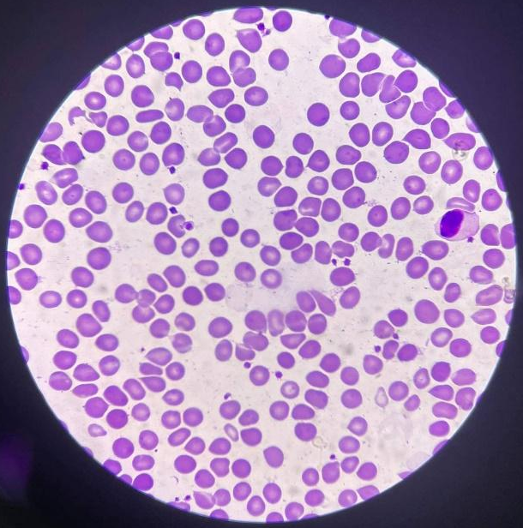
platelets: 19 Platelets: 25

WBC: 1- Lymphocyte WBC: 1- Neutrophil
Platelets: 24 Platelets: 16
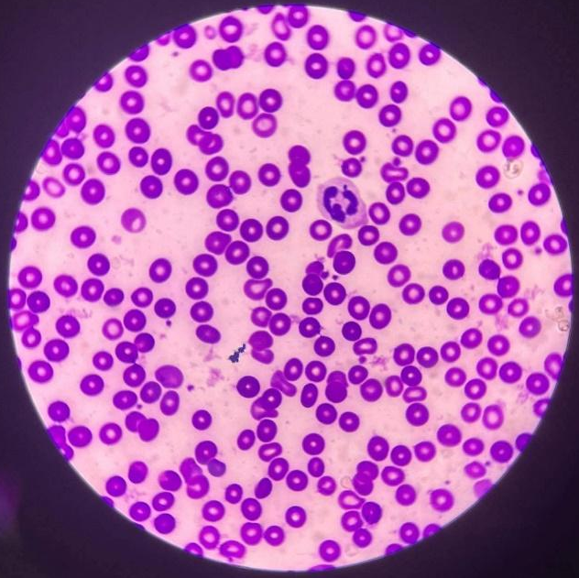
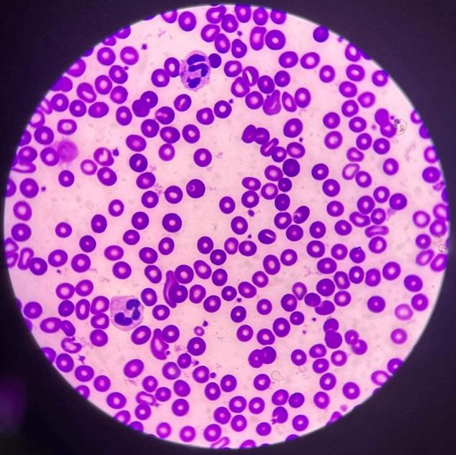

WBC: 1- Neutrophil WBC: 2- Neutrophils
Platelets: 16 Platelets: 25
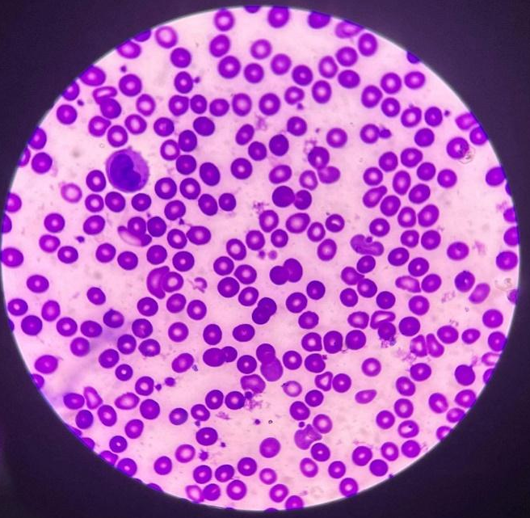
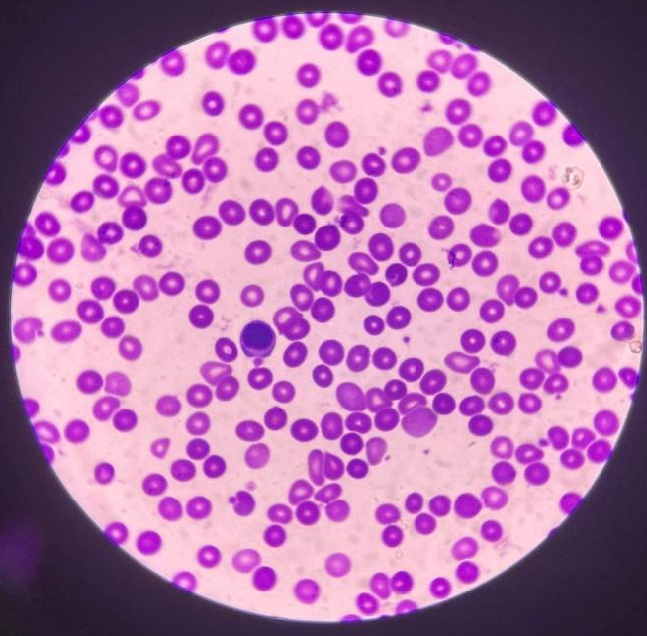

WBC: 1-Monocyte WBC: 1-Lymphocyte
Platelets: 26 Platelets: 25

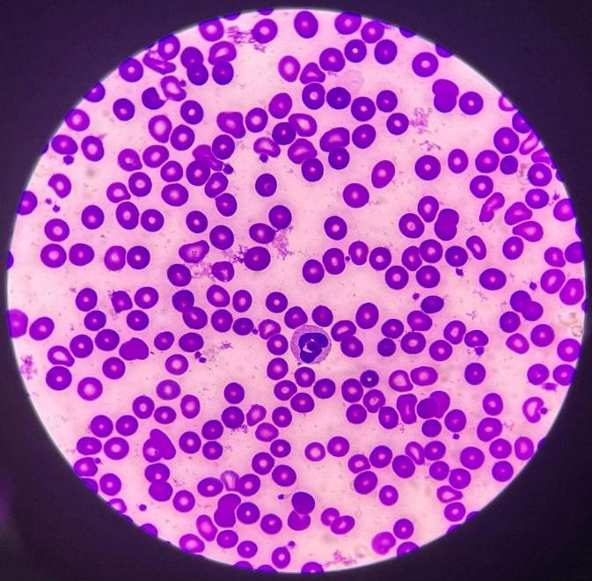
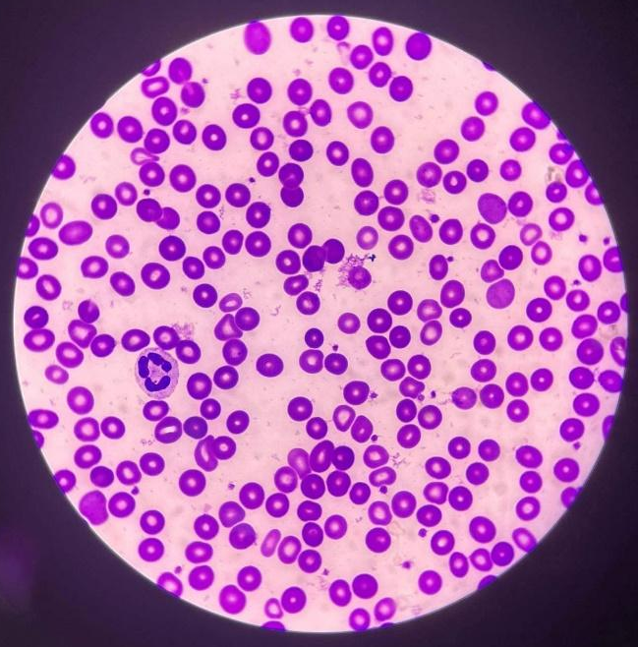

WBC: 1-Neutrophils WBC: 1-Neutrophil
Platelets: 21 Platelets: 26

Computation:
X 2,000 = 2,400/mm³
1+2+1+1+1+2+1+1+1+1
10
WBC Estimate =

X 20,000 = 446,000/mm³
19+25+24+16+16+25+26+25+21+26
10
Platelet Estimate =

RBC Morphology = 3+ pokilocytes/OIF
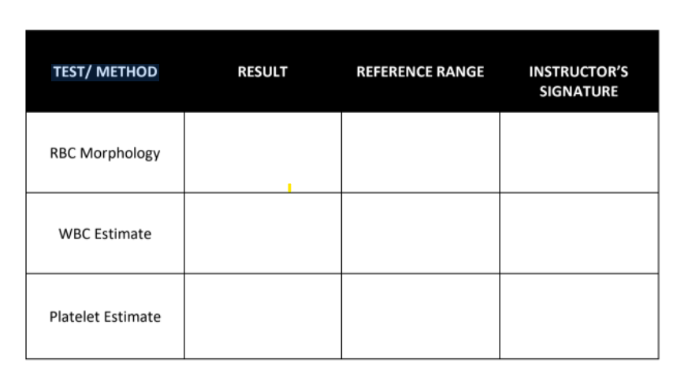
1+ = 2-10 poikilocytes (1-5%)
2+ = 11-20 poikilocytes (6-10%)
3+ = 21-50 poikilocytes (11-25%)
4+ = 50 above poikilocytes
3+
2,400/mm³
4,500 to 11,000/ mm³
150,000-450,000/mm³
446,000/mm³
2,400/mm³

Time and Date Performed: 4:00 PM, 06/03/22
Date Submitted: June 3, 2022
Medical Technologist: Felicy Jane E. Pactores

