Activity 2: Peripheral Smears

Name of Patient: Randelle Talania DOB: 2002-12-08

In this prepared slides, identify and count the number of WBCs and platelets you can find per field (specify type of white blood cell) and compute for the WBC estimate and platelet estimate.
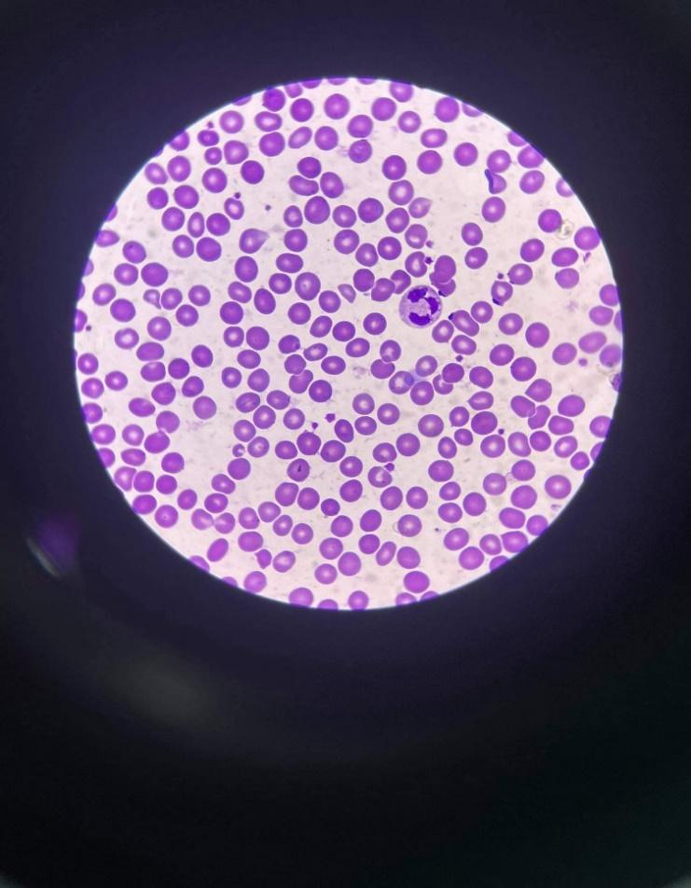 | 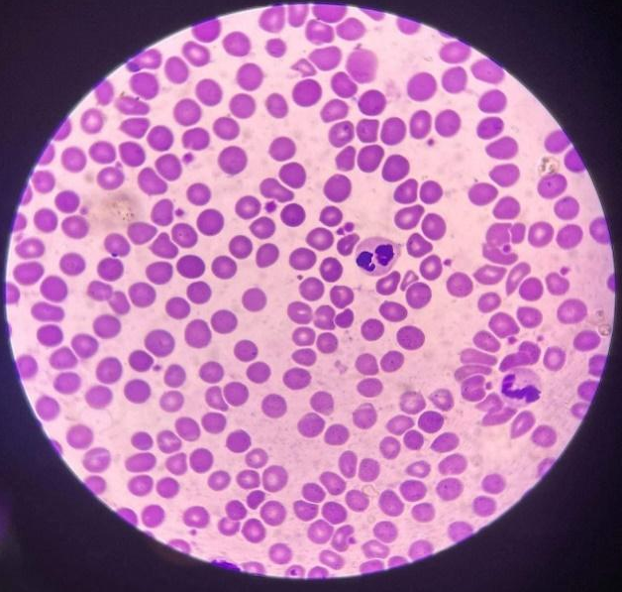
WBC - 1 : neutrophil | WBC - 2 : neutrophil, neutrophil
platelet: 12 | platelet: 15
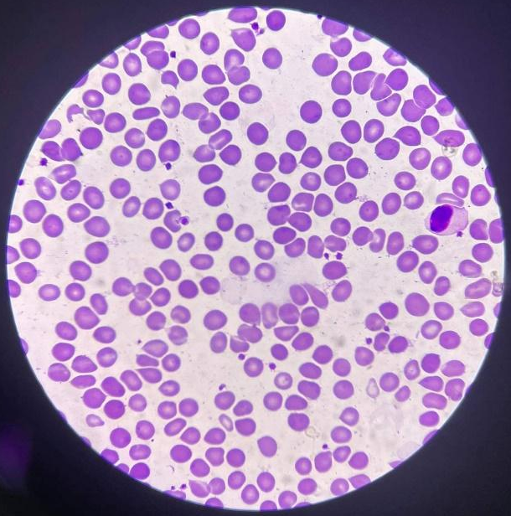 | 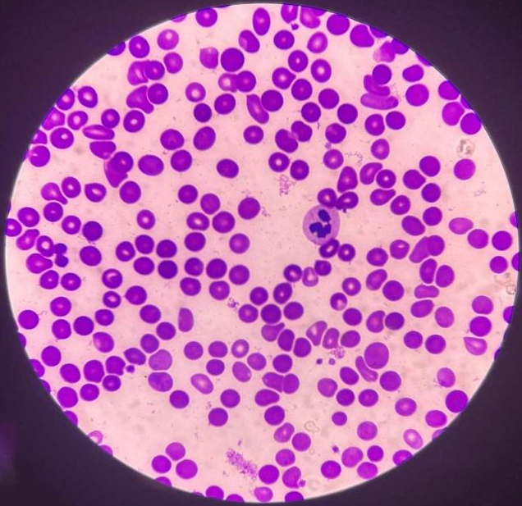
WBC - 1 : monocyte | WBC - 1 : neutrophil
platelet: 13 | platelet: 5
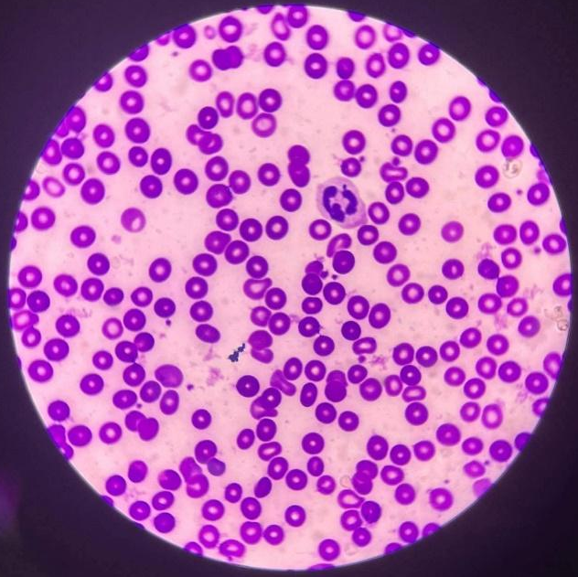 | 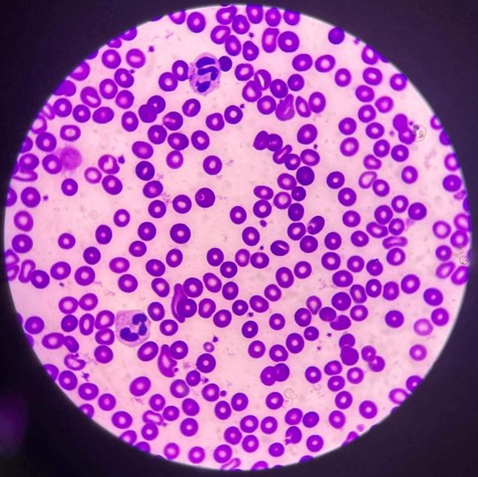
WBC - 1 : neutrophil | WBC - 2 : neutrophil, neutrophil
platelet: 9 | platelet: 15
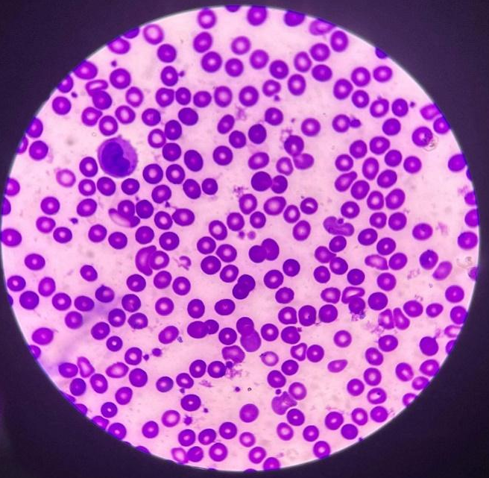 | 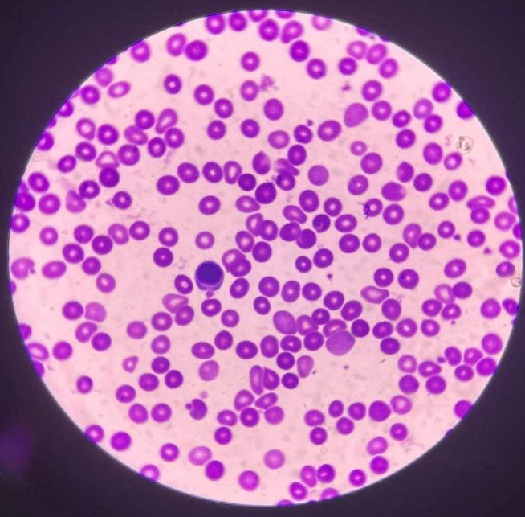
WBC - 1 : monocyte | WBC - 1 : lymphocyte
platelet: 17 | platelet: 9

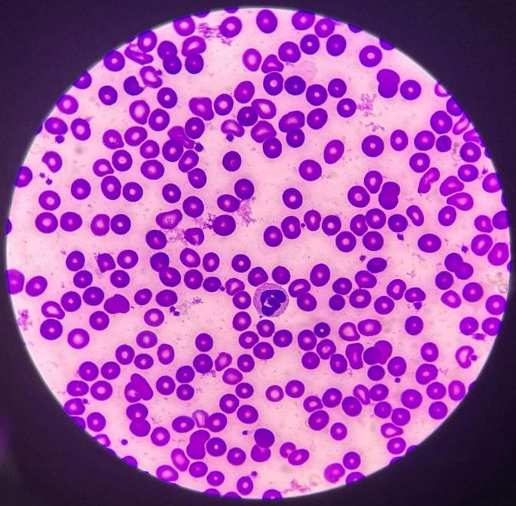 | 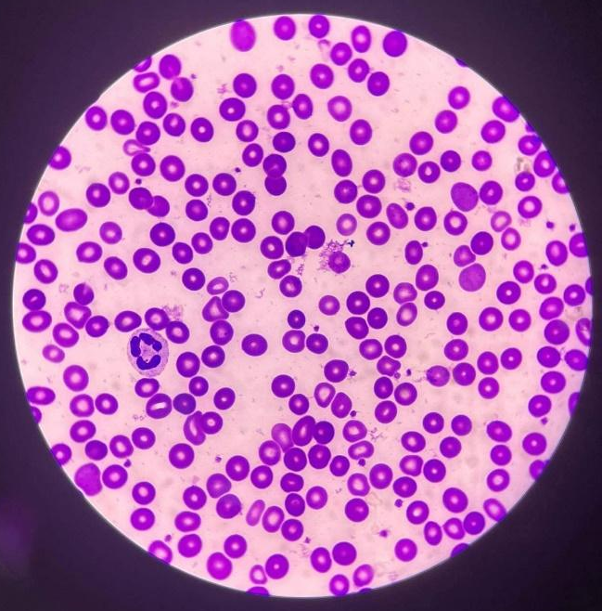
WBC - 1 : neutrophil | WBC - 1 : neutrophil
platelet: 18 | platelet: 20

Computation:
WBC estimate:
$$WBC estimate= \frac{\left(1+2+1+1+1+2+1+1+1+1\right)}{10} ×2,000$$

$=$2,400 mm³

platelet estimate:
$$Platelet estimate= \frac{\left(12+15+13+5+9+15+17+9+18+20\right)}{10} ×20,000$$

$=$266,000 mm³

TEST/METHOD | RESULT | REFERENCE RANGE | INSTRUCTOR’S SIGNATURE
RBC Morphology | 6.5 | 1+ = 2 – 10 poikilocytes/OIF (1-5%)
WBC Estimate | Conventional:  2,400/mm³  SI unit: 2.4 × 10⁹/L | Conventional:  4,500-11,000/mm³  SI unit: 4.5-11.0 × 10⁹/L
Platelet Estimate | Conventional:  266,000 mm³  SI unit: 266 × 10⁹/L | Conventional:  150,000-450,000/mm³  SI unit: 150-450 × 10⁹/L

Time and Date Performed: 10:00 AM, 05/31/22
Date Submitted: 05/31/22
Medical Technologist: Carl Stewart

