Activity 2: Peripheral Smears

Name of Patient: Jacelle Monte DOB: 2002-10-04

In this prepared slides, identify and count the number of WBCs and platelets you can find per field
(specify type of white blood cell) and compute for the WBC estimate and platelet estimate.

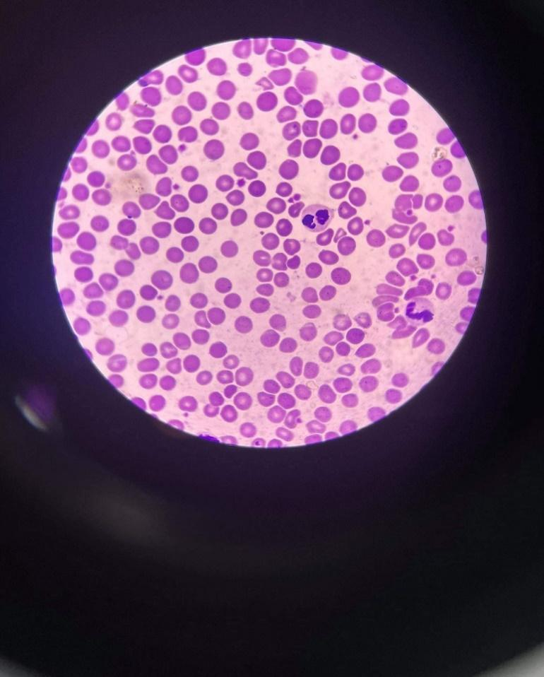
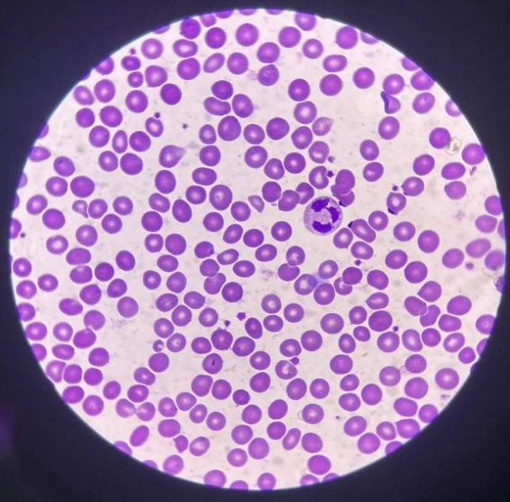

wbc: 2, neutrophil WBC: 2, neutrophils
platelet: 15 platelet: 21
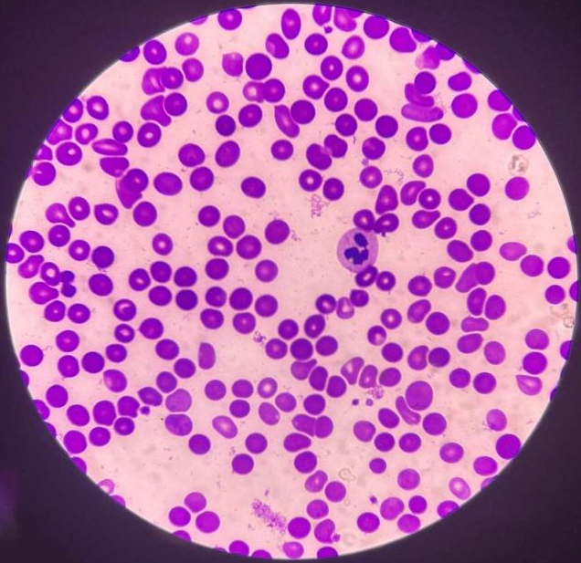
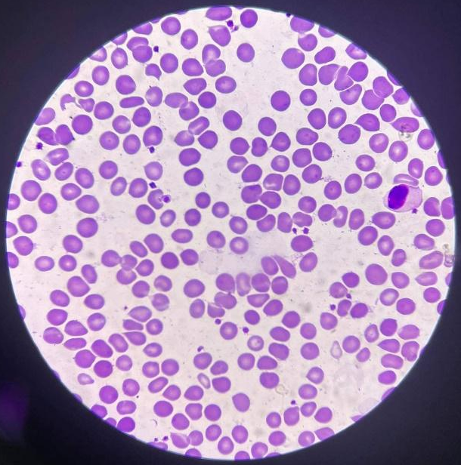

WBC: 1, monocyte WBC: 1, neutrophil
Platelet: 20 platelet: 7
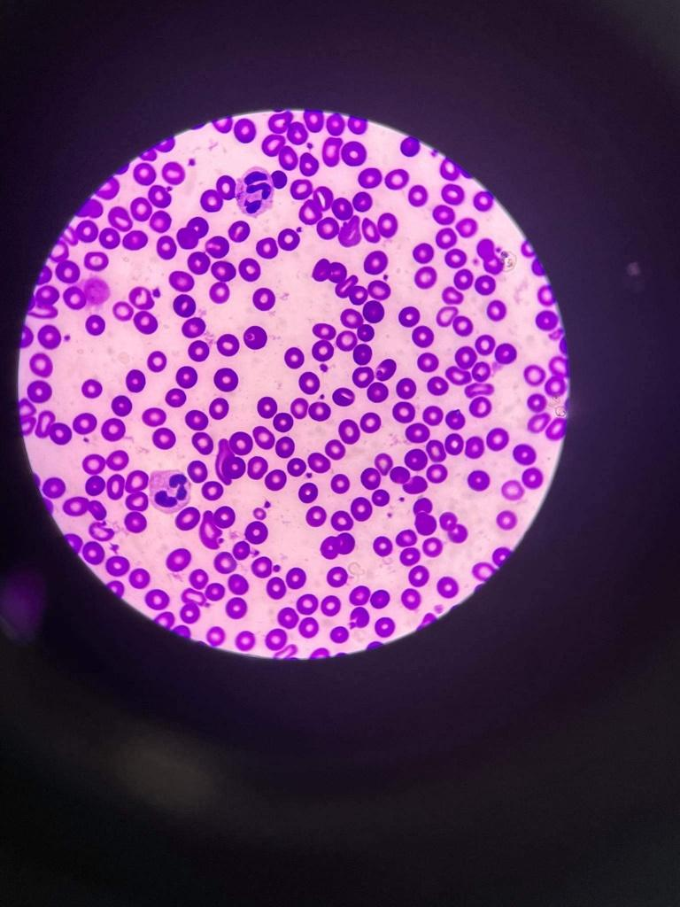
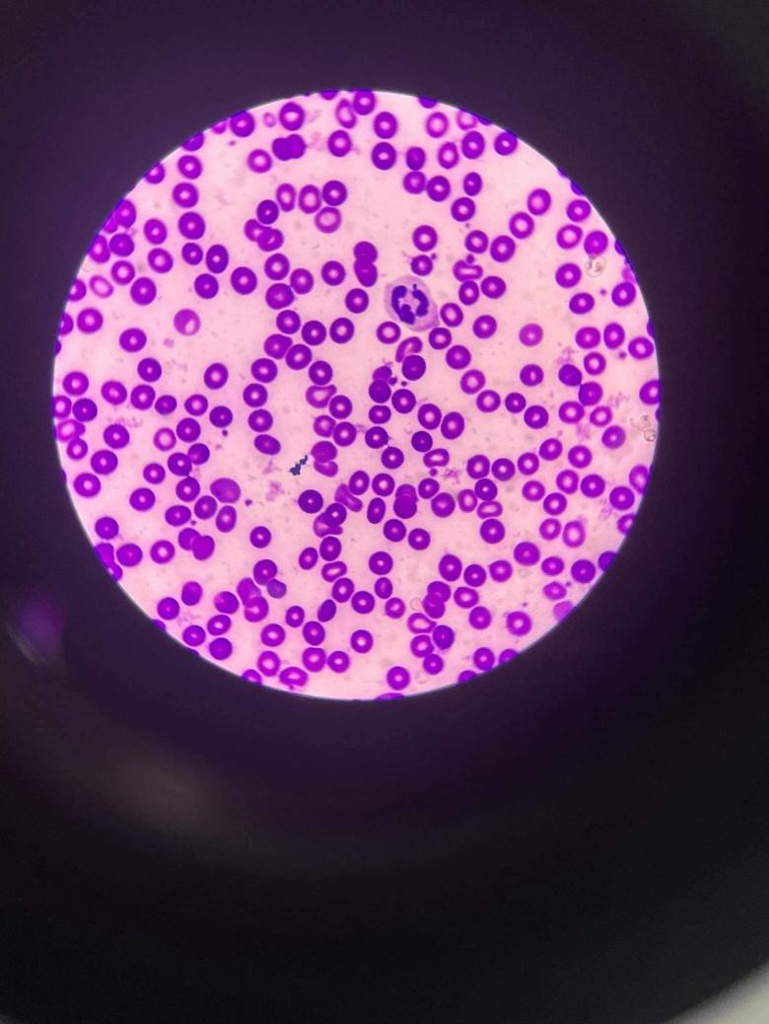

WBC: 1, neutrophil WBC: 2, neutrophil
Platelet: 15 platelet: 24
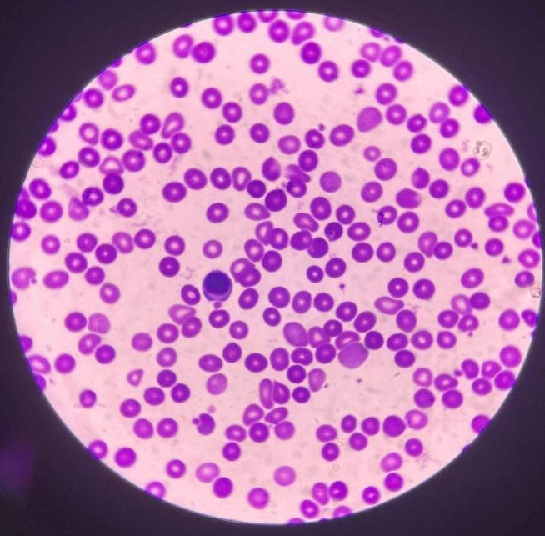
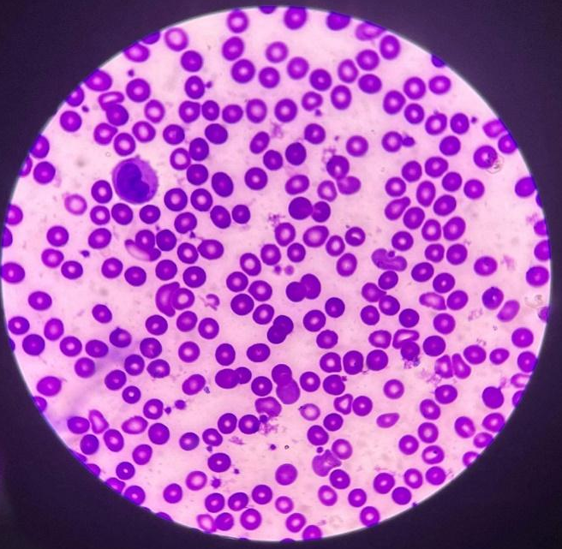
WBC: 1, monocyte WBC: 1, lymphocyte
Platelet: 24 platelet: 13
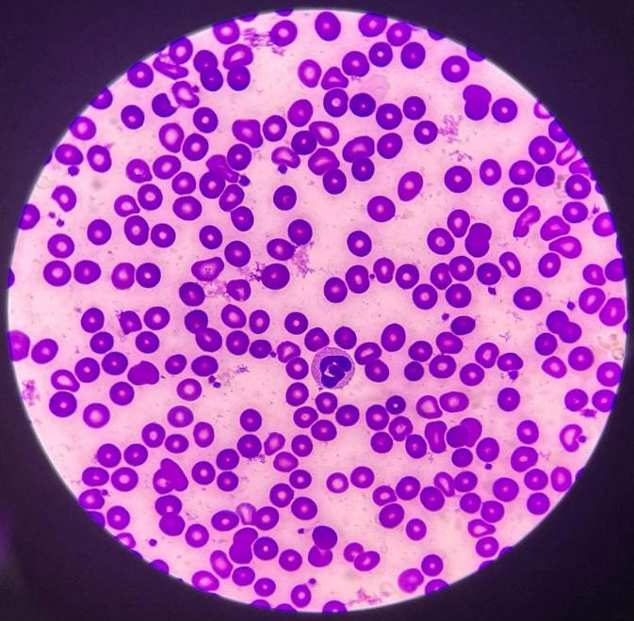
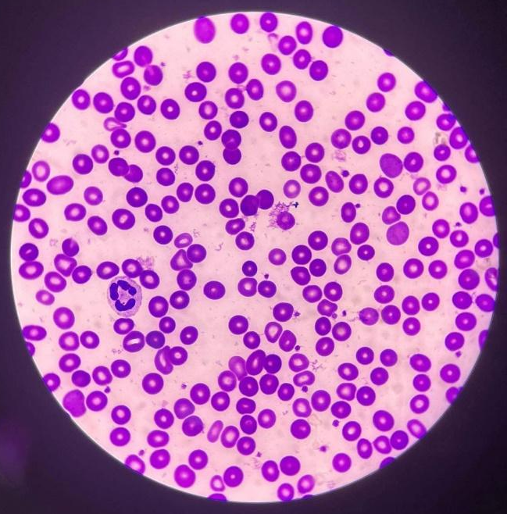

WBC: 1, neutrophil WBC: 1, neutrophil
Platelet: 21 platelet: 21

Computation:
WBC count:
$((1+2+1+1+1+2+1+1+1+1)÷10)×2,000$
(12/10) x 200 = 2,400

platelet count:
$\left(\left(15+21+20+7+15+24+24+13+21+21\right)÷10\right)×20,000$
= 181
181/10 = 18.1
18.1 X 20,000 =
Conventional Unit: 362,000/mm³
SI Unit: 362x 10⁹ / L

Test / Method | Result | Reference Range | Instructors Signature
RBC Morphology | 20+27+33+41+19+23+20+24+36+26  10  = 26.9  = 3+ | 1+ = 2 – 10 poikilocytes/OIF (1-5%)  2+ = 11-20 pokilocytes/ OIF (6 to 10%)  3+ = 21 to 50 poikilocytes/ OIF (11 to 25%)  4+ = 51 and above poikilocytes/ OIF
WBC Estimate | 2,400 | 4,500-11,000
Platelet Estimate | Conventional Unit: 362,000/mm³  SI Unit: 362x 10⁹ / L | Conventional Unit: 150,000-450,000 / mm³  SI Unit: 150-450 x 10⁹ / L

Time and Date Performed: 2:00pm ; June 3, 2022
Date Submitted: June 3, 2022
Medical Technologist: Mercado, Hershey S.

