Activity 2: Peripheral Smears

Name of Patient: _Ruth Angeli G. Fernandez__________ DOB: _07/01/2002_______

In this prepared slides, identify and count the number of WBCs and platelets you can find per field
(specify type of white blood cell) and compute for the WBC estimate and platelet estimate.

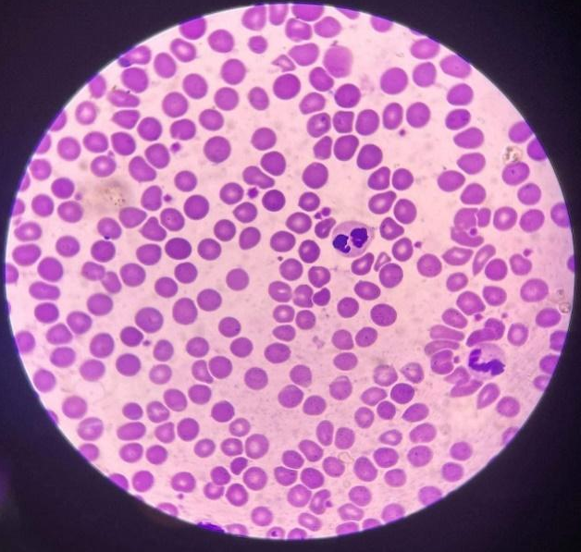
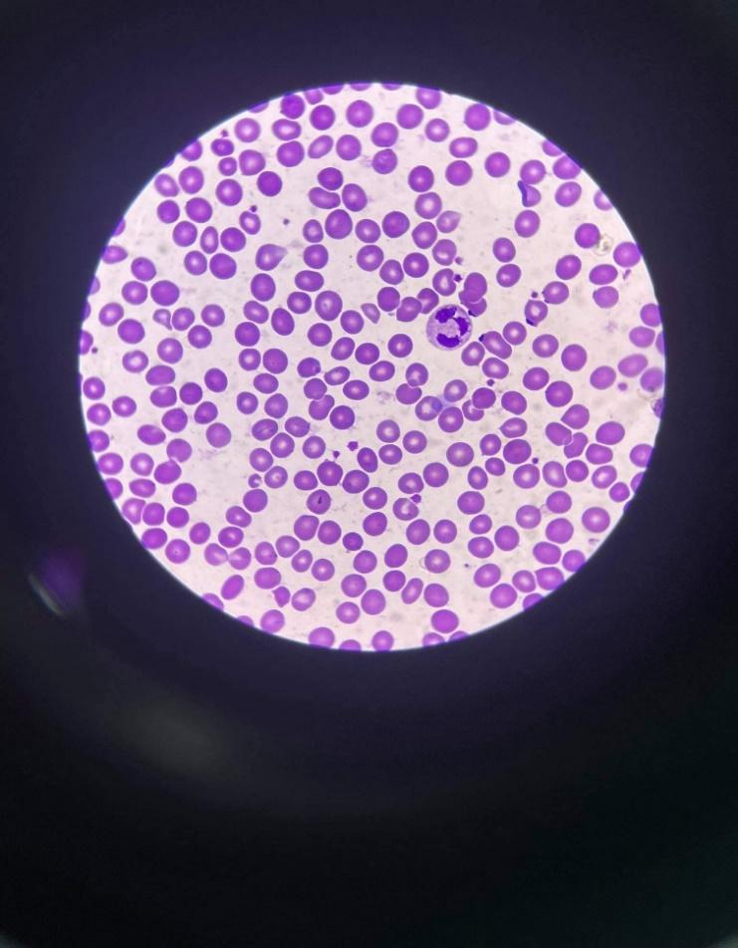

WBC: 2 - basophil and eosinophil
Platelets: 19
RBC: 26
WBC:1 - neutrophil
Platelets: 14
RBC: 20

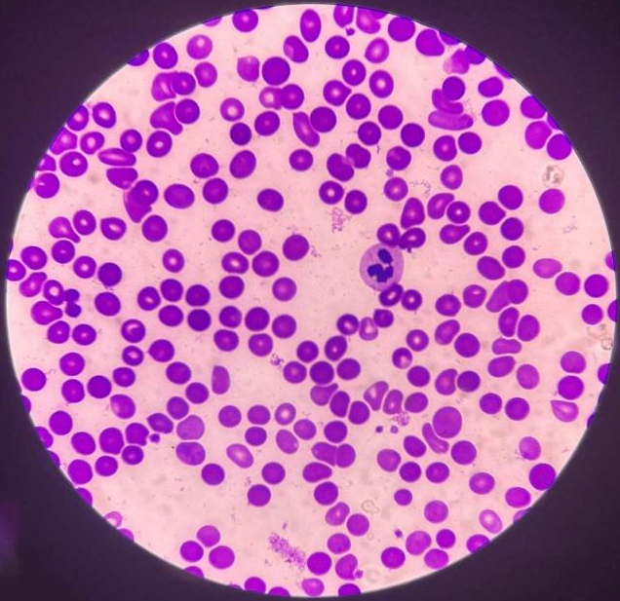
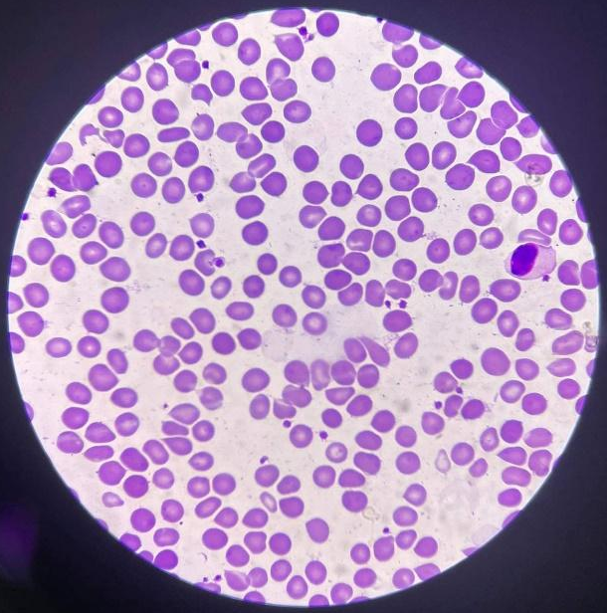

WBC: 1 - neutrophil
Platelets: 9
RBC: 30
WBC: 1 - monocyte
Platelets: 22
RBC: 18
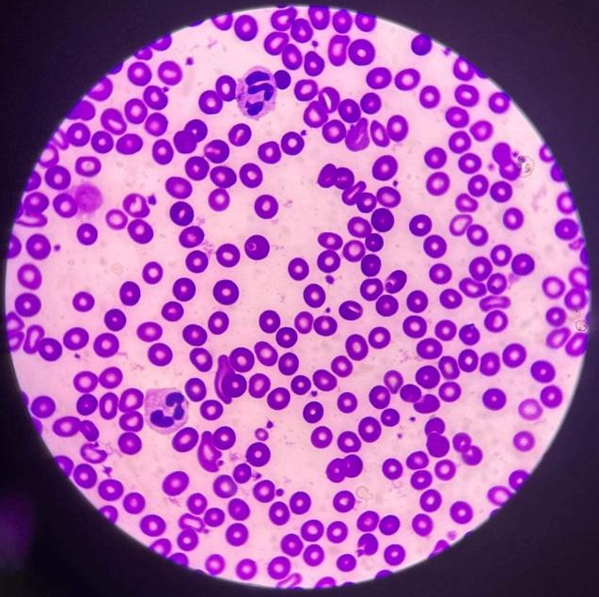
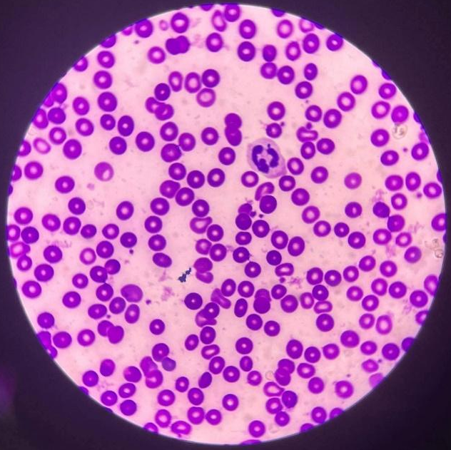

WBC: 2 - neutrophils
Platelets: 27
RBC: 21
WBC: 1 - neutrophil
Platelets: 15
RBC: 15

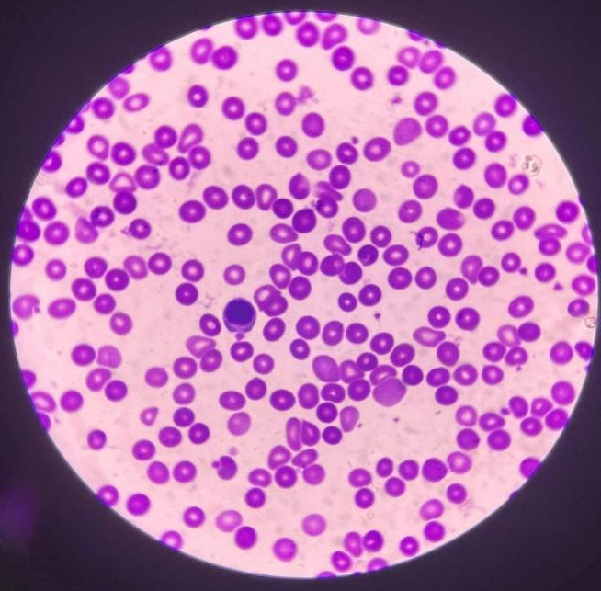
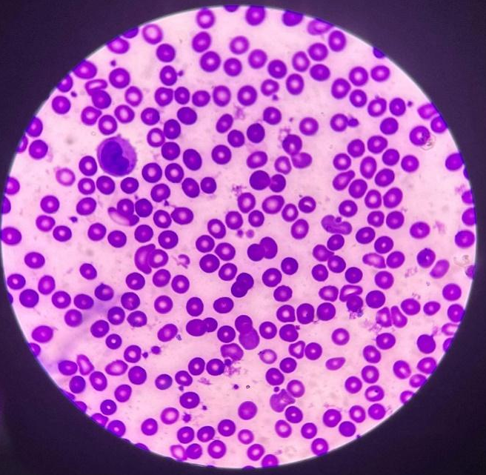

WBC: 1 - lymphocyte
Platelets: 14
RBC: 27
WBC – 1: monocyte
Platelets: 26
RBC: 16

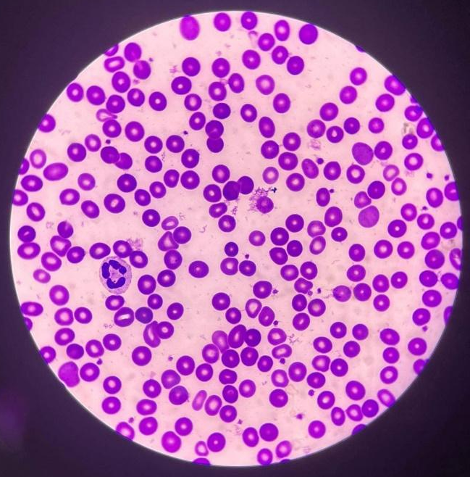
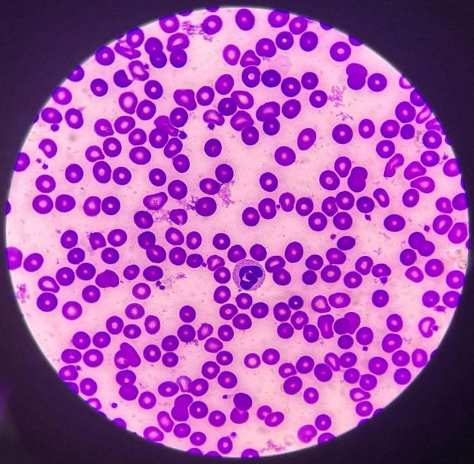
WBC: 1 - neutrophil
Platelets: 22
RBC: 19
WBC: 1 - neutrophil
Platelets: 22
RBC: 29

Computation:
WBC estimate:
1+2+1+1+1+2+1+1+1+1= 12/10 = 1.2 (Average) per 10 HPFs
1.2 x 2000 = 2400
(approximate estimation of 2,400 WBCs)

platelet count:
14+19+22+9+15+27+26+14+22+22 = 190/10 = 19 (Average) per 10 OIFs
19 x 20000 = 380,000
(approximate estimation of 380,000 platelets)
RBC morphology:
20+26+18+30+15+21+16+27+29+19 = 221/10 = 22.1 (Average) per 10 OIFs
22.1 = 3+

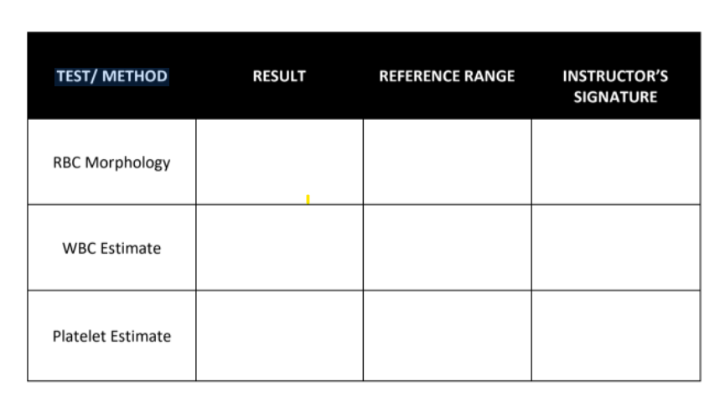
2,400 cells/mm
Conventional Unit: 150 ,000 – 450,000/mm3
4,500 to 11,000 WBCs per microliter
21 to 50 poikilocytes/OIF (11 to 25%)
3+ poikilocytes/OIF
380,000/mm3

Time and Date Performed: _2:13 PM and 06/05/2022_______
Date Submitted: _06/05/2022__________
Medical Technologist: _AIROSE B. FLORES________________

RBC morphology
Name of Patient: Ruth Angeli G. Fernandez
Date of Birth: 07/01/2002
Age: 19
Sex: Female
Name of test: RBC morphology
Results: 3+ poikilocytes/OIF
Reference range: 1+ = 2 – 10 poikilocytes/OIF (1-5%)
2+ = 11-20 poikilocytes/OIF (6-10%)
3+ = 21 to 50 poikilocytes/OIF (11 to 25%)
4+ = 51 and above poikilocytes/OIF
Interpretation: Not normal RBC morphology
Name of Medical Technologist: Airose B. Flores
Date Performed: 06/05/2022
Time Performed: 2:26 PM

WBC Estimate
Name of Patient: Ruth Angeli G. Fernandez
Date of Birth: 07/01/2002
Age: 19
Sex: Female
Name of test: WBC Estimate
Results: 2,400 cells/mm
Reference range: 4,500 to 11,000 WBCs per microliter
Interpretation: Below normal white blood cell count
Name of Medical Technologist: Airose B. Flores
Date Performed: 06/05/2022
Time Performed: 2:33 PM

Platelet Estimate
Name of Patient: Ruth Angeli G. Fernandez
Date of Birth: 07/01/2002
Age: 19
Sex: Female
Name of test: Platelet Estimate
Results: 380,000/mm3
Reference range: Conventional Unit: 150,000 – 450,000/mm3
Interpretation: Normal Platelet Count
Name of Medical Technologist: Airose B. Flores
Date Performed: 06/05/2022
Time Performed: 2:36 PM

