Activity 2: Peripheral Smears

Name of Patient: Hershey S. Mercado
DOB: 09/18/2002

In this prepared slide, identify and count the number of WBCs and platelets you can find per field (specify type of white blood cell) and compute for the WBC estimate and platelet estimate.

1. 2.
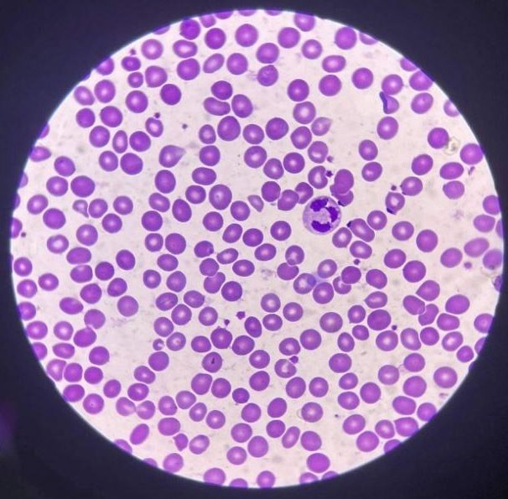
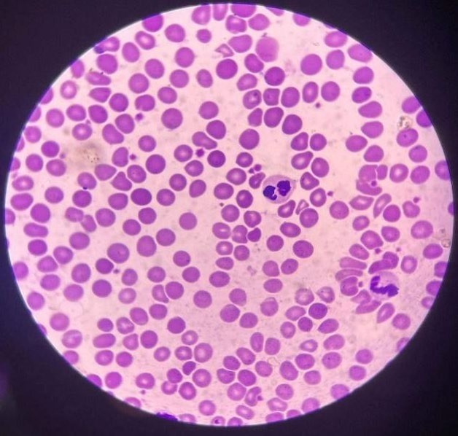
WBC -1: Neutrophil WBC - 2: Basophil and Eosinophil
Platelet: 14 Platelet: 19

RBC: 20 RBC: 26

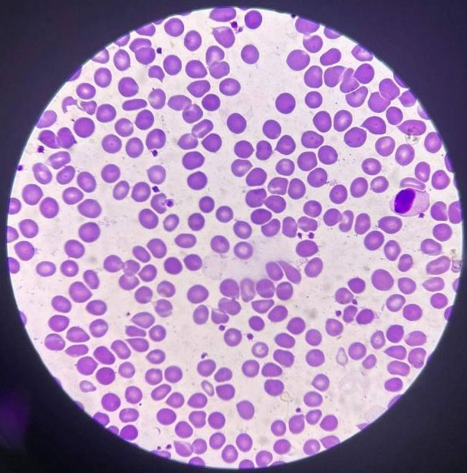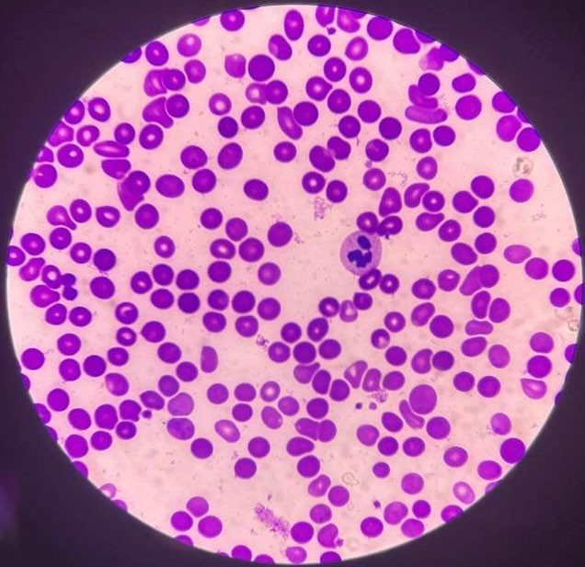
WBC - 1: Monocyte WBC- 1: Neutrophil
Platelet: 22 Platelet: 9

RBC: 18 RBC: 30

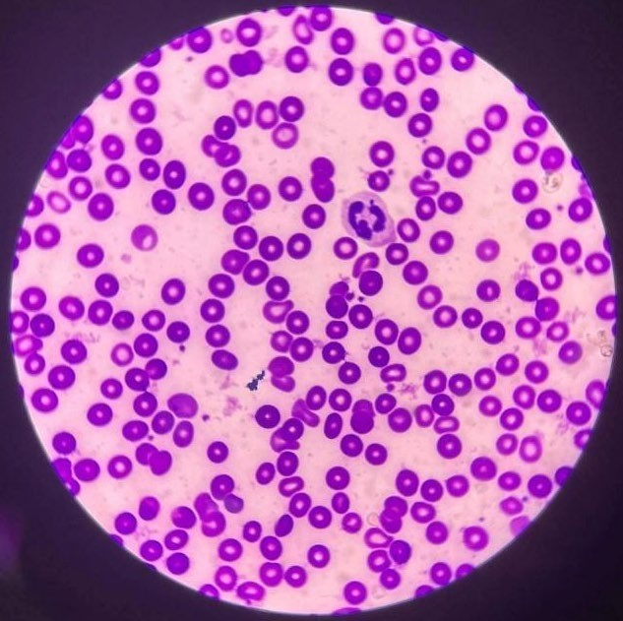
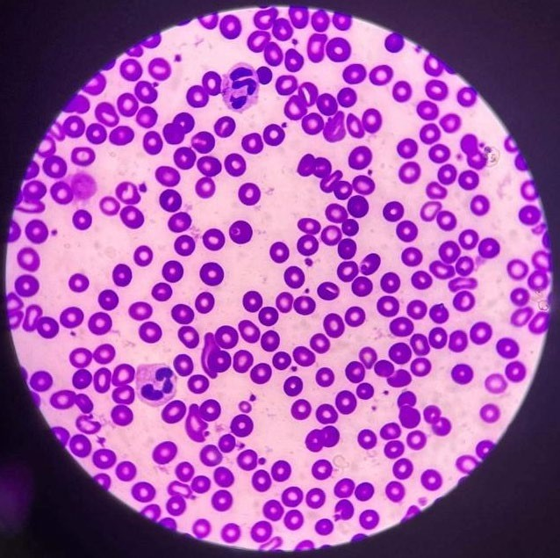
WBC -1: Neutrophil WBC- 2: Neutrophils
Platelet: 15 Platelet: 27

RBC: 15 RBC: 21

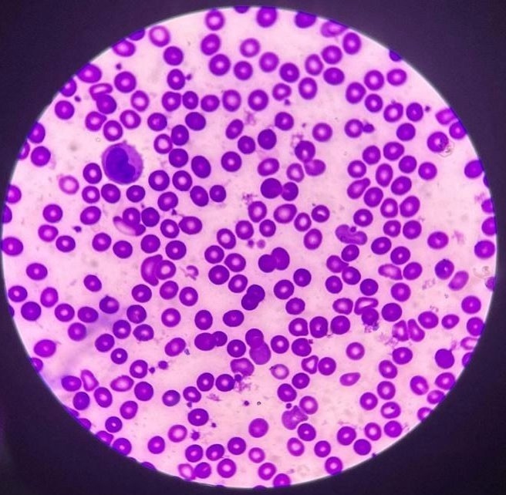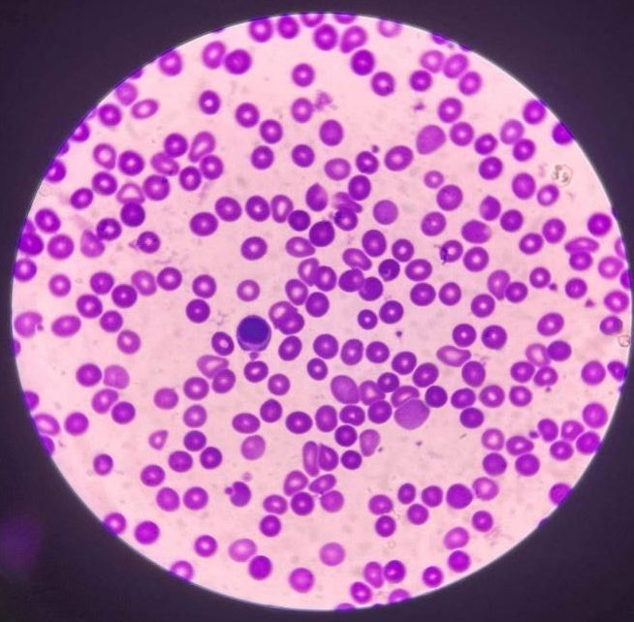

WBC- 1: Monocyte WBC- 1: Lymphocyte
Platelet: 26 Platelet: 14

RBC: 16 RBC: 27

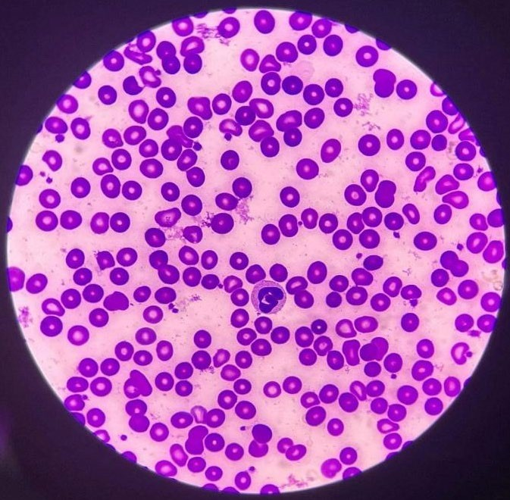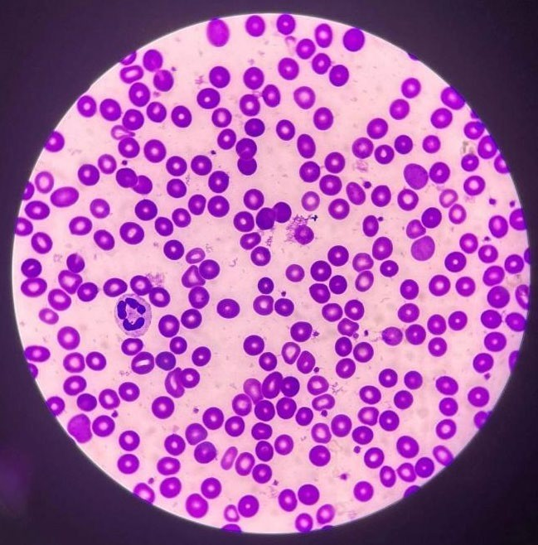

WBC- 1: Neutrophil WBC- 1: Neutrophil
Platelet: 22 Platelet: 22

RBC: 29 RBC: 19

Computation:
RBC Morphology:

Reference Range:

20 + 26 + 18 + 30 + 15 + 21 + 16 + 27 + 29 + 19 = 221
221 / 10 = 22.1
22.1 = 3+

GRADING USED FOR POIKILOCYTOSIS:
- 1+ = 2 – 10 poikilocytes/OIF (1-5%)
- 2+ = 11-20 pokilocytes/ OIF (6 to 10%)
- 3+ = 21 to 50 poikilocytes/ OIF (11 to 25%)
  - 4+ = 51 and above poikilocytes/ OIF

WBC estimate:

Reference Range:

1 + 2 + 1 + 1 + 1 + 2 + 1 + 1 +1 + 1 = 12
12 / 10 = 1.2
1.2 x 2000 = 2,400

Adult female normal range = 4,500 to 11,000 WBCs per microliter Adult male normal range = 5,000 to 10,000 WBCs per microliter

Platelet count:

Reference Range:

14 + 19 + 22 + 9 + 15 + 27 + 26 + 14 + 22 + 22 = 190
190/10= 19
19 x 20,000= 380,000

Conventional Unit: 150,000-450,000/mm3
SI Unit: 150-450x109/L

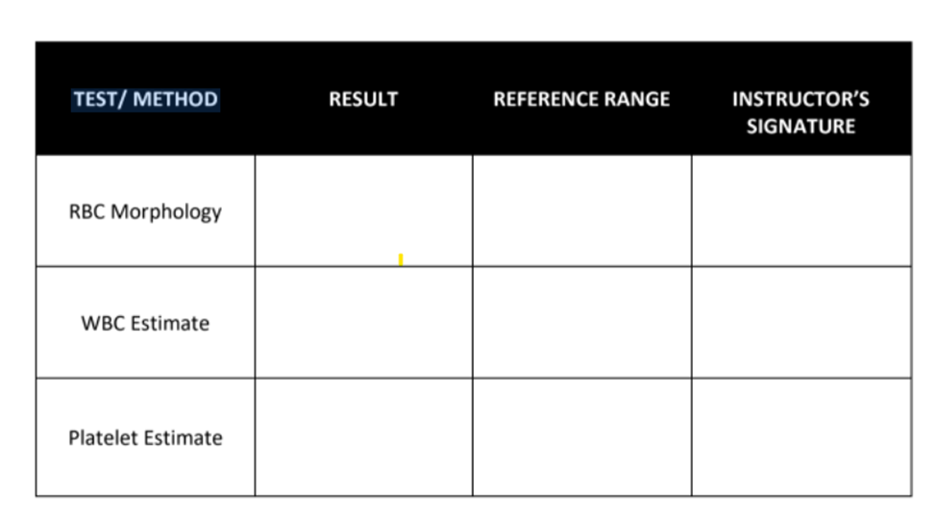
21 to 50 poikilocytes/OIF (11 to 25%)
Conventional Unit: 150 ,000 – 450,000/mm3
380,000/mm3
4,500 to 11,000 WBCs per microliter
2,400 cells/mm
3+ poikilocytes/OIF
Time and Date Performed: 2:37 P.M. and 06/05/2022
Date Submitted: 06/05/2022
Medical Technologist: JACELLE ROSE M. MONTE

RBC Morphology
Name of Patient: Hershey S. Mercado
Date of Birth: 09/18/2002
Age: 19
Sex: Female
Name of test: RBC morphology
Results: 3+ poikilocytes/OIF
Reference range: 1+ = 2 – 10 poikilocytes/OIF (1-5%)
2+ = 11-20 poikilocytes/OIF (6-10%)
3+ = 21 to 50 poikilocytes/OIF (11 to 25%)
4+ = 51 and above poikilocytes/OIF
Interpretation: Not normal RBC morphology
Name of Medical Technologist: Jacelle Rose M. Monte
Date Performed: 06/05/2022
Time Performed: 3:05 P.M.

WBC Estimate
Name of Patient: Hershey S. Mercado
Date of Birth: 09/18/2002
Age: 19
Sex: Female
Name of test: WBC Estimate
Results: 2,400 cells/mm
Reference range: 4,500 to 11,000 WBCs per microliter
Interpretation: Below normal white blood cell count
Name of Medical Technologist: Jacelle Rose M. Monte
Date Performed: 06/05/2022
Time Performed: 3:38 P.M.

Platelet Estimate
Name of Patient: Hershey S. Mercado
Date of Birth: 09/18/2002
Age: 19
Sex: Female
Name of test: Platelet Estimate
Results: 380,000/mm3
Reference range: Conventional Unit: 150,000 – 450,000/mm3
Interpretation: Normal Platelet Count
Name of Medical Technologist: Jacelle Rose M. Monte
Date Performed: 06/05/2022
Time Performed: 3:47 P.M.

