Activity 2: Peripheral Smears

Name of Patient: Marydel O. Cagadas DOB: December 31, 2002

In these prepared slides, identify and count the number of WBCs and platelets you can find per field (specify type of white blood cell) and compute for the WBC estimate and platelet estimate.
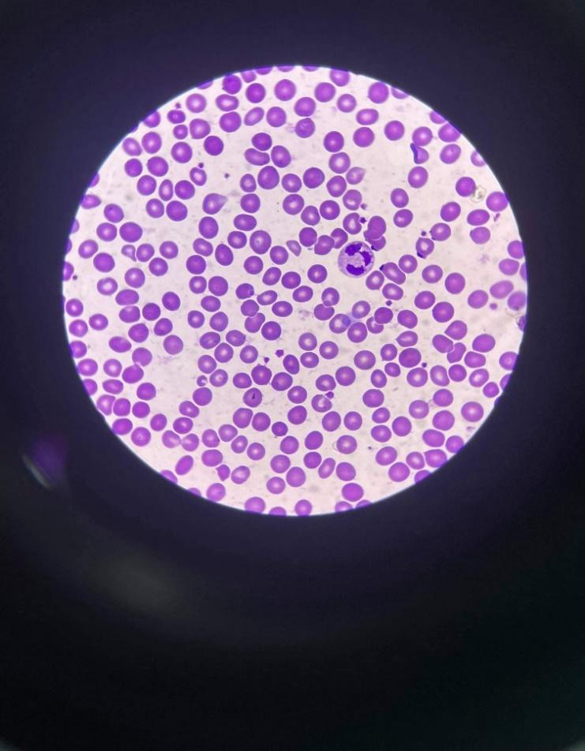
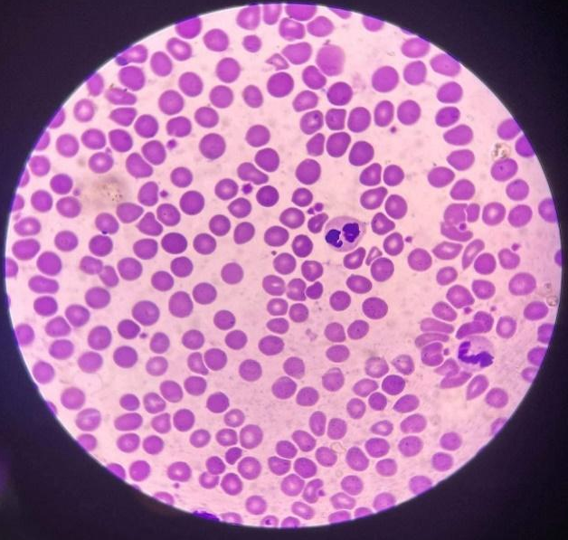

WBC: 1 (Neutrophil) Platelets: 16 WBC: 2 (Neutrophil & Eosinophil) Platelets: 20

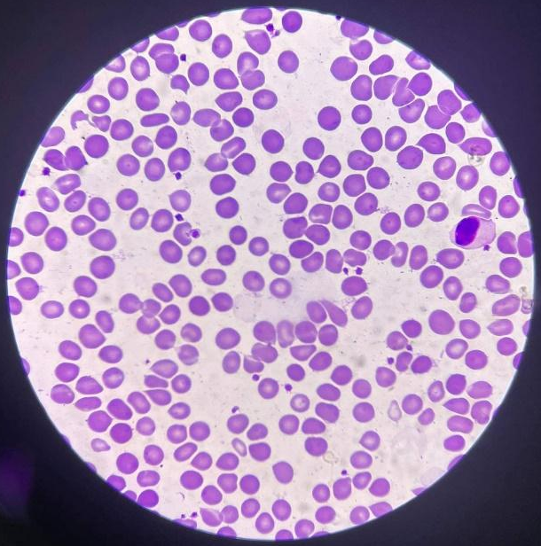
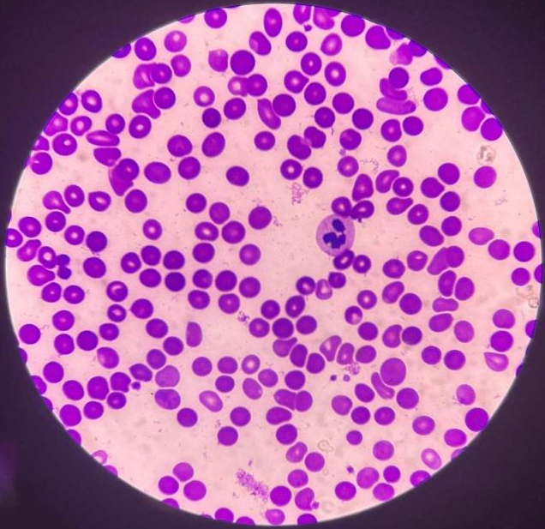

WBC: 1 (Lymphocyte) Platelets: 19 WBC: 1 (Neutrophil) Platelets: 7
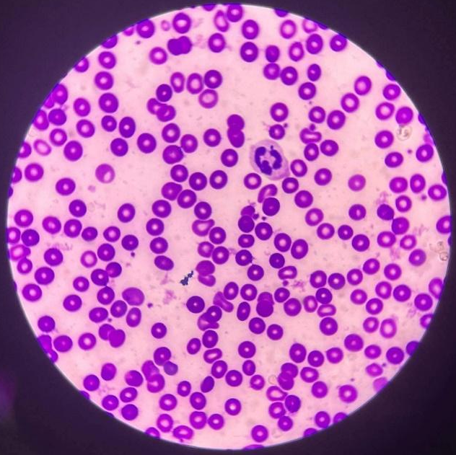
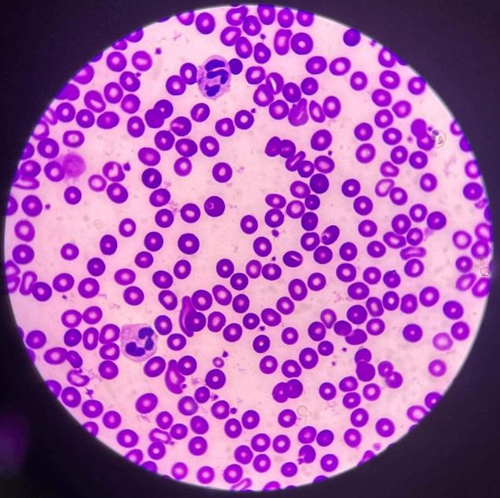

WBC: 1 (Neutrophil) Platelets: 12 WBC: 2 (Neutrophil) Platelets: 24

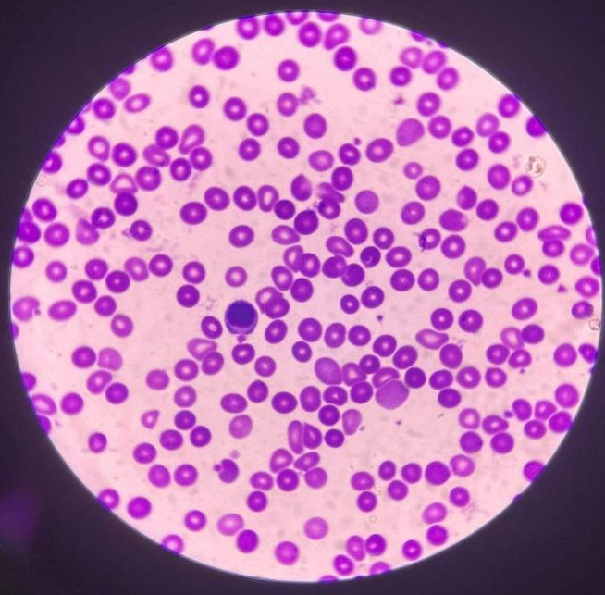
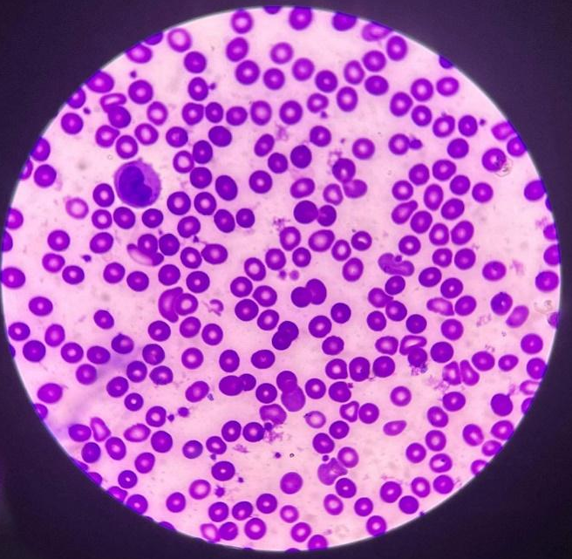

WBC: 1 (Monocyte) Platelets: 20 WBC: 1 (Lymphocyte) Platelets: 10
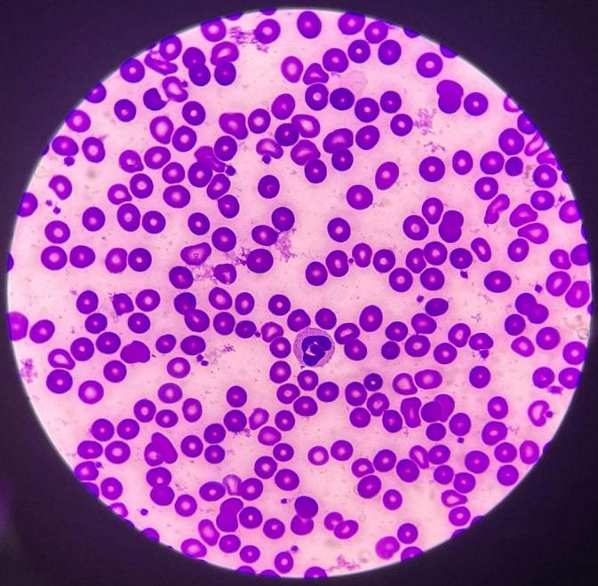
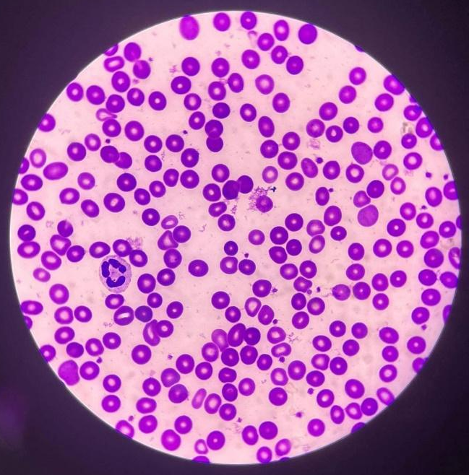
WBC: 1 (Basophil) Platelets: 21 WBC: 1 (Neutrophil) Platelets: 20

COMPUTATION

WBC estimate: (Ref. Range = 4,500-11,000/mm³ or 4.5 to 11.0 × 10⁹/L)

$Total: \frac{12}{10}=1.2 x 2000=2,400$/mm³ or 2.4 × 10⁹/L

Platelet Count: (Ref. Range = 150,000 to 450,000/ mm³ or 150 to 450 × 10⁹/L)

$Total: \frac{169}{10}=16.9 x 20000=338,000$/mm³ or 338 × 10⁹/L

RBC Morphology:
(Ref. Range = 1+ = 2 – 10 poikilocytes/OIF (1-5%)
2+ = 11-20 poikilocytes/OIF (6 to 10%)
3+ = 21 to 50 poikilocytes/OIF (11 to 25%)
4+ = 51 and above poikilocytes/OIF)

$Total: \frac{235}{10}=23.5= 3+ =21-50 Poikilocytes (11 to 25\%)$

Time and Date Performed: 2:34 PM; June 2, 2022
Date Submitted: June 3, 2022
Medical Technologist: Reign Francis A. Gacasan

