Activity 2: Peripheral Smears

Name of Patient: Torres Alleiah Mae A. DOB: November 11, 2002

In this prepared slides, identify and count the number of WBCs and platelets you can find per field
(specify type of white blood cell) and compute for the WBC estimate and platelet estimate.

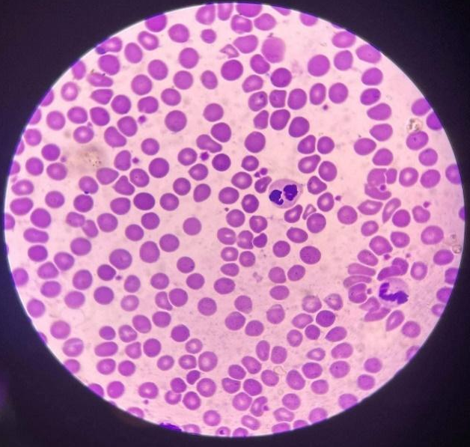
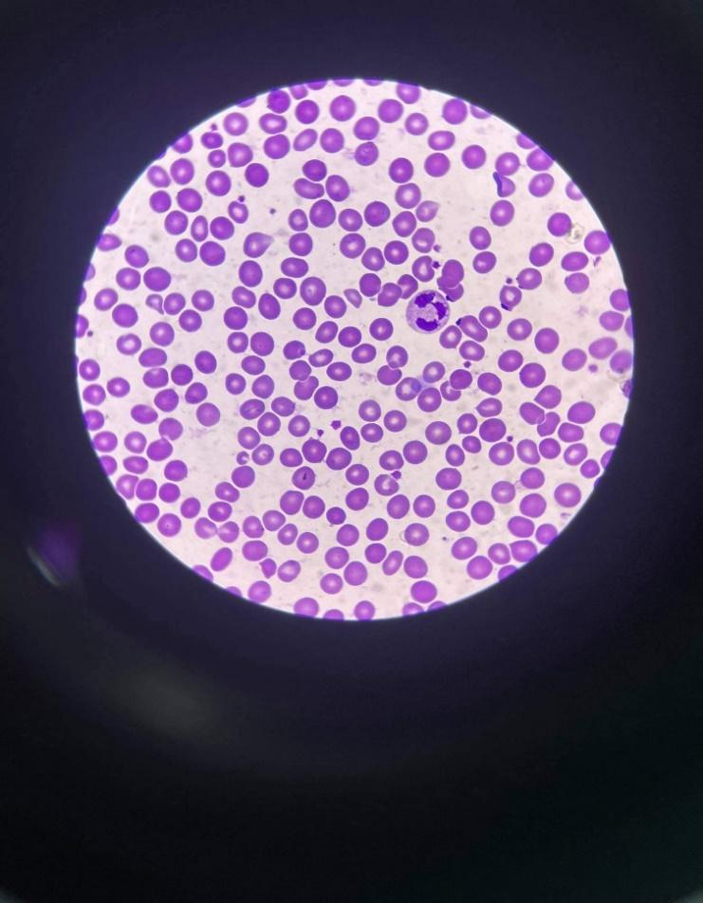

___ No. of WBCs: 2 = neutrophil No. of WBCs: 2 = neutrophil
___No. of Platelets: 19_______ No. of Platelets: 18
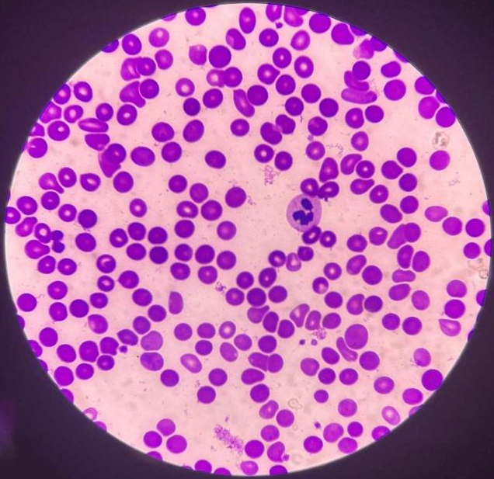
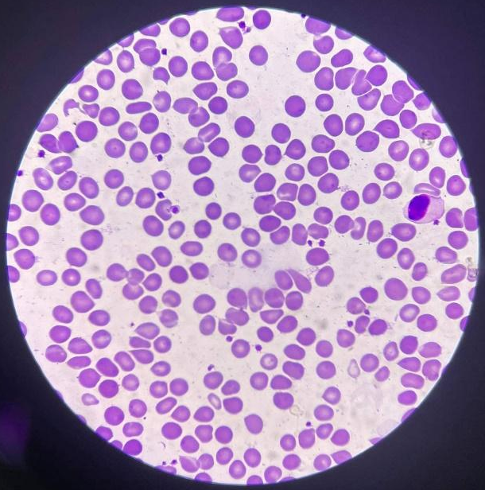

___ No. of WBCs: 1 = lymphocyte No. of WBCs: 1 = neutrophil
___No. of Platelets: 24_______ No. of Platelets: 4
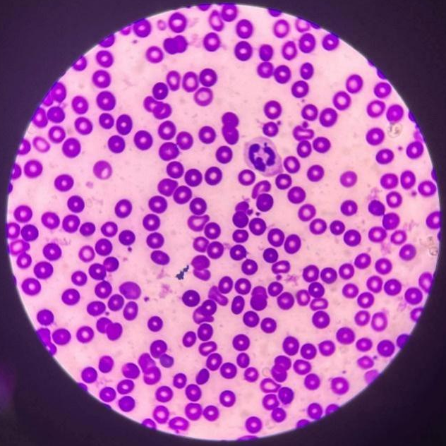
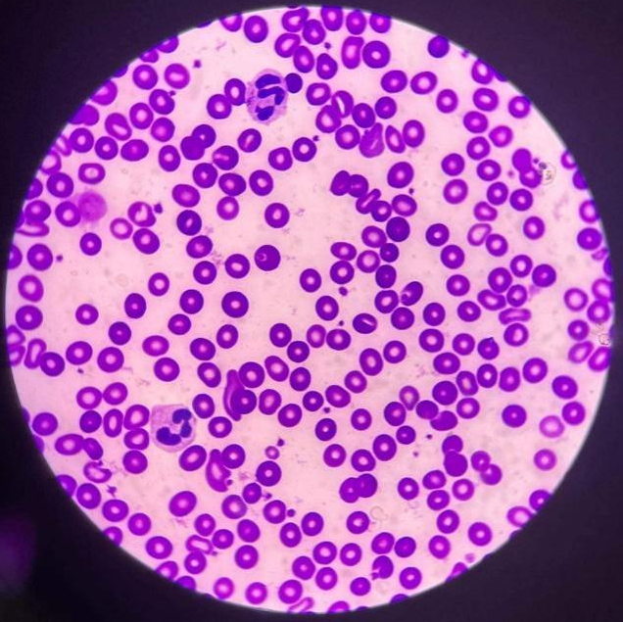

___ No. of WBCs: 1 = neutrophil No. of WBCs: 2 = neutrophil
___No. of Platelets: 11_______ No. of Platelets: 23

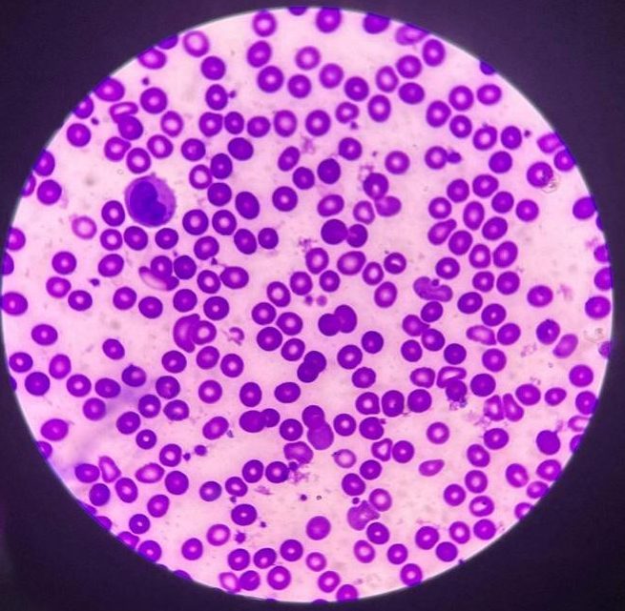
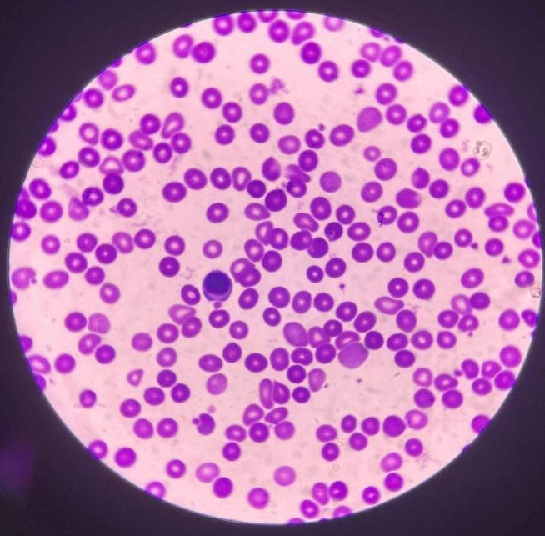

___ No. of WBCs: 1 = monocyte No. of WBCs: 1 = lymphocyte
___No. of Platelets: 24_______ No. of Platelets: 12

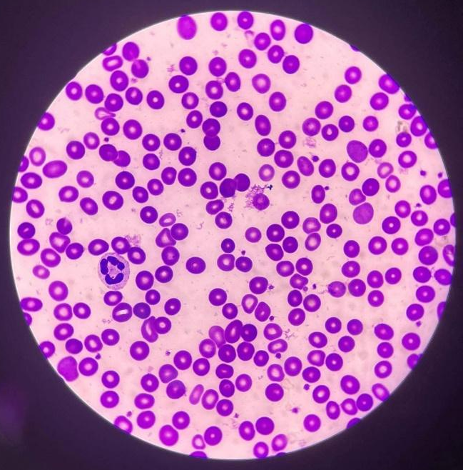
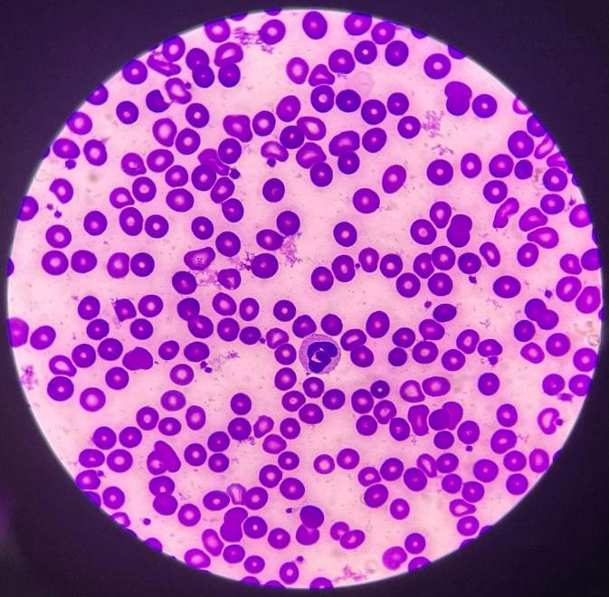
___ No. of WBCs: 1 = neutrophil No. of WBCs: 1 = neutrophil
___No. of Platelets: 21_______ No. of Platelets: 23

Computation:

WBC estimate : (2+2+1+1+2+1+1+1+1)/10 x 2000 = 2,400/mm^3
Platelet estimate : ( 19+18+24+4+11+23+24+12+21+23 )/10 x 2000 = 358 000 mm^3
RBC Morphology = 3 + poikilocytes/OIF

Test/Method | Result | Reference Range | Instructor’s signature
RBC Morphology | 3+ | 1+ = 2-10 poikilocytes (1-5%)  2+ = 11-20 poikilocytes (6-10%)  3+ = 21-50 poikilocytes (6-10%)  4+ = 50 above poikilocytes (6-10%)
WBC Estimate | 2400 mm^3 | 4,500 to 11,000 WBCs/mm^3  (4.5 to 11.0 × 10^9/L)
Platelet Estimate | 358 00 mm^3 | 150,000 to 400,000 platelets/ mm^3  (150-400 x 10^9/L)

Time and Date Performed: _6/3/2022
Date Submitted: _6/3/2022
Medical Technologist: _Keziah Marie O. Vilches

