Name: Joana Mae A. Macabinguil Section: MT 14 LAB - A
ACTIVITY 3: BLOOD TYPING
I. ABO FORWARD GROUPING AND RH TYPING
A. Slide Method
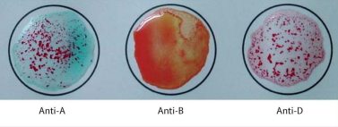
Reaction: + (Positive agglutination) O (No agglutination) + (Positive agglutination)
Antigen/s detected: anti - A
ABO & Rh Blood Group: A - POSITIVE
POST–LABORATORY QUESTIONS:
- What is an antiserum?
  - Antiserum is a blood serum that contains antibodies against certain surface glycoproteins. It is used to determine or detect if erythrocytic antigens A and/ or B are present on the surface of human red blood cells.

- What kind of antigen will anti–A detect? Anti–B?
  - The antigen will Anti-A detects would be the A antigen and Anti-B would detect the B antigen.

- When is blood typing ordered?
  - Blood typing ordered may happen when a person becomes a volunteer or represents a patient’s donor for an organ, tissue, or bone marrow transplant. It is one of the primary tests used to determine if a possible donor and recipient are compatible.

- Name the common causes of false positive and false negative results in ABO Testing?
  - The following are the common cause of false positive or false negative results in ABO Testing such as bacterial or chemical contamination of test materials, old blood specimens, insufficient incubation time or temperature, incorrect centrifugation, improper storage of materials, or omission of test samples.

- What is Rh Typing?
  - Rh typing is used to test to determine whether you have a protein on the outermost surface of your red blood cells known as the Rh factor. If the result of the test is Rh negative meaning you don’t have Rh factor in your blood. But it is Rh positive means you have Rh factor in your blood.

