Name: Shajn Justin Majarocon Section: A
ACTIVITY 3: BLOOD TYPING
I. ABO FORWARD GROUPING AND RH TYPING
A. Slide Method
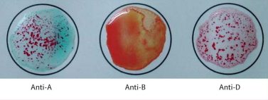
Reaction: Positive Agglutination Negative Agglutination Positive Agglutination
Antigen/s detected: Antigen A
ABO & Rh Blood Group: A Rh Positive
POST–LABORATORY QUESTIONS:
- What is an antiserum?
An anti serum is a blood serum that contains specific antibodies against an infective organisms, like bacteria and viruses, and toxic substances.

- What kind of antigen will anti-A detect? Anti-B?
The anti-A will detect an A antigen while the Anti-B will detect the B antigen.

- When is blood typing ordered?
The test must be done when blood transfusion or when classifying a person’s blood for donation.
Also when identifying the blood type the the child when a woman is pregnant.

- Name the common causes of false positive and false negative results in ABO Testing.
False positive and false negative results in ABO Testing occur due to technical errors. It could be due to un-calibrated centrifuges, contamination or contaminated reagents, use of the wrong reagents, dirty materials and aged blood samples.

- What is Rh Typing?
The Rh factor, is a type of protein found on the outside of blood cells. Rh typing is used to determine whether this protein is present in your blood cells. If you are Rh negative, you do not have the Rh Factor and if you are positive, then the Rh factor is present in your blood.

