Name: Felicy Jane E. Pactores Section: MT 14 – A (lab)
ACTIVITY 3: BLOOD TYPING
I. ABO FORWARD GROUPING AND RH TYPING
A. Slide Method
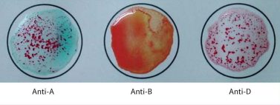
Reaction: Positive Agglutination Negative Agglutination Positive Agglutination
Antigen/s detected: A antigen
ABO & Rh Blood Group: “A” Rh Positive
POST–LABORATORY QUESTIONS:
- What is an antiserum?

Antiserum is a serum containing immunoglobulins from the blood of humans or animals that have been immunized with an antigenic content or from those who have healed from disease and have naturally developed antibodies against specific antigens.

- What kind of antigen will anti–A detect? Anti–B?

Anti-A will detect A antigen, while anti-B will detect B antigen.

- When is blood typing ordered?

If a person would become an option for an organ, tissue, or bone marrow transplant, or when they desire to become a donor, blood typing may be ordered. It's one of the first of many tests used to see if a possible donor and recipient are compatible.

- Name the common causes of false positive and false negative results in ABO Testing.

False-positive or false-negative test results can occur due to microbial or chemical contamination of test materials, old blood specimens, insufficient incubation time or temperature, improper centrifugation, inappropriate storage areas, or omission of test samples.

- What is Rh Typing?

Rhesus (Rh) typing determines whether you have an Rh factor protein on the outer layer of your red blood cells. You are Rh-negative if you do not have Rh factor in your blood. You are Rh-positive if you have Rh factor in your blood. The majority of people are Rh-positive.

