Name: ________________________ Section: ____________________________
MT 14 - A
Frances Camille M. Real
ACTIVITY 3: BLOOD TYPING
I. ABO FORWARD GROUPING AND RH TYPING
A. Slide Method
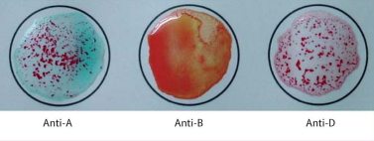
+ (Positive agglutination)
+ (Positive agglutination)
0 (No agglutination)
Reaction: ___________________ __________________ ___________________
anti-A
Antigen/s detected: _____________
A - POSITIVE
ABO & Rh Blood Group: _____________
POST–LABORATORY QUESTIONS:
- What is an antiserum?
- Antiserums are being used to detect if erythrocytic antigens are present or not in human red blood cells.

- What kind of antigen will anti–A detect? Anti–B?
- The antigen anti-A would detect would be the A antigen while anti-B would detect the B antigen.

- When is blood typing ordered?
- Blood typing may be ordered if a person would become a patient’s donor for either organ, tissue, or even a bone marrow transplant. This is one of the first tests that is done to see if a possible donor and receiver would be compatible.

- Name the common causes of false positive and false negative results in ABO Testing.
- The common causes for false positive or false negative test results may be microbial or chemical contamination of the materials used, old blood samples, insufficient incubation time or temperature, poor centrifugation, not good enough storage facilities, or improper handling of test specimens.

- What is Rh Typing?
- Rh Typing is a test that determines whether or not you have a specific protein Rh factor on the surface of your red blood cells.

