Name: Carl Stewart Section: MT 14 - A (LAB)
ACTIVITY 3: BLOOD TYPING
I. ABO FORWARD GROUPING AND RH TYPING
- Slide Method
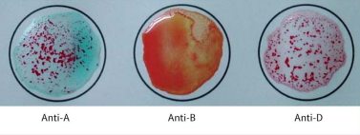
Reaction:
+ | 0 | +
Antigen/s detected: A antigen
ABO & Rh Blood Group: A Rh Positive

POST–LABORATORY QUESTIONS:
1. What is an antiserum?
- An antiserum, or antisera, is a substance used to determine the antigen/s present on red blood cells. It is typically used in blood typing, in anti-A and anti-B configurations specifically.

2. What kind of antigen will anti–A detect? Anti–B?
- Antiserum anti-A will detect antigen A, while anti-B will detect antigen B.

3. When is blood typing ordered?
- Blood typing is typically ordered when a person decides to donate blood, or in another case, become an organ donor.

4. Name the common causes of false positive and false negative results in ABO Testing.
- A common cause of erroneous results in ABO testing is prematurely checking for results- a 2-minute wait period must be observed before reading results.

5. What is Rh Typing?
- Rh Typing is a determination of the Rhesis (Rh) protein on the outer later of a person’s red blood cells. A person may be typed as Rh Positive and Rh negative.

