Name: Reign Francis A. Gacasan Section: MT 14 (LAB) – C
ACTIVITY 3: BLOOD TYPING
I. ABO FORWARD GROUPING AND RH TYPING
A. Slide Method
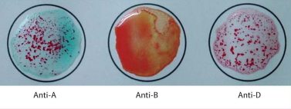

Reaction: Anti-A: Positive (+) or Agglutination
Anti-B: Negative (-) or No Agglutination
Anti-D: Positive (+) or Agglutination
Antigen/s detected: A Antigen
ABO & Rh Blood Group: A+ (positive) or A Rh D Positive
POST–LABORATORY QUESTIONS:
- What is an antiserum?

Antisera are chemicals used in blood typing to determine which antigens are present on the membranes of red blood cells. Antisera A and B are used for ABO blood type typing, whereas antisera D is used for Rh or Rhesus blood group typing.

- What kind of antigen will anti–A detect? Anti–B?

Anti-A serum detects only A antigens, whereas anti-B serum detects only B antigens.

- When is blood typing ordered?

When a patient requires a blood transfusion, a blood type test is ordered. The same procedure applies to persons who want to be blood donors and organ transplant recipients. In general, blood typing is used to determine compatibility with certain blood types.

- Name the common causes of false positive and false negative results in ABO Testing.

The following are common reasons of false positive and false negative ABO testing results:
- Contamination of test materials by bacteria or chemicals
- Aged blood samples
- Improper material storage
- Using the incorrect antisera or having failed to include antisera
- Exclusion of test samples

- What is Rh Typing?
Rhesus or Rh typing is a blood test that determines whether or not the Rh factor is present on the surface of your red blood cells. The Rh factor is a protein that is inherited. Your blood type is positive (+) if the Rh protein is found on your RBCs. If the Rh protein is missing from your RBCs, you have a negative blood type (-).

