Activity 2: Peripheral Smears

Name of Patient: Francis Faith Antique DOB: 03/04/2002

In this prepared slides, identify and count the number of WBCs and platelets you can find per field
(specify type of white blood cell) and compute for the WBC estimate and platelet estimate.

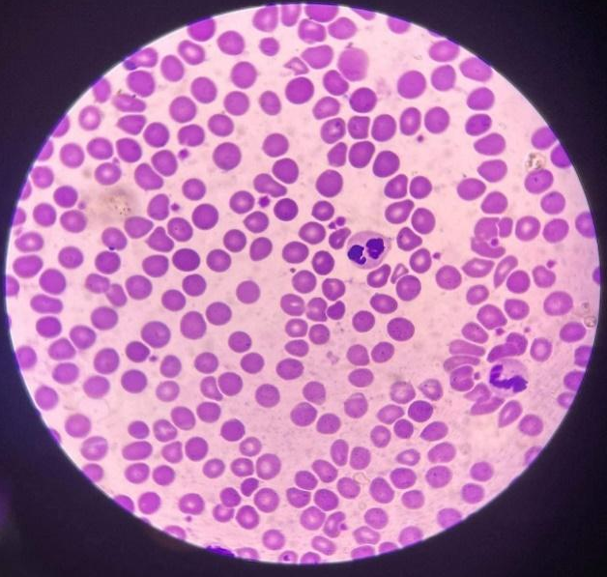
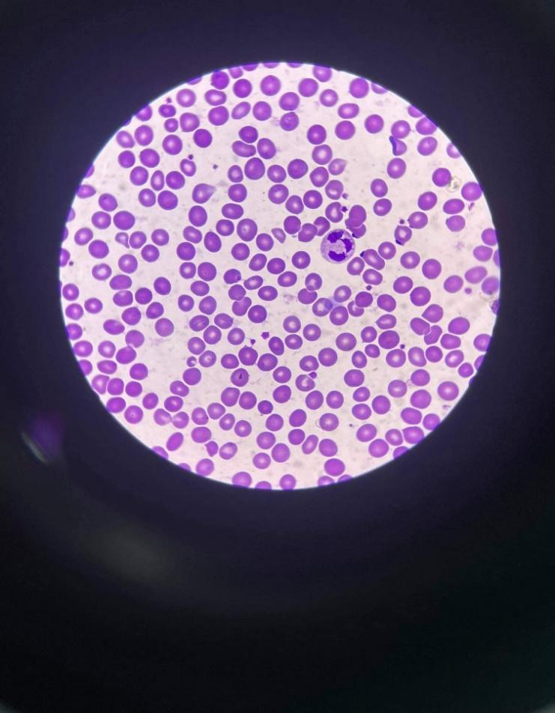

Wbc: 1 – neutrophil Wbc: 2 – neutrophil
Platelet: 16 Platelet: 16
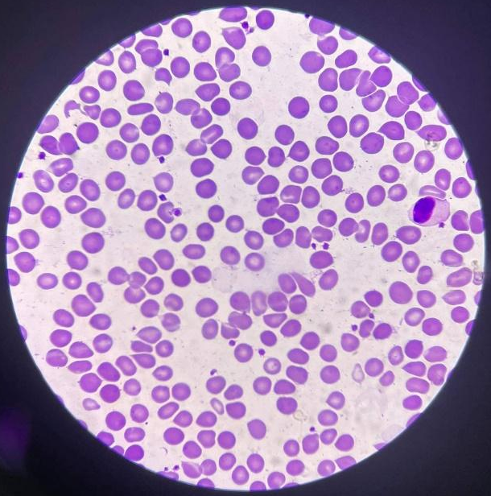
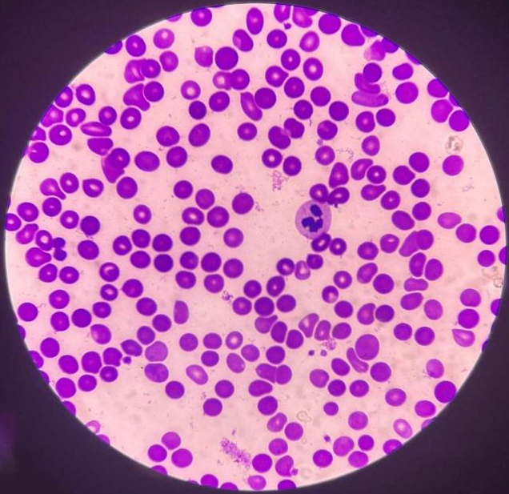

Wbc: 1 – lymphocyte wbc: 1 – neutrophil
Platelet: 20 platelet: 7
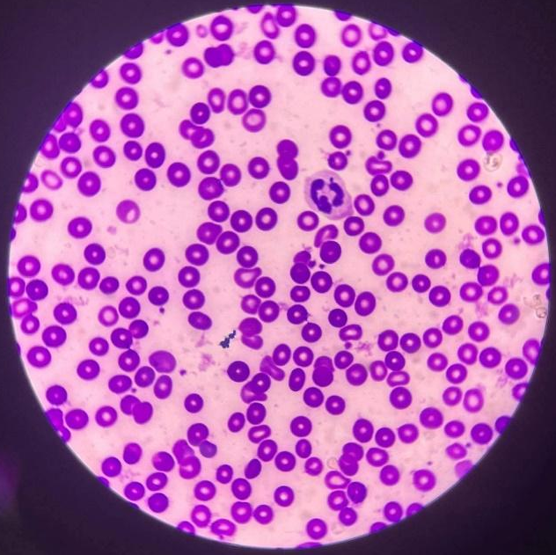
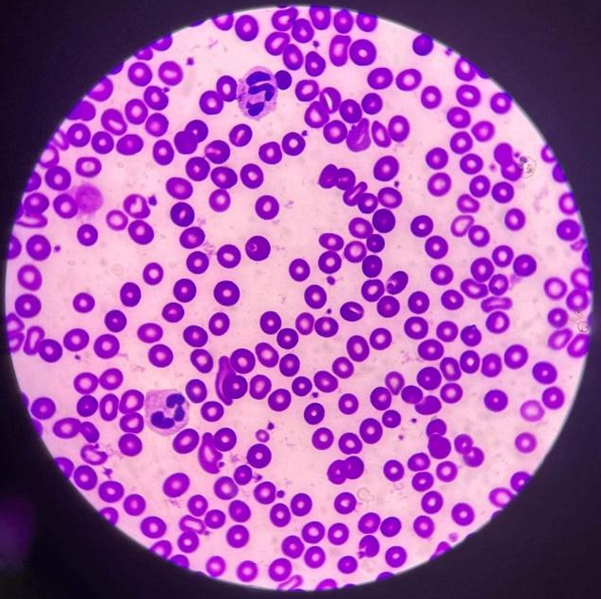

Wbc: 1 – neutrophil wbc: 2 - neutrophil
Platelet: 14 platelet: 21

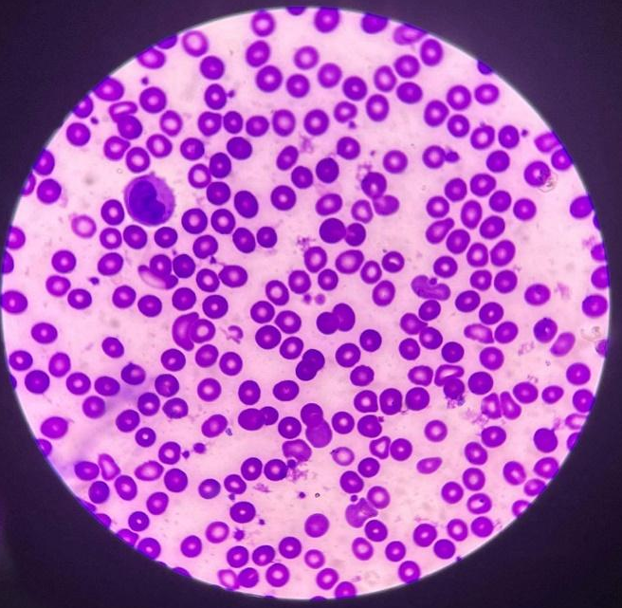
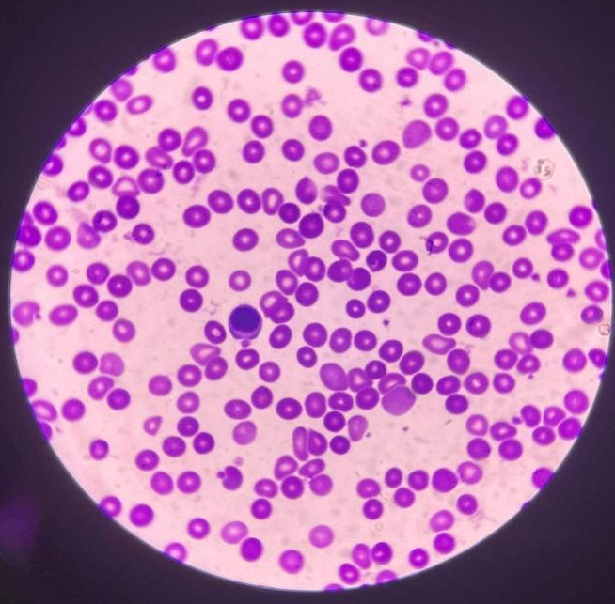

Wbc: 1 – monocyte wbc: 1 - lymphocyte
Platelet: 24 platelet: 13
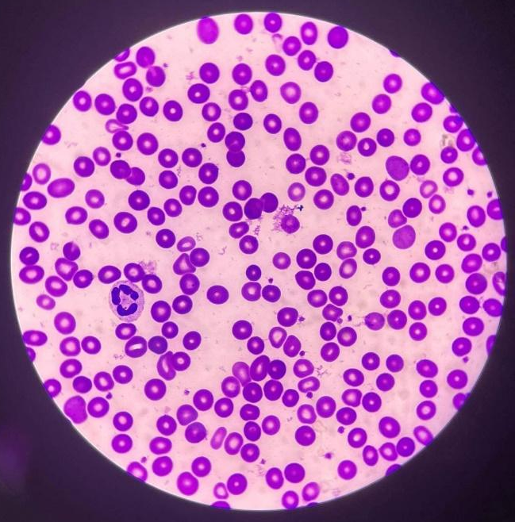
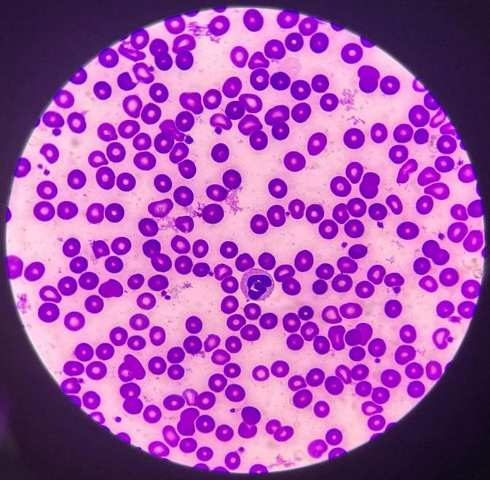
Wbc: 1 – neutrophil wbc: 1 – neutrophil
Platelet: 22 platelet: 21

Computation:

WBC count: 12 / 10 = 1.2 X 2,000 = 2,400

platelet count: 174 / 10 = 7.4 X 20,000 = 148,000 mm³

RBC Morphology: 217 / 10 = 22 = 3+
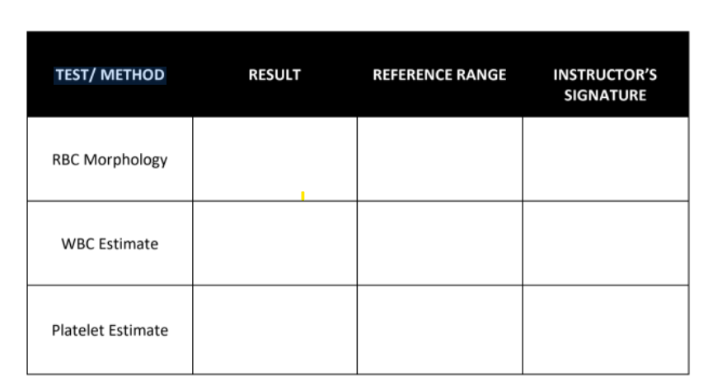
4,500 to 11,000

150,000 to 450,000
148,000mm³
2,400
3+

Time and Date Performed: 10:23 PM, 6/3/2022
Date Submitted: 6/3/2022
Medical Technologist: Elain S. Balsamo

