
LABtobacillus
Institute of Laboratory Sciences
Silliman University

FILARIASIS
Filariasis Test Strip (Blood)

(LABORATORY TECHNICAL PROCEDURE)

INTENDED USE
The Bioline Filariasis Test Strip is an in vitro immunochromatographic assay for the qualitative detection of Wuchereia bancrofti antigen in human capillary whole blood samples collected by fingerstick. It is intended to aid in the rapid diagnosis of lymphatic filariasis caused by W. boncrofti. It is recommended that negative test results be confirmed by standard diagnostic methods such as thick smear microscopy, membrane filtration, or another antigen detection method. Negative results do not preclude infection with W. bancrofti and should not be used as the sole basis for treatment or other management decisions.
SUMMARY
Lymphatic filariasis is a parasitic disease, caused by microscopic, thread-like worms. The adult worms live in the human lymph system and release microscopic worms, called microfilariae, into the blood. Approximately 90% of lymphatic filariasis is caused by W. bancrofti. If the infection is left undiagnosed and untreated, it can cause lymphedema and, ultimately, the disfiguring and debilitating condition known as elephantiasis. W. bancrofti infection can also cause hydrocele, or swelling of the scrotum. Lymphatic filariasis is widely considered to be a Neglected Tropical Disease; it affects over 120 million people in 80 countries in the tropics and subtropics around the world.
Diagnosis of lymphatic filariasis using traditional microscopy methods can be difficult and requires precise and meticulous techniques, as it involves the identification of microfilariae in the blood of the infected person. Microscopy requires skilled handling of the sample preparation and an experienced technologist for interpretation of the blood smear. In addition, due to nocturnal periodicity, the microfilariae are only present in the peripheral circulatory system at night, so collection of an acceptable sample for microscopy must be done at night.
The Bioline Filariasis Test Strip is a very simple, rapid method for the diagnosis of lymphatic filariasis, using whole blood collected by fingerstick. The easy-to-use format and rapid results allow for its use in settings in which traditional microscopy methods may not be readily available, where it can provide information to assist with treatment decisions.

PRINCIPLE OF THE PROCEDURE
The Bioline Filariasis Test Strip is an in vitro, immunochromatographic, membrane assay for the detection of W. bancrofti antigen in capillary whole blood, collected via fingerstick. The test uses two different antibodies. One antibody is attached to colloidal gold and impregnated into a pink pad on the Test Strip. A second antibody is immobilized on the membrane. The blood sample is added to the lower half of the exposed white Sample Pad. The sample flows through the pink area of the pad and up the membrane, allowing any antigen in the sample to be labeled with the colloidal gold-labeled antibody. The antigen-antibody complex is then immobilized in the test result area of the Test Strip.
Test results are interpreted at 10 minutes, based on the presence or absence of a pink-to-purple colored Test Line. A pink-to-purple procedural Control Line will appear in a valid test.
WARNINGS AND PRECAUTION
- For in vitro diagnostic use.
- Ensure that all kit components are equilibrated to ambient temperature (15-37°C) before use.
- The test strip is sealed in a protective foil pouch; do not use it if the pouch is damaged or open. Leave the test strip sealed in its foil pouch until just before use. Keep storage boxes dry.
- Do not use kit past its expiration date.
- Optimal results will be obtained by strict adherence to the instructions provided herein.
- Handle the test strip carefully. Hold it only at the top, which is the end without the arrows. Do not touch or apply pressure to the functional areas of the test strip, including the white sample pad at the bottom of the test strip.
- If using the patient result sticker, place it at the top of the test strip, as described above. Do not place it over the functional area of the test strip, including the white sample pad.
- If using the plastic work tray, do not let the test strip touch the side of the tray, as doing so could cause false results.
- When interpreting test results, use a bright unfiltered light.
- Patient samples and used test strips should be handled as potentially infectious materials. Observe established precautions against microbial hazards. The use of lab coats, gloves and safety eye glasses is strongly recommended.
- When collecting blood samples, use the micropipettes provided in the kit. See the detailed instructions in the Specimen Collection and Handling section below that explain how to properly use the micropipettes.
- Micropipettes are single use items - do not use multiple specimens.
13. Excessive air circulation and direct sunlight may slow the flow of the sample. During testing, protecting the devices from excessive air circulation and direct sunlight is recommended.
MATERIALS AND EQUIPMENT
To perform the Filariasis Test, the following materials and equipment are required:
- Lancets capable of delivering a minimum volume of 75pL whole blood
- Sterile wipes or pads
- Clock, timer or stopwatch
- Disposable Gloves
- Test strips
- Micropipettes
- Patient result stickers
ENTS a
QUALITY CONTROL
Daily Quality Control:
The Bioline Filariasis Test Strip has a built-in (internal) procedural control. For daily quality control, Abbott suggests that you record the results of this control for each test

Procedural Controls:
The pink-to-purple line in the top half of the result area of a tested strip (close to the area labeled with "C”) can be considered an internal positive procedural control. If the sample flows and the reagents are working properly, this line will always appear. The clearing of background color on a tested strip is a negative background control. Background color should not interfere with the reading of the test result.

External Positive and Negative Controls:
Good laboratory practice suggests that external positive and negative controls be run to ensure that: test reagents are working, and the test is correctly performed. At a minimum, Abbott recommends that external controls be run once with each new shipment. Recommended external controls are listed below. Alternatively, laboratories may use different controls, providing control results are as expected. Each lab should establish its own positive and negative external quality control samples and procedures. For a negative control, a whole blood sample from a presumed W. bancrofti non-infected individual can be tested, following the specimen collection and test procedures described below. For a positive control, a sample from a confirmed W. bancrofti positive individual or a sample containing W. bancrofti antigen can be used.

External Control Procedure:
If pipetting a control, use a calibrated pipette and apply 75 pL of the control to the lower half of the sample pad. See the Result Interpretation section for instructions on interpreting the results. Other controls may be tested in order to conform with:
• local and/or federal regulations,
• accrediting groups, and/or,
• your laboratory’s standard Quality Control procedures
SPECIMEN COLLECTION and HANDLING

- Prepare patient for fingerstick sample collection. The best locations for fingersticks are the 3rd and 4th fingers. Do not use the tip of the finger or the center of the finger pad. Avoid the side of the finger where there is less soft tissue, where vessels and nerves are located, and where the bone is closer to the surface. The 2nd (index) finger tends to have thicker, callused skin. The fifth finger tends to have less soft tissue overlying the bone. Avoid puncturing a finger that is cold or cyanotic, swollen, scarred, or covered with a rash. Avoid fingers with rings on.
- Warm up the fingers if needed. Have the patient hold their hand downwards to increase blood flow to the finger. Note: The patient should always sit higher than the person performing the fingerstick.
- Wipe the tip of the appropriately selected finger with an alcohol swab and let the alcohol air dry.
- Use a sterile lancet to make a skin puncture just off the center of the finger pad. Do not squeeze or apply strong repetitive pressure (milking) to the site; this may result in hemolysis or tissue-fluid contamination of the specimen. If necessary, gentle massaging of the finger may be conducted in order to ensure a steady blood flow.
- Wipe off the first drops of blood with a dry cloth or gauze. Ensure steady blood flow that generates large enough drops of blood. If necessary, wipe off another drop, until blood flows freely.
- Allow blood to flow freely from the pricked finger directly into the micropipette provided in the test kit by following the instructions provided below. Test immediately. Inadequate specimen collection or improper sample handling may yield false or invalid results.
TEST PROCEDURE for CAPILLARY WHOLE BLOOD SAMPLES
Allow all kit components to equilibrate to ambient temperature (15-37°C) before testing.
Remove the test strip from the foil pouch immediately prior to use. Place the test strip in the plastic work tray, so the indicator arrows point toward the operator. If not using the work tray, lay the test strip on a flat surface. Discard the desiccant included in the pouch. If using the patient result sticker, place it at the top of the test strip, which is the end without the arrows.
Do not touch the exposed Sample Pad.
- Using a micropipette provided in the test kit, slowly add the patient sample to the lower half of the exposed white sample pad by gently squeezing the bulb (see Step 2 of the instructions for using the micropipettes above). Note: See the indicator arrows on the bottom of the test strip that show where the sample pod is located. Avoid applying excessive pressure on the sample pad during sample addition and do not apply pressure to the functional areas of the test strip. Important: Incorrect addition of sample may cause erroneous results.
- Start a timer for 10 minutes. When possible, de not disturb or move the test strip after the sample has been added. If it is necessary to move the test strip, keep it flat and move it very carefully by sliding it. Do not hold the test strip in a vertical position after the sample has been added.
- Interpret the results in the result area of the test strip 10 minutes after adding the sample. Note: See the Procedure Cord for an actual size graphic of the test strip that shows the location of the control and test lines.
READING THE TEST RESULT
Result | Suggested Report
Positive | Positive for W. bancrofti antigen. This result does not rule out co-infections with other pathogens.
Negative | Negative for W. bancrofti antigen. W. bancrofti infection cannot be ruled out, as antigen levels in the sample may be below the detection limit of the test. Abbott suggests that negative test results be confirmed by standard diagnostic methods such as thick smear microscopy, membrane filtration, or another antigen detection method.

RESULT INTERPRETATION

Positive Test Result
A positive test result produces a pink-to-purple control line in the top half of the result area of the test strip and a pink-to-purple test line in the lower half of the result area, any pink-to-purple visible test line is positive. Do not interpret the test result until 10 minutes have elapsed from when the sample was added.

Negative Test Result
A negative test result produces a pink-to-purple control line in the top half of the result area of the test strip and the absence of a test line in the lower half of the result area. To ensure that low positive samples have had sufficient time to develop, a negative result should not be recorded until 10 minutes have elapsed from when the sample.
Invalid Test Result
The test is invalid if the control line in the top half of the result area of the test strip does not appear, whether a test line is present or not. If this occurs, the test should be repeated with a new test strip and a fresh sample. Contact Abbott Technical Support if the problem persists.

Example of Results:
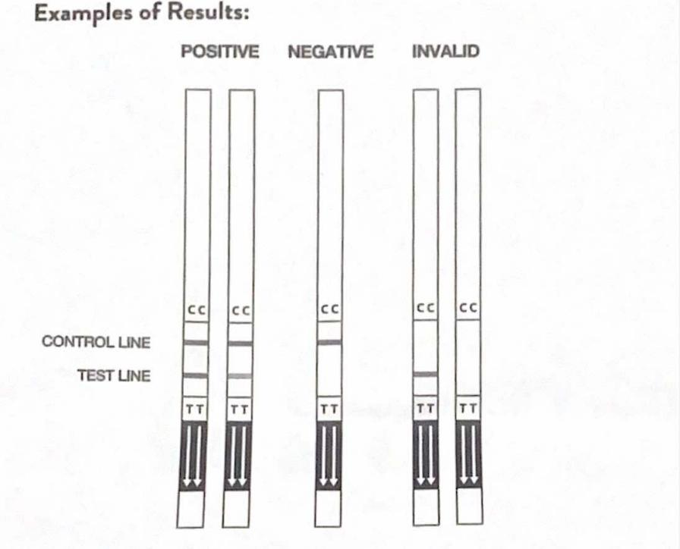

PERFORMANCE CHARACTERISTICS
Bioline Filariasis Test Strip Test Performance vs. Comparator Method - Prospective Clinical Study
The clinical performance of the Bioline Filariasis Test Strip was established in a multi-site, prospective, clinical study conducted in Liberia in a W. bancrofti endemic area in April and May of 2012.
A total of 519 prospective blood specimens, collected from children (ages 6 to 18 years of age) and adults (18 years or older), were evaluated in the Bioline Filariasis Test Strip test and compared to a commercially available rapid immunochromatographic test. Evaluated specimens were capillary whole blood samples, collected via fingerstick. Twenty-three percent (23%) of the population tested was greater than 5 years of age but less than 10 years, 19% was 10 - 18 years of age, and 58% was greater than 18 years.
Bioline Filariasis Test Strip test performance versus the comparator method, for all subjects combined, is detailed below. There were 519 Bioline Filariasis tests performed, and 16 were invalid (3% - 16/519), leaving 503 tests available for the analysis presented below. One of the 16 invalid Abbott tests was also invalid on the comparator method.

 | Comparator Method + | Comparator Method -
Bioline Filariasis + | 97 | 27* | 124
Bioline Filariasis - | 1 | 378 | 379
 | 98 | 405 | 503
LIMITATIONS
A negative test result does not exclude infection with W. boncrofti. Therefore, the results obtained with the Bioline Filariasis Test Strip should be used in conjunction with standard disgnostic methods to make an accurate diagnosis.
The Bioline Filanasis Test Strip detects antigen from both viable and non-viable W. bancrofti. Test performance depends on antigen load in the specimen and may not directly correlate with microscopy performed on the same specimen.
Performance of the Bioline Filariasis Test Strip has not been established for monitoring treatment of Lymphatic Filariasis. Residual antigen may be detected following elimination of the parasite by anti-filarial treatment.
The Bioline Filariasis Test Strip prospective clinical study, summarized in the section below, was conducted in a W. bancrofti endemic area. Performance of the Bioline Filariasis Test Strip has not been established in non-endemic, low infection level areas. Performance of the Bioline Filariasis Test Strip has not been established in children 5 years old and younger.

Bibliography
1. World Health Organization Global Programme to Eliminate Lymphatic Filariasis, Progress Report 2000-2009 and Strategic Plan 2010-2020; 2010. 2. ﻿﻿﻿
2. www.cdc.gov/parasites/lymphaticfilariasis/
3. M.M. Ismail, et al. Prolonged clearance of microfilaraemia in patients with bancroftian filariasis after multiple doses of ivermectin or diethylcarbamazine. Trans. R. Soc. Trop. Med. Hyg; 1996, 90(6):684-688.

