Name: Moira Alliah A. Gemeniano Section: MT 14 – A (LAB)
ACTIVITY 3: BLOOD TYPING
- ABO FORWARD GROUPING AND RH TYPING
  - Slide Method
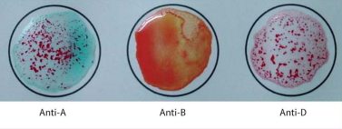
Reaction: + 0 +
Antigen/s detected: Antigen A
ABO & Rh Blood Group: “A” Rh Positive

POST–LABORATORY QUESTIONS:
- What is an antiserum?
An antiserum is a blood serum which carries specific antibodies. In blood typing, it is used to detect what kind of antigen is present on the membrane of the given red blood cells. This is achieved when the antiserum is mixed with the blood sample to see if it agglutinates to that specific serum or not.

- What kind of antigen will anti–A detect? Anti–B?
The anti-A serum will detect the A antigen, it can be seen when the blood sample agglutinates with the serum. The anti-B serum, on the other hand, will detect the B antigen, this is also determined when the blood sample agglutinates with the serum.

- When is blood typing ordered?
Blood typing is ordered when a person will either donate their blood or receive blood from another person. This is to know if their blood is compatible for blood transfusion. When the type of blood is incorrectly transfused to the patient, it may pose critical problems to the patient’s body.

- Name the common causes of false positive and false negative results in ABO Testing.
The list below are some common causes of false positive and negative results in ABO Testing:
  - The contamination of materials and equipment for the blood typing process.
  - Wrong incubation time and temperature of the sample.
  - Inappropriate centrifugation process done.
  - The use of aged specimens and the exclusion of some blood samples.

- What is Rh Typing?
Rh Typing is utilized in to know if the protein Rh factor is present on the membrane of the patient’s red blood cells. When the blood sample contains the protein, it will be labeled as Rh positive, but when it doesn’t, it is labeled as Rh negative.

