Blood Typing
Name of Patient: Ace Morrieson Ganta Sex:
Date of Birth: 12/14/2001 Age: 20

Result: Anti-A: + Agglutination
Anti-B: 0 Agglutination
Anti-D: + Agglutination
Antigens Detected: A-antigen & D-Rh-antigen
ABO & Rh Blood Group: A Rh-D positive/ A+

Reference Range: Blood Type (Anti-A, Anti-B, Anti-D)
A+ / A-Positive: (_+ 0 +)
A- / A-Negative: (_+ 0 0)
B+ / B-Positive: (_0 + +)
B- / B-Negative: (_0 + 0)
AB+ / AB-Positive: (_+ + +)
AB- / AB-Negative: (_+ + 0)
O- / 0-Negative: (_0 0 +)
O- / 0-Negative: (_0 0 0)

Interpretation: The patient’s blood sample agglutinates with the Anti-A and Anti-D sera, but not with Anti-B sera. Hence, the blood sample belongs to type A-positive (A+).

Name of Medical Technologist: Vince Zsanize S. Figues

Date Performed: 6/3/2022 Time Performed: 6:51 P.M.

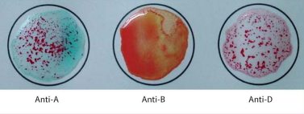

Reaction: + 0 +
Antigen/s detected: A-antigen & D-Rh-Antigen
ABO & Rh blood Group: A Rh-D positive (A+)

