Hematocrit
Name of Patient: Ace Morrieson Ganta Sex:
Date of Birth: 12/14/2001 Age: 20

Result: Conventional Unit: 35%
SI Unit: 0.35 L/L

Reference Range: Conventional Unit: 40-54%
SI Unit: 0.40-0.54 L/L

Interpretation: The patient has 35% of hematocrit value. This is lower compared to the normal range values in males, which is 40-54%.

Name of Medical Technologist: Vince Zsanize S. Figues

Date Performed: 5/20/2022 Time Performed: 11:48 A.M.

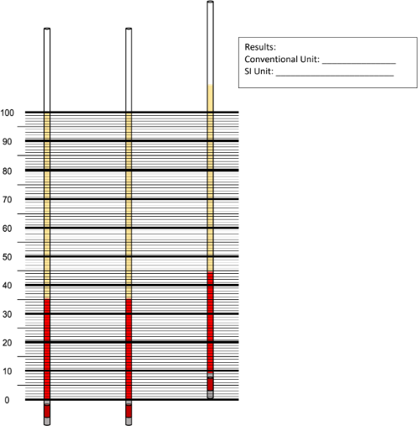
Hematocrit Test Result
0.35 L/L
35%

The first and second capillary tubes exhibit the correct positions for reading the results properly. The results convey that the patient has a 35% hematocrit value as its conventional unit. Meanwhile, it has a 0.35 L/L hematocrit value as its SI Unit.

