RBC Morphology
Name of Patient: Ace Morrieson Ganta Sex:
Date of Birth: 12/14/2001 Age: 20

Result: 22.5 poikilocyte/ OIF
Grade: 3+

Reference Range: Grading System:
1+ = 2-10 poikilocytes/OIF
2+ = 11-20 poikilocytes/ OIF
3+ = 21-50 pokilocytes/ OIF
4+ = 51 and above poikilocytes/ OIF

Interpretation: The patient has a grade of 3+ in RBC morphology. This indicates that the patient’s average RBC morphology falls within the range of 21 to 50 poikilocytes in each oil immersion field.

Name of Medical Technologist: Vince Zsanize S. Figues

Date Performed: 6/3/2022 Time Performed: 6:36 P.M.

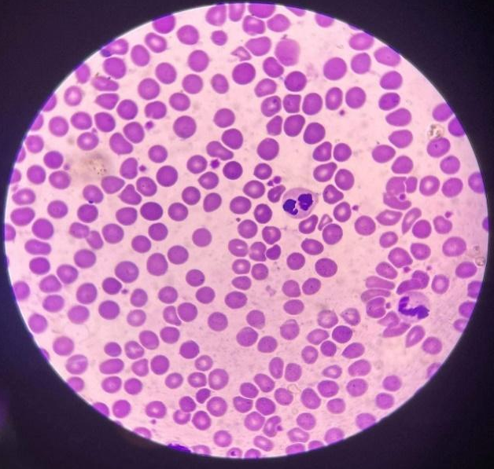
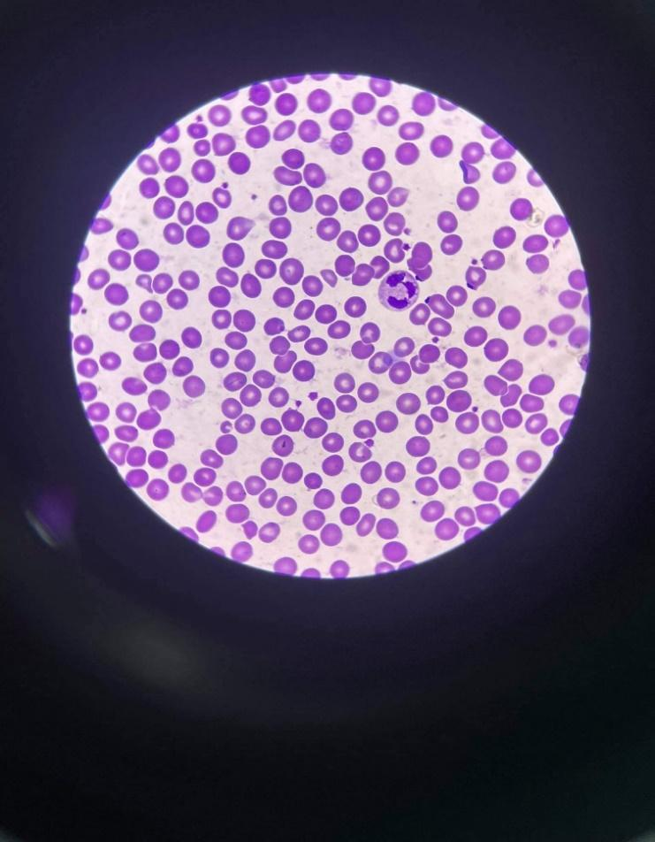

Poikilocytes: 18 Poikilocyte: 26
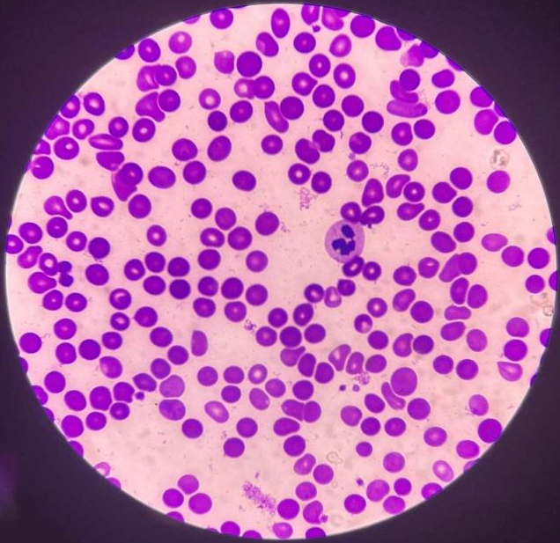
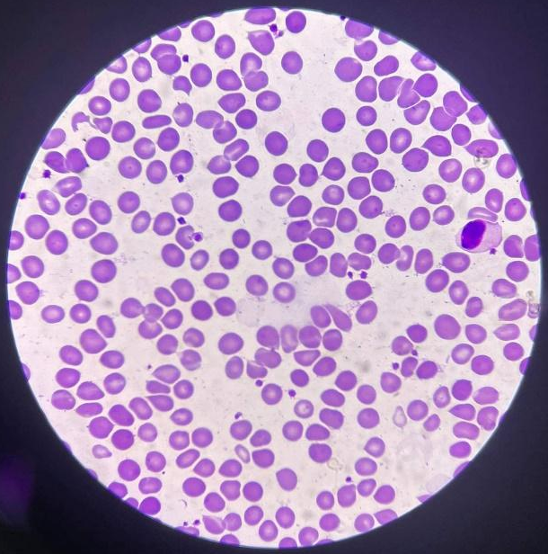

Poikilocytes: 18 Poikilocyte: 26

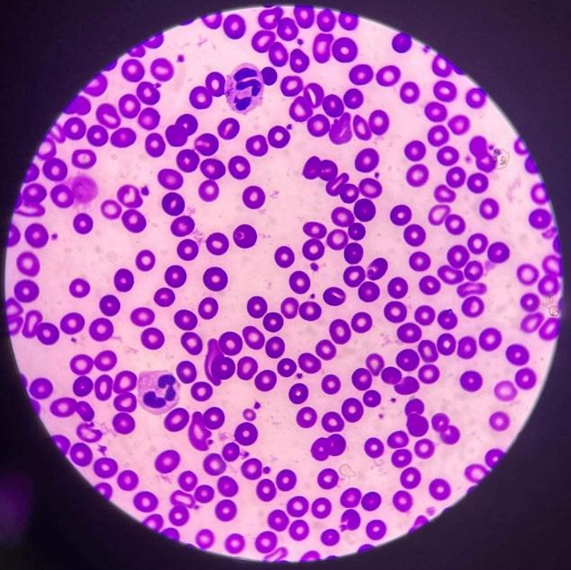
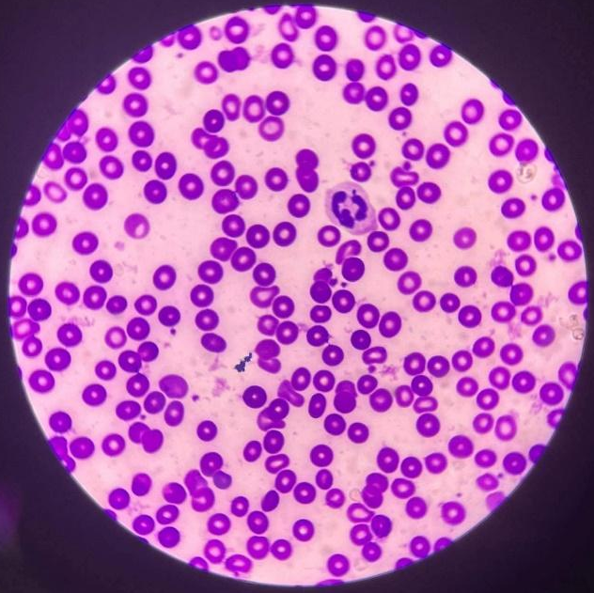

Poikilocytes: 20 Poikilocyte: 27
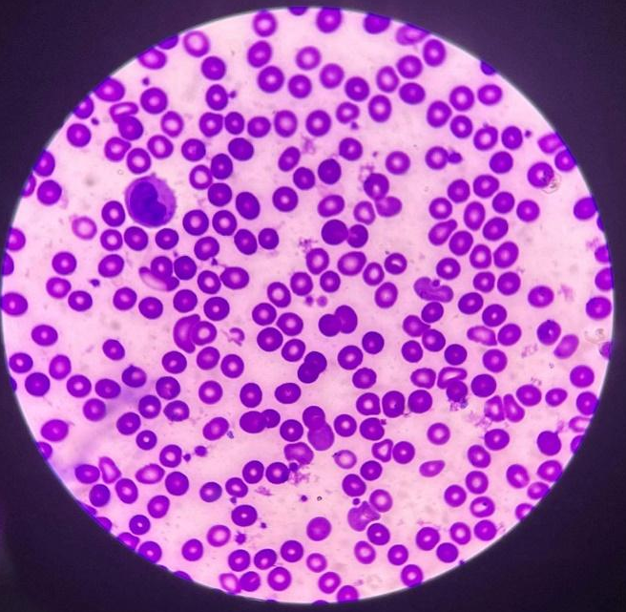
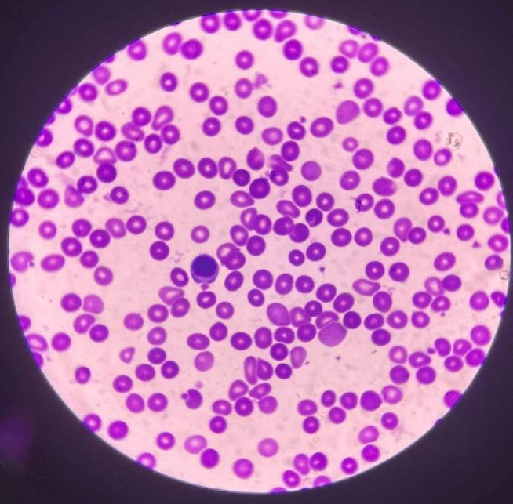

Poikilocytes: 12 Poikilocyte: 21

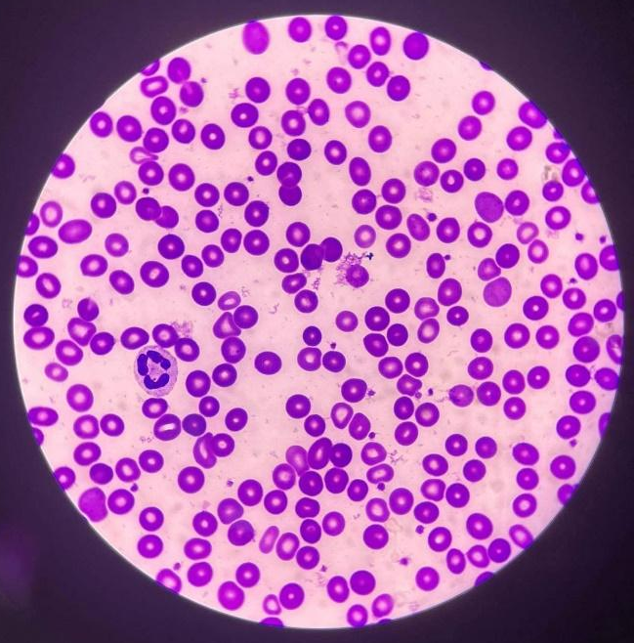
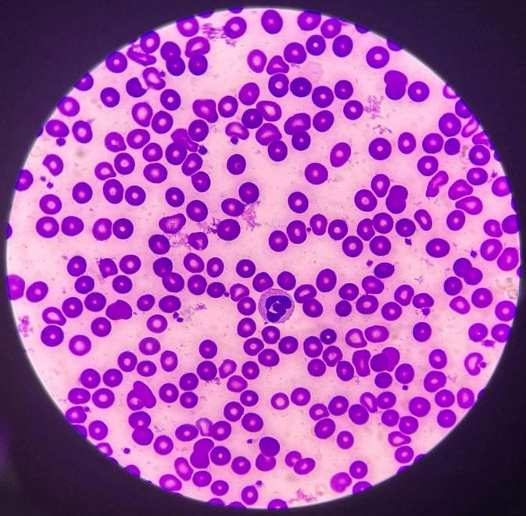

Poikilocytes: 18 Poikilocyte: 32
Computation:
RBC Morphology:
RBC Morphology:
Grading System:
1+ = 2-10 poikilocytes/OIF
2+ = 11-20 poikilocytes/ OIF
3+ = 21-50 pokilocytes/ OIF
4+ = 51 and above poikilocytes/ OIF
$$=\frac{Total number of poikilocyte }{10}$$

$$=\frac{18+26+20+27+12+21+18+32+32+19}{10}$$

$$RBC Morphology=22.5 poikilocyte/OIF$$

Grade:
3+ = 21-50 pokilocytes/ OIF

