WBC Estimate
Name of Patient: Ace Morrieson Ganta Sex:
Date of Birth: 12/14/2001 Age: 20

Result: Conventional Unit: 2,400 mm³
SI Unit: 2.4x10⁹ /L

Reference Range: Conventional Unit: 4,500-11, 000 mm³
SI Unit: 4.5-11.0x10⁹ /L

Interpretation: The patient’s WBC estimate of 2,400 mm³ is relatively lower than the reference range, indicating the suppressed ability of the body to fight against infection.

Name of Medical Technologist: Vince Zsanize S. Figues

Date Performed: 6/3/2022 Time Performed: 5:58 P.M.

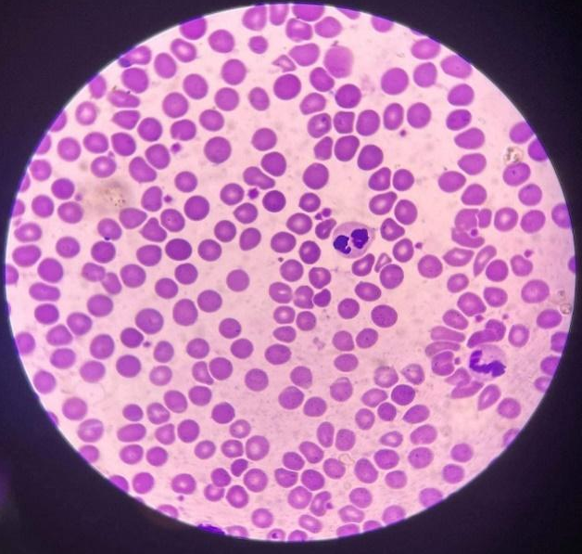
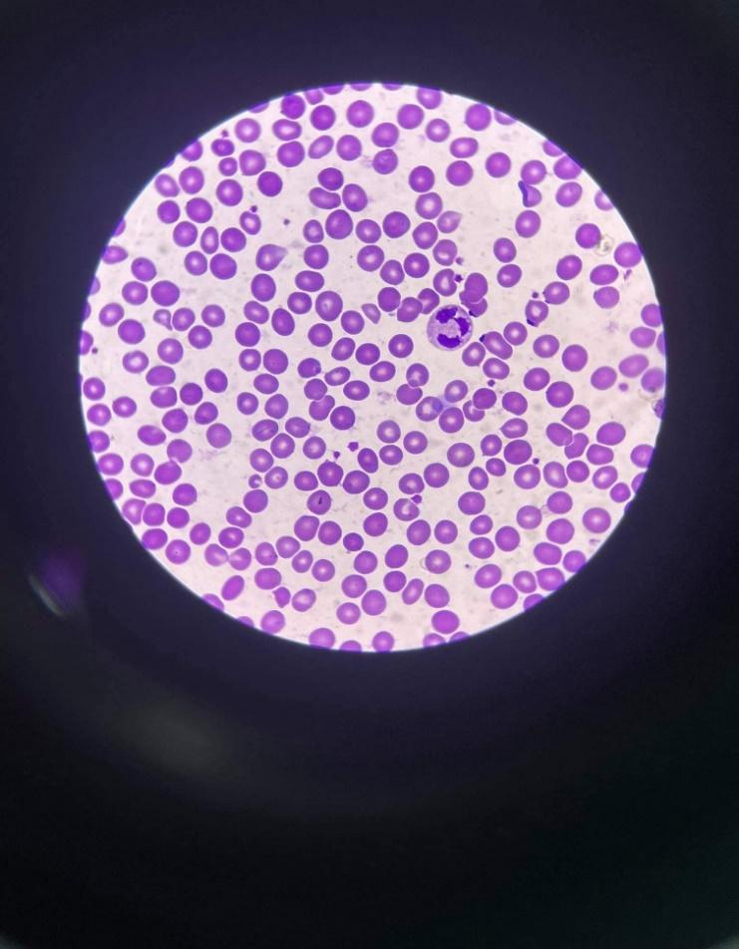

WBC: Neutrophil-1 WBC: Eosinophil-1; Neutrophil-1
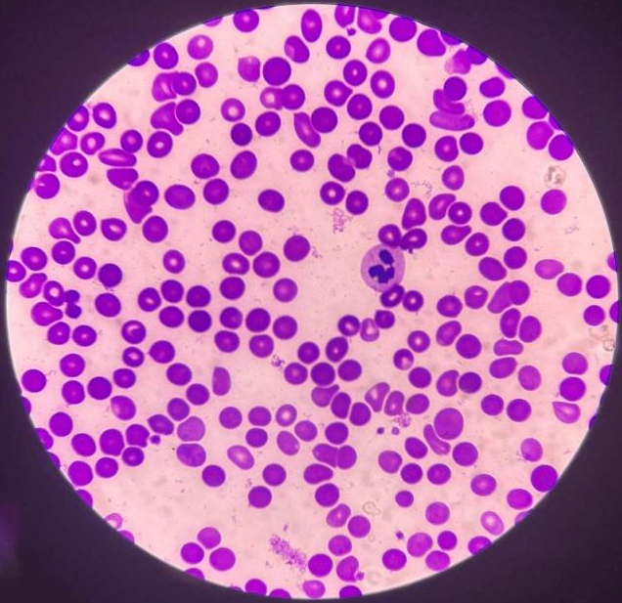
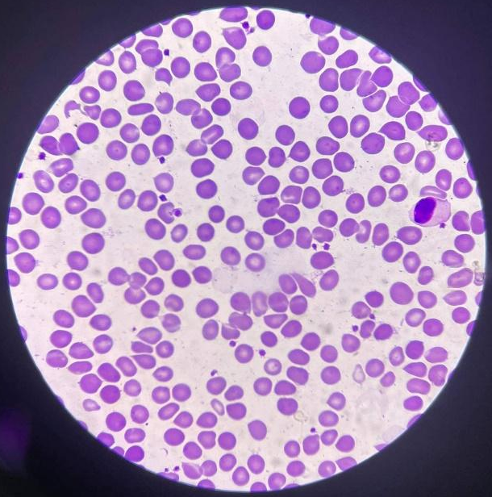

WBC: Monocyte-1 WBC: Neutrophil-1

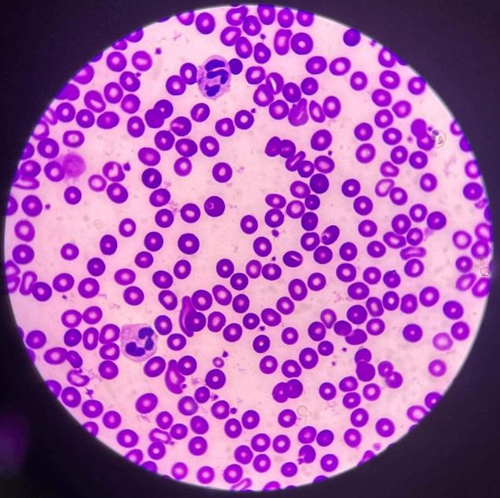
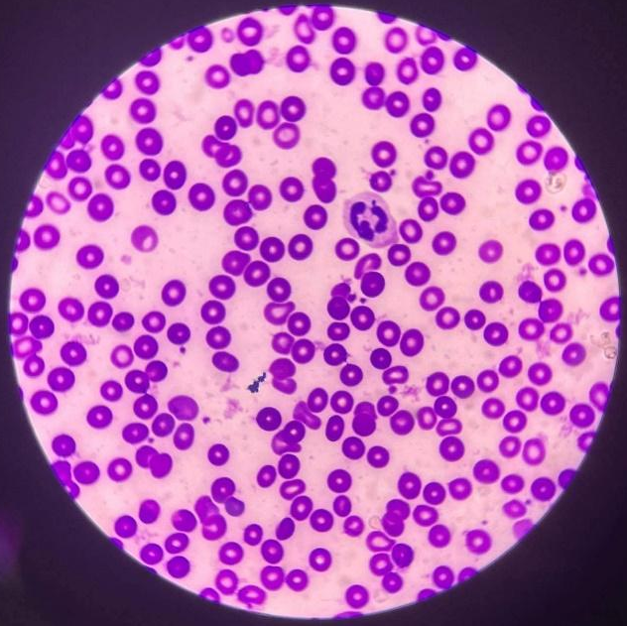

WBC: Neutrophil-1 WBC: Neutrophil-2

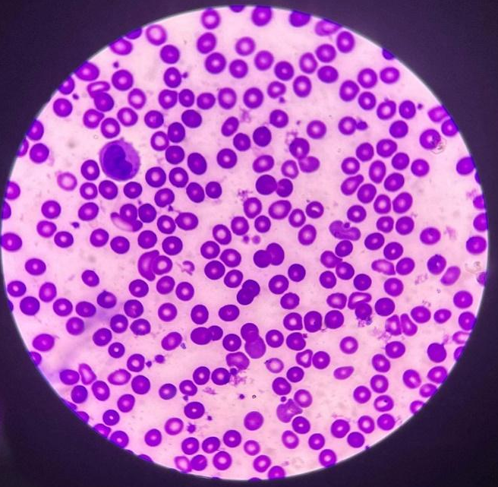
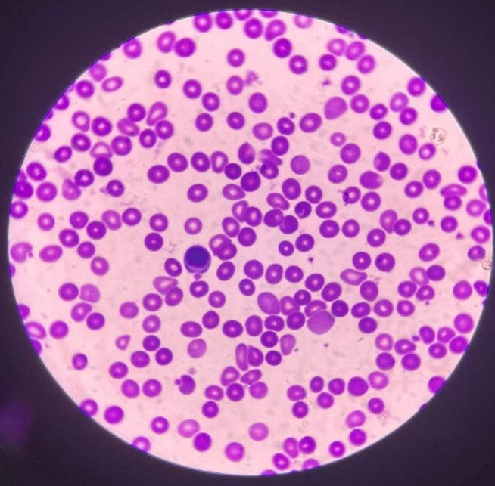

WBC: Monocyte-1 WBC: Lymphocyte-1

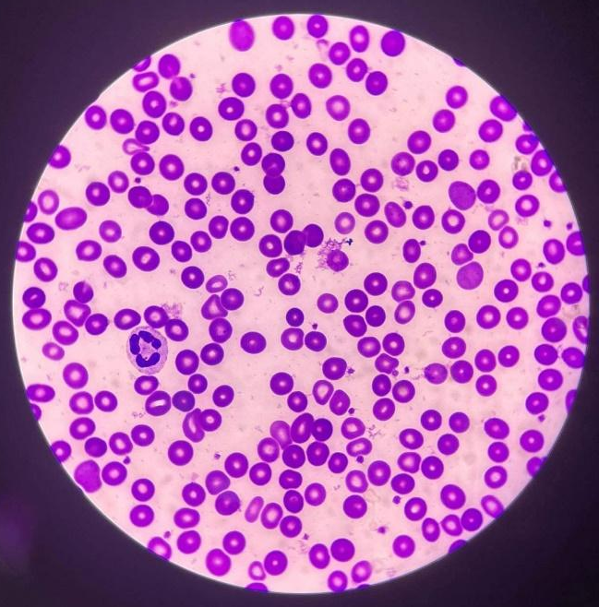
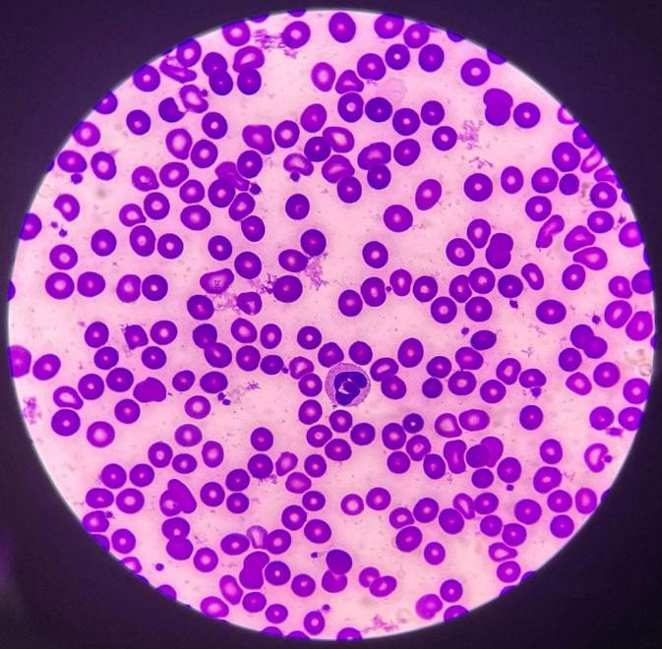

WBC: Neutrophil-1 WBC: Neutrophil-1

Computation:
WBC Estimate:
$$Average=\frac{Total number of WBC count}{10}$$
$$=Average×2,000$$
$$=1.2×2,000$$
$$Average=\frac{1+1+1+1+1+1+2+1+1+1+1}{10}$$
$$=2,400$$
$$Average=1.2$$

