Platelet Estimate
Name of Patient: Ace Morrieson Ganta Sex:
Date of Birth: 12/14/2001 Age: 20

Result: Conventional Unit: 3,800,000 mm³
SI Unit: 3.8x10⁹ /L

Reference Range: Conventional Unit: 150,000-450, 000 mm³
SI Unit: 150-450x10⁹ /L

Interpretation: The patient’s estimated platelets are normal since his platelet value of 380,000 mm³ falls within the reference range of 150,000-450,000 mm³.

Name of Medical Technologist: Vince Zsanize S. Figues

Date Performed: 6/3/2022 Time Performed: 6:56 P.M.

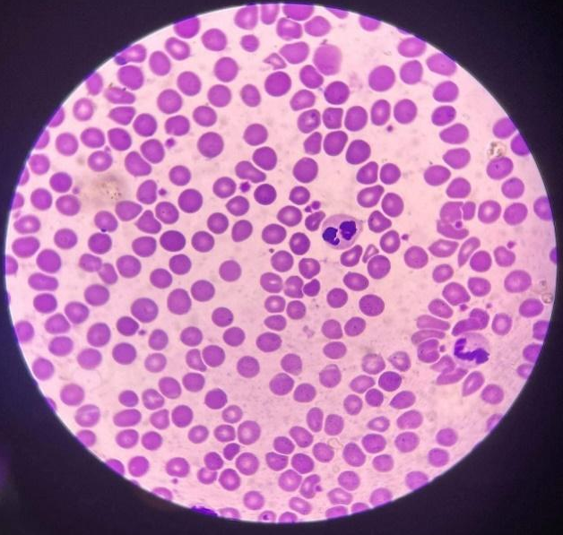
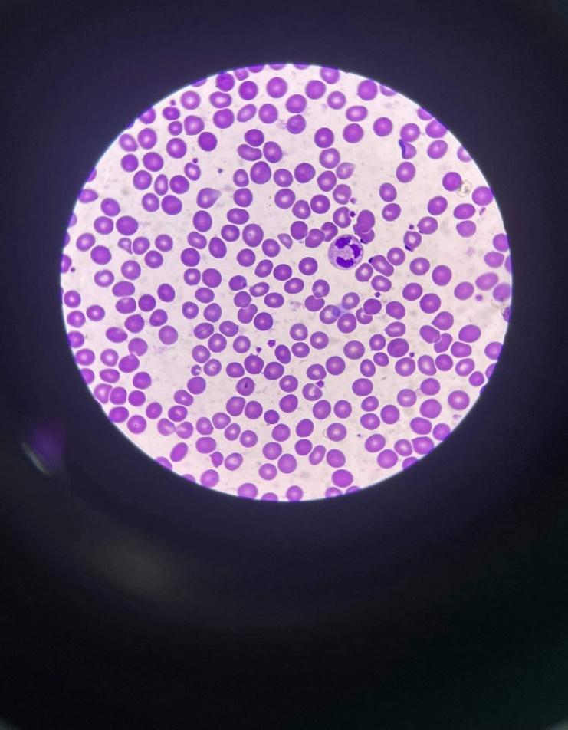

Platelet: 16 Platelet: 19
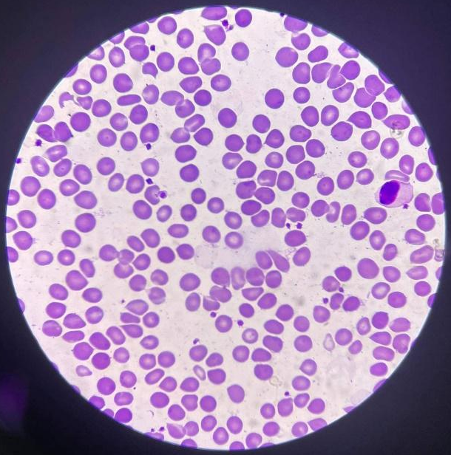

Platelet: 22 Platelet: 8

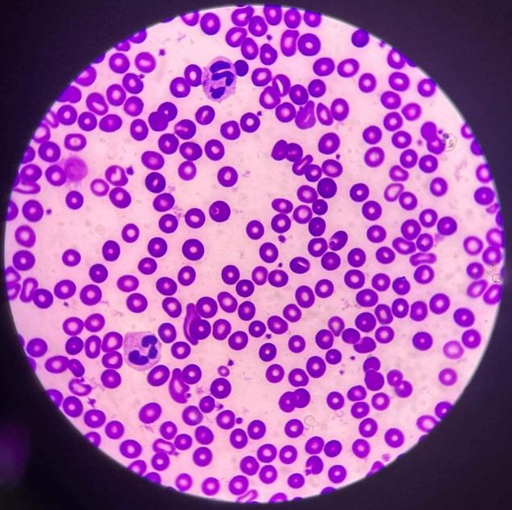

Platelet: 16 Platelet: 24
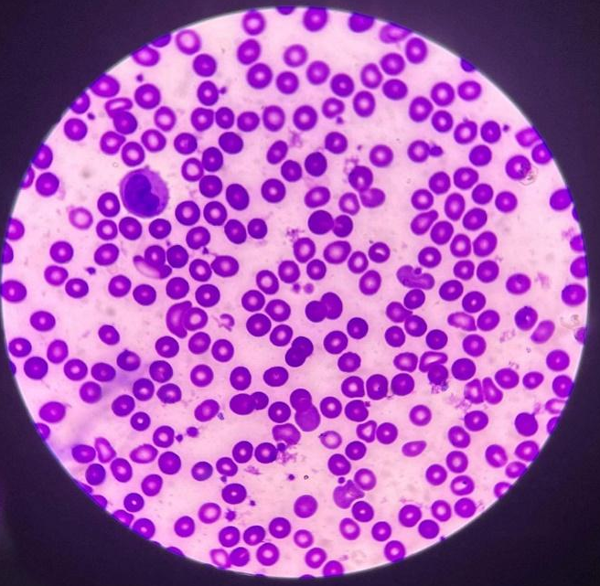

Platelet: 27 Platelet: 14

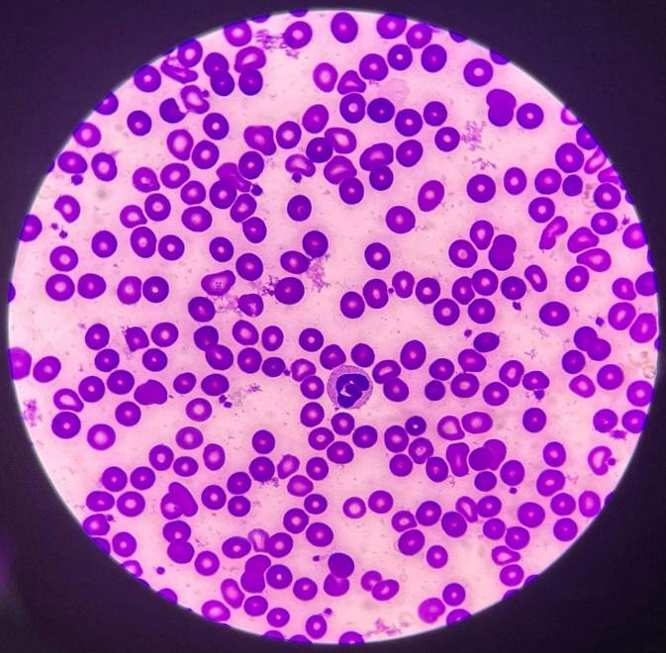

Platelet: 22 Platelet: 22

Computation:
Platelet Count:
$$=Average×20,000$$
$$=190×20,000$$
$$Average=\frac{16+19+22+8+16+24+27+14+22+22}{10}$$
$=380,000$ mm³ (Conventional Unit)
or
380x 10⁹/ L (SI Unit)
$$Average=190$$

