Sera C. Silot
MT 14 - D LEC

Practice problems for material management

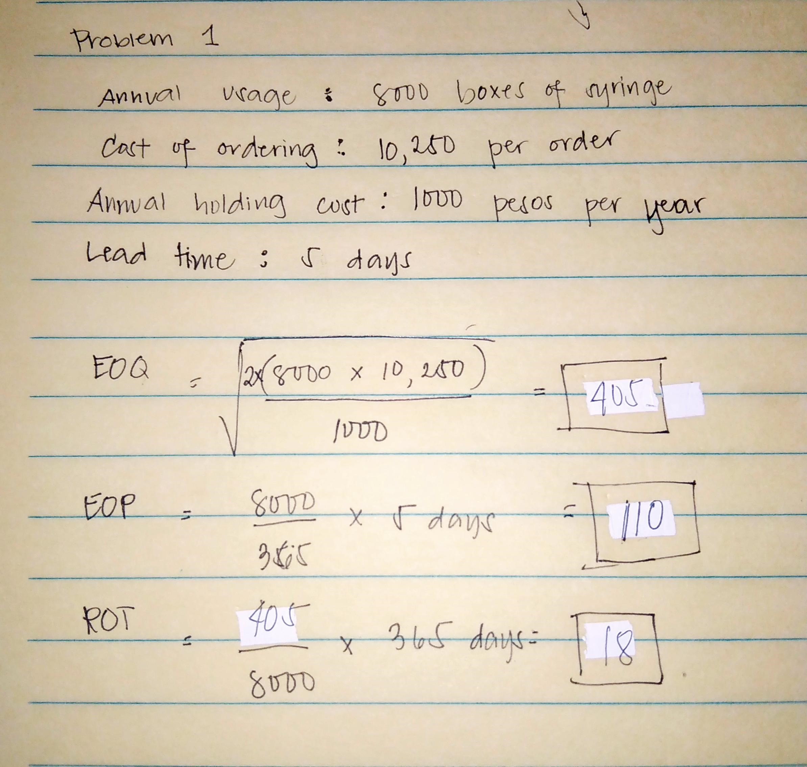
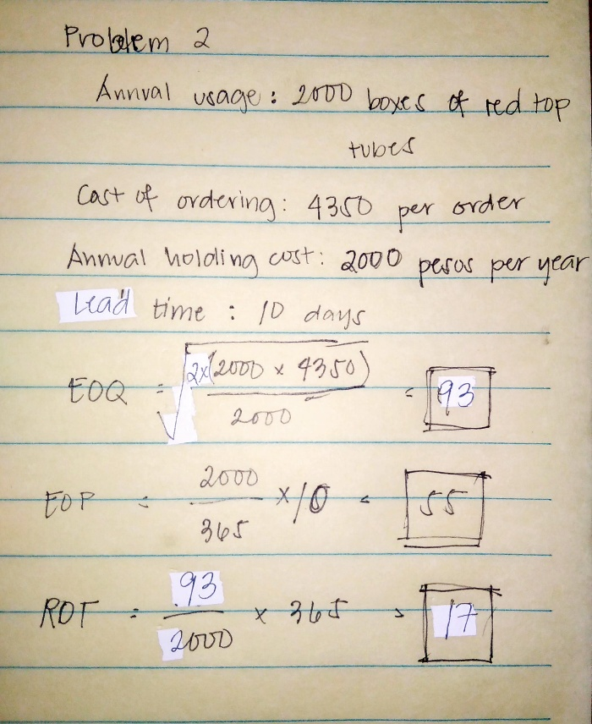

For maximum financial benefit and storage space utilization, order 93 boxes of syringe each time the inventory drops to 55 (about every 17 Days).
For maximum financial benefit and storage space utilization, order 405 boxes of syringe each time the inventory drops to 110 (about every 18 Days).

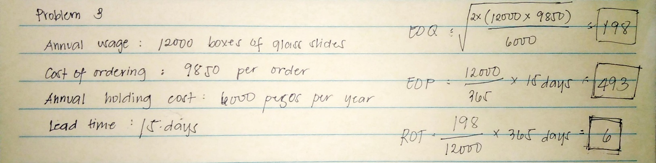
For maximum financial benefit and storage space utilization, order 198 boxes of syringe each time the inventory drops to 493 (about every 6 Days).

