ELAR ATHENA F. CATAYLO
MT14-CC

What is the difference between the policy, process and procedure?

POLICY
A policy sets out the strategic direction of the organization as decided by senior management. A policy will lay out a destination, but won’t give any direction on how this is to be executed. In simple terms, it refers to the set of guidelines that should be followed by the organization and employees in order to achieve compliance. For example a policy would contain a statement such as: ‘The performance of each employee in their respective sections will be tracked everyday’, but wouldn't give any instructions on how a policy is followed.
PROCESS
A process is a method that outlines what you do, but not how you do it. There may be an action such as "Complete time and attendance spreadsheet" in a business process for recording time and attendance for all employees and contractors, but no information on how that is carried out is provided. There is a presumption that the person in charge would be aware of how to do the task and where to locate the necessary supplies.
PROCEDURE
A procedure composes any further instructions or information needed. The precise actions that a person would need to take in order to execute any activity described in a process should be specified in a procedure or work instruction.

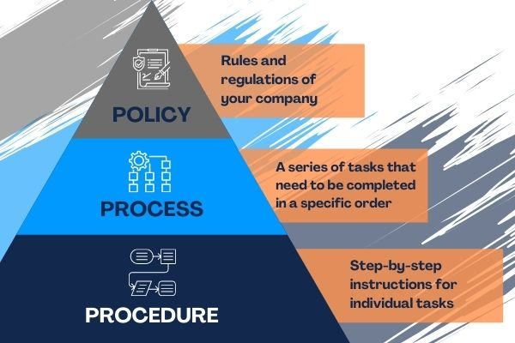
In conclusion, a policy is a set of rules that should be followed, a process is a set of inter-related activities that turn inputs into outputs in conformity to the policy and a procedure is a set of instructions on how a specific task in the process is achieved.

