Activity 2: Peripheral Smears

Name of Patient: Cedrick Babor DOB: 2003-01-31
In this prepared slides, identify and count the number of WBCs and platelets you can find per field (specify type of white blood cell) and compute for the WBC estimate and platelet estimate.

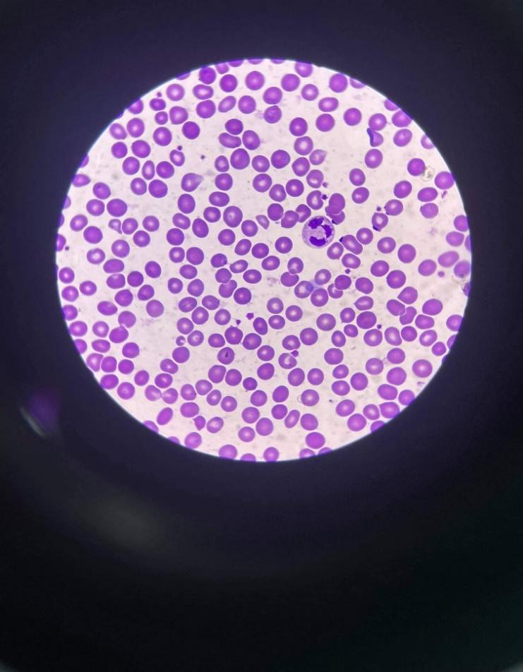
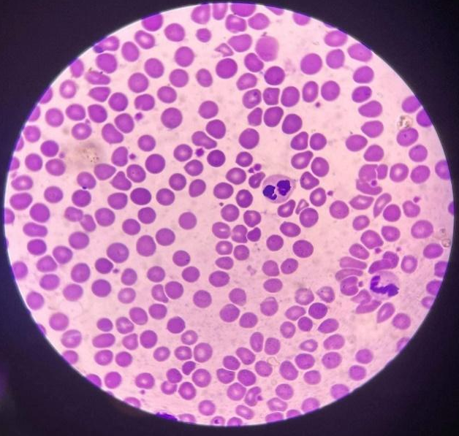
WBC: 1 Type : Neutrophil WBC: 2 Type: Neutrophil
Platelet: 13 Platelet: 20
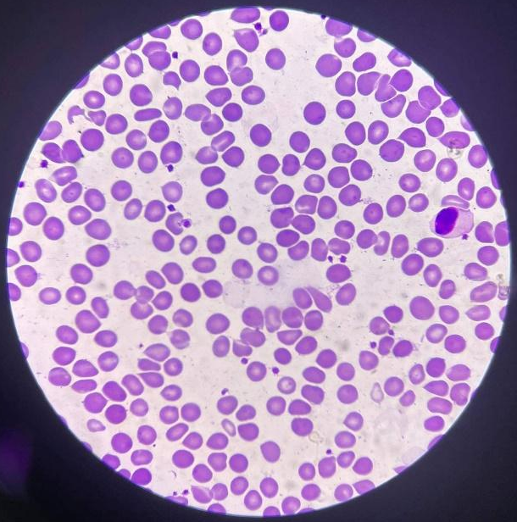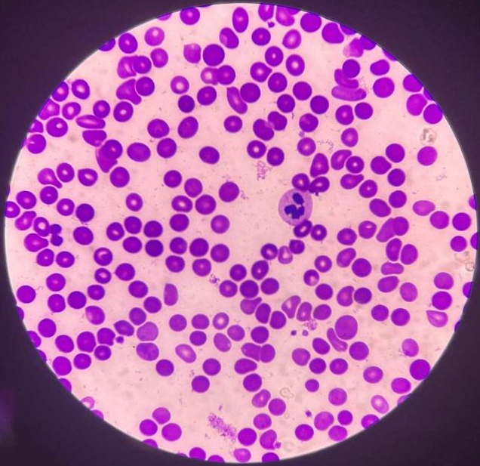
WBC: 1 Type : Monocyte WBC: 1 Type: Neutrophil
Platelet: 19 Platelet: 7
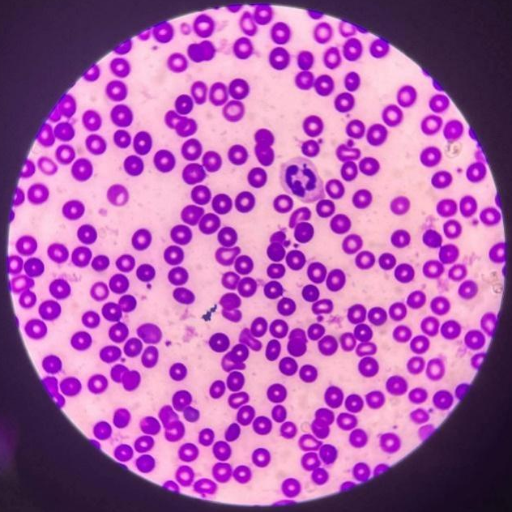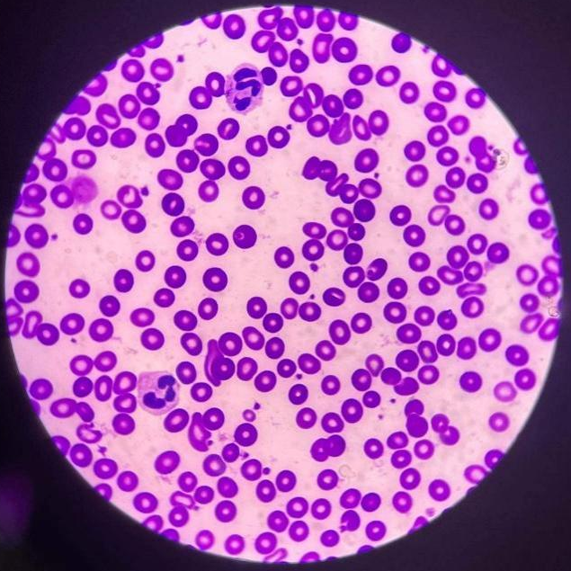
WBC: 1 Type : Neutrophil WBC: 2 Type: Neutrophil
Platelet: 15 Platelet: 23

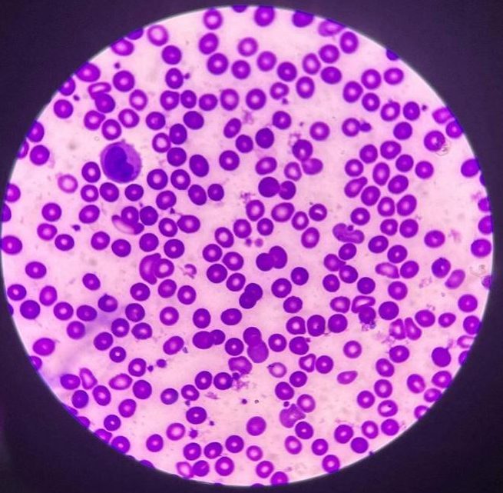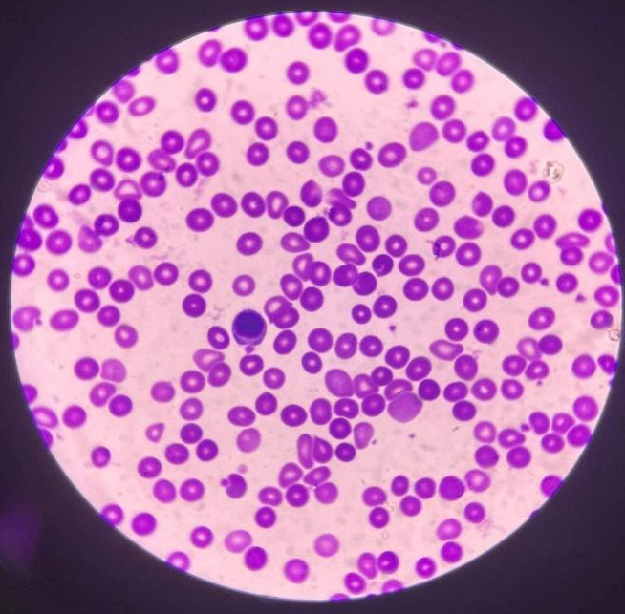
WBC: 1 Type : Monocyte WBC: 1 Type: Lymphocyte
Platelet: 24 Platelet: 11

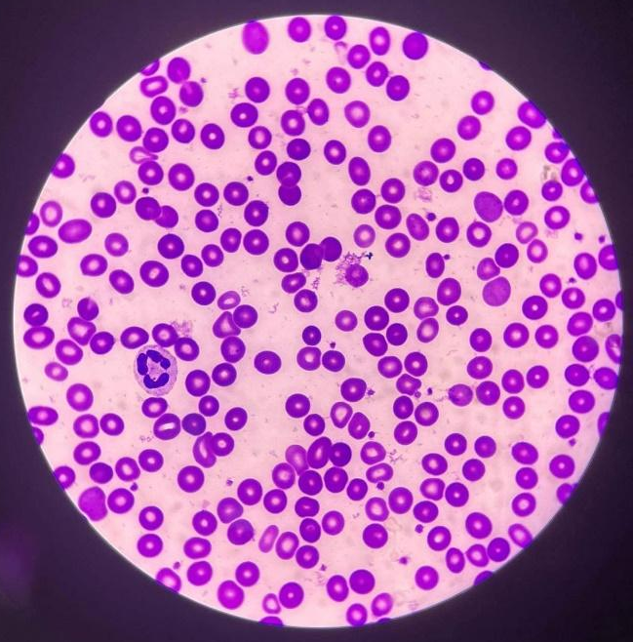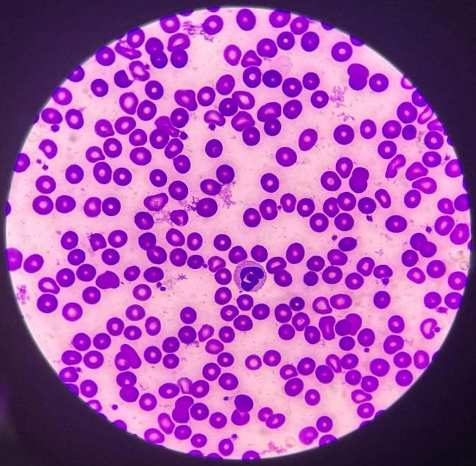
WBC: 1 Type : Neutrophil WBC: 1 Type: Neutrophil
Platelet: 22 Platelet: 21

Computation:
WBC Estimate:
$((1+2+1+1+1+2+1+1+1+1)÷10)×2,000$
(12/10) x 2,000
=2,400

Platelet Estimate:
$((13+20+19+7+15+23+24+11+22+21)÷10)×20,000$
Conventional Unit: 350,000/mm³
SI Unit: 350 x 10⁹ / L

Test / Method | Result | Reference Range | Instructors Signature
RBC Morphology | 21+28+32+39+17+23+20+24+34+26  10  = 26.4  = 3+ | 1+ = 2 – 10 poikilocytes/OIF (1-5%)  2+ = 11-20 pokilocytes/ OIF (6 to 10%)  3+ = 21 to 50 poikilocytes/ OIF (11 to 25%)  4+ = 51 and above poikilocytes/ OIF
WBC Estimate | 2,400 | 4,500-11,000
Platelet Estimate | Conventional Unit: 350,000/mm³  SI Unit: 350 x 10⁹ / L | Conventional Unit: 150,000-450,000 / mm³  SI Unit: 150-450 x 10⁹ / L

Time and Date Performed: May 30,2022 ; 10:05pm
Date Submitted: June 1,2022
Medical Technologist: Babia, Rey Yzzabella N.

