MT14-CC ATTENDANCE

ELAR ATHENA F. CATAYLO
ROLE: TABLE TENNIS OFFICIAL (SCORER/ UMPIRE)
DATE: March 25, 2023 - April 1, 2023

DUTIES DURING THE INTRAMURALS

Umpire
- The umpire is authorized to apply the Rules and Regulations of Table Tennis.
- His/ her main duty is to judge the points or fouls in the game.
- In Table Tennis doubles, the umpires ensure the sequence of service for both players as well as the playing conditions for the match.
Scorer
- The scorer has to count the points won keeping in view the service and judgment of the umpire.

SU INTRAMURALS 2023 DOCUMENTATION

LARONG PINOY OPENING CEREMONY

VENUE: Ravello Ballfield
DATE: 03/25/2023

VENUE: Cimafranca
DATE: 03/26/2023

TABLE TENNIS WOMEN/ MEN (SCORER/ UMPIRE)
VENUE: Multi-Purpose Room (MPR)
DATE: 03/27-31/2023

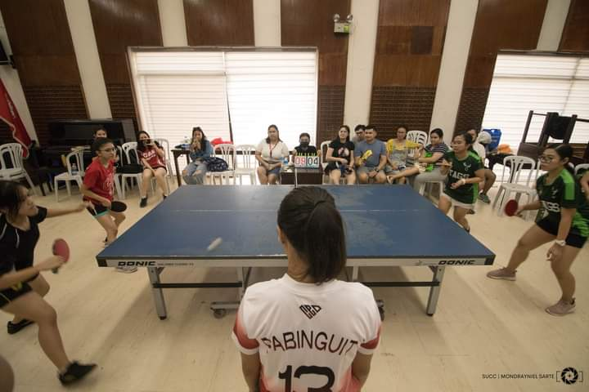
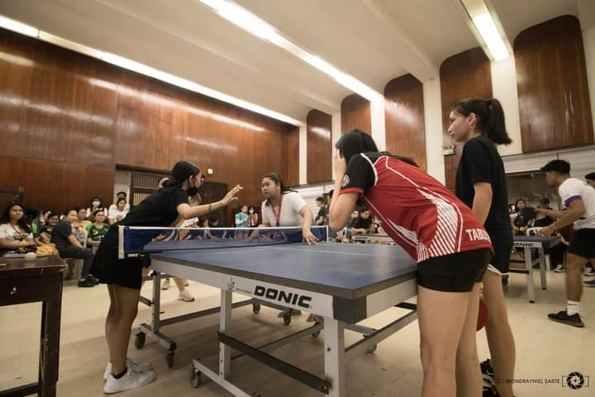


CLOSING CEREMONY
VENUE: Lamberto Macias Sports Complex
DATE: 04/1/2023

