Worksheet 1: Hematocrit
Use this worksheet with Laboratory partner.

Patient 1 – Carl Stewart
Identify which among the capillary tube/s is/are positioned correctly. After which, read the haematocrit level of the tube. Report correct patient’s results by scanning patient QR code.

Conventional unit: 56%
SI Unit: 0.56 L/L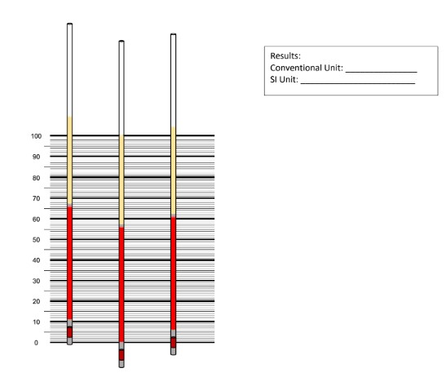
Left – incorrect, center – correct, right – incorrect

Patient 2 – Randelle Talania
Identify which among the capillary tube/s is/are positioned correctly. After which, read the haematocrit level of the tube. Report correct patient’s results by scanning patient QR code.
Conventional unit: 35%
SI Unit: 0.35 L/L
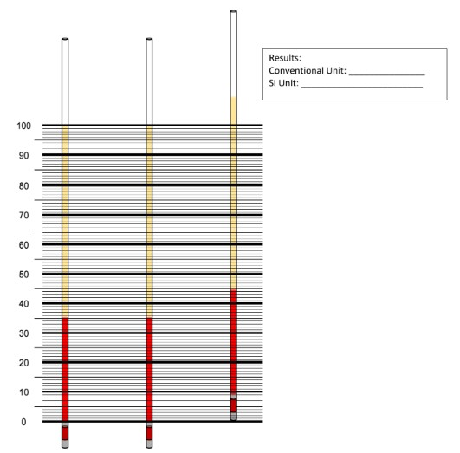
Left – correct, center – correct, right – incorrect

