Worksheet 1: Hematocrit
Use this worksheet with Laboratory partner.

Patient 1 (John Emmanuel P. Capada)
Identify which among the capillary tube/s is/are positioned correctly. After which, read the haematocrit level of theP tube. Report correct patient’s results by scanning patient QR code.
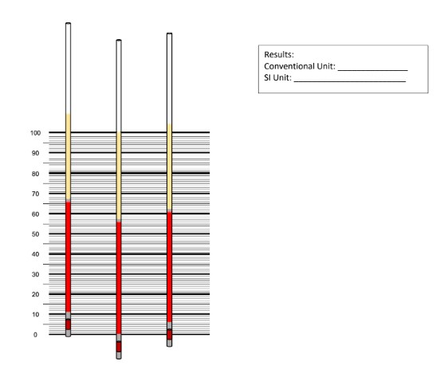
(2nd Tube)
The 2nd tube is the only one positioned correctly.
0.56 L/L
56%

Patient 2 (Moira Alliah A. Gemeniano)
Identify which among the capillary tube/s is/are positioned correctly. After which, read the haematocrit level of the tube. Report correct patient’s results by scanning patient QR code.

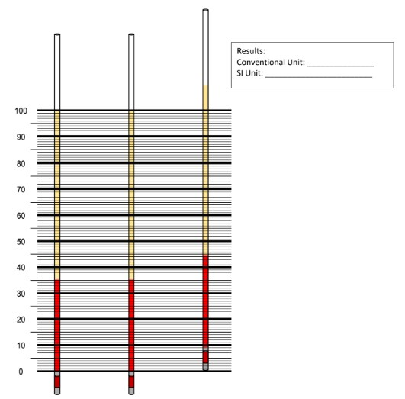
0.35 L/L
35%
(2nd Tube)
The 1st and the 2nd capillary tubes are the ones positioned correctly.
0.35 L/L
35%
(1st Tube)

