Worksheet 1: Hematocrit
Use this worksheet with Laboratory partner.

Patient 1
Identify which among the capillary tube/s is/are positioned correctly. After which, read the haematocrit level of the tube. Report correct patient’s results by scanning patient QR code.
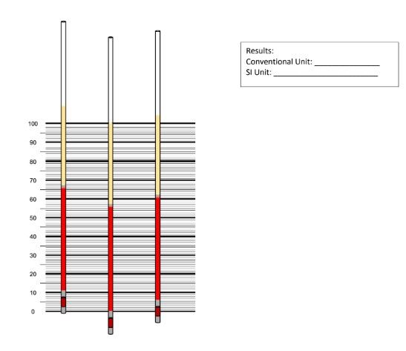
Results:
2nd tube
Conventional Unit: 56%
SI Unit: 0.56 L/L
- The 2nd capillary tube is correctly positioned.

Patient 2
Identify which among the capillary tube/s is/are positioned correctly. After which, read the haematocrit level of the tube. Report correct patient’s results by scanning patient QR code.
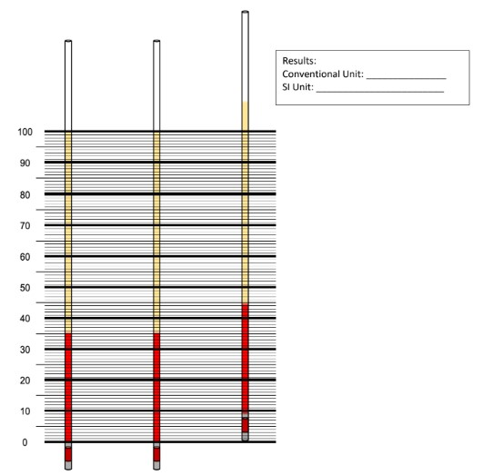
Results:
1st tube
Conventional Unit: 35%
SI Unit: 0.35 L/L

2nd tube
Conventional Unit: 35%
SI Unit: 0.35 L/L

- The 1st and the 2nd capillary tubes are correctly positioned.

