Worksheet 1: Hematocrit
Use this worksheet with Laboratory partner.

Patient 2 (Jacelle Rose Monte)

Identify which among the capillary tube/s is/are positioned correctly. After which, read the haematocrit level of the tube. Report correct patient’s results by scanning patient QR code.

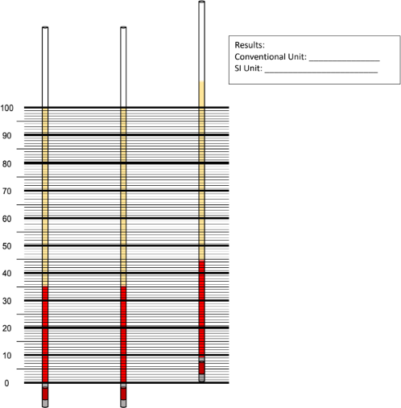
0.35
5
35%

