Worksheet 1: Hematocrit
Use this worksheet with Laboratory partner.

Patient 2 (Goldymyrrh Faye Larena)

Identify which among the capillary tube/s is/are positioned correctly. After which, read the haematocrit level of the tube. Report correct patient’s results by scanning patient QR code.

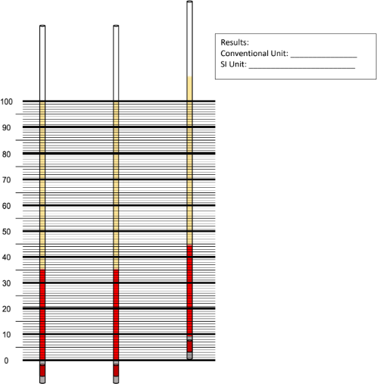
0.39 – 0.45
35-49
35 and 35

Screenshots
