Worksheet 1: Hematocrit
Use this worksheet with Laboratory partner.

Patient 1

Identify which among the capillary tube/s is/are positioned correctly. After which, read the hematocrit level of the tube. Report correct patient results by scanning patient QR code.
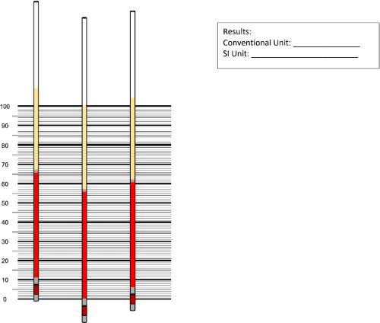

0.39 – 0.45
35-49
56

SCREENSHOTS:

