Worksheet 1: Hematocrit
Use this worksheet with Laboratory partner.

Patient 1 ( Ruth Angeli Fernandez)

Identify which among the capillary tube/s is/are positioned correctly. After which, read the hematocrit level of the tube. Report correct patient’s results by scanning patient QR code.

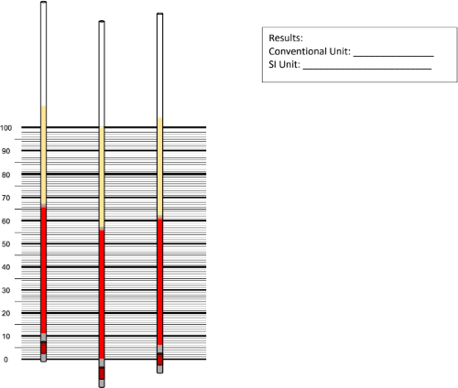
56
35 - 49
0.39 – 0.45
