Name: Theresa Michelle L. Biliran Section: BSMT 1 – MT14 Section E
ACTIVITY 3: BLOOD TYPING
I. ABO FORWARD GROUPING AND RH TYPING
A. Slide Method
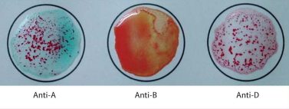
Reaction: + 0 +
Antigen/s detected: Antigens A and D
ABO & Rh Blood Group: “A” Rh D Positive
POST–LABORATORY QUESTIONS:
- What is an antiserum?
An antiserum is a blood serum that contains antibodies against certain antigens that is injected to treat or prevent disease. Antisera are used to determine which antigens are on the red cells.

- What kind of antigen will anti–A detect? Anti–B?
Anti-A will detect B antigen and Anti-B will detect the A antigen.

- When is blood typing ordered?
A blood typing is often requested when a person becomes a candidate for an organ, tissue, or bone marrow transplant, or when a person chooses to give blood, blood typing may be required. It is one of the first of many tests used when determining whether a potential donor and recipient are compatible.

- Name the common causes of false positive and false negative results in ABO Testing.
The following can all result in erroneous positive or negative test findings: bacterial or chemical contamination of test materials, old blood specimens, insufficient incubation time or temperature, poor centrifugation, improper storage of materials, or omission of test.

- What is Rh Typing?
Rhesus (Rh) typing is used to determine whether you have a protein on the outer layer of your red blood cells called Rh factor. Rh negative means you don't have Rh factor in your blood. You are Rh positive if you have Rh factor in your blood. The majority of people are Rh positive.

